LAMP (Software bundle), <https://en.wikipedia.org/wiki/LAMP_(software_bundle)>

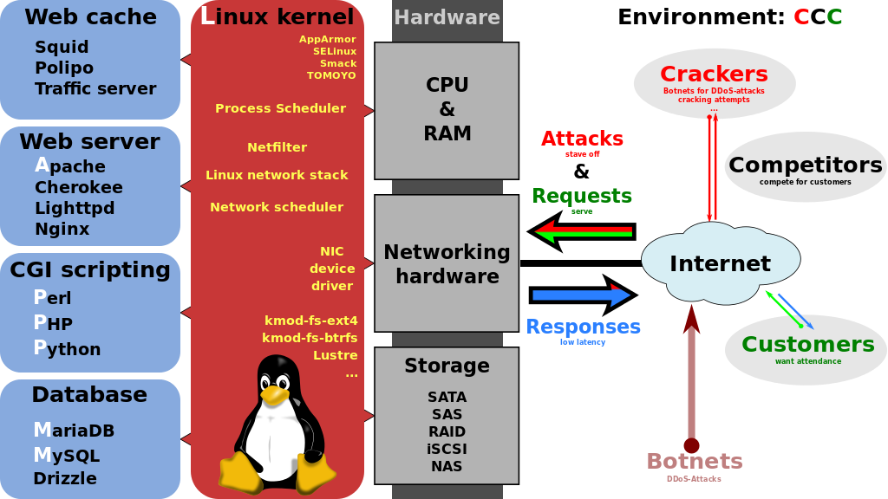

* Linux.org, <http://www.linux.org/>
  + RedHad Linux, <http://www.redhat.com/en/technologies/linux-platforms> ; <https://access.redhat.com/downloads>
  + Ubuntu, <http://www.ubuntu.com/>
  + Debian, <https://www.debian.org/>
  + Oracle Linux
* Apache HTTP Server Project, <http://httpd.apache.org/>
  + Apache httpd 2.4.16 Released – 2015/7/15
* MySQL, <https://www.mysql.com/>
* P
  + PHP, <http://php.net/>
  + Perl (Practical Extraction and Reporting Language)
  + Python

XAMPP Apache + MySQL + PHP + Perl, <https://www.apachefriends.org/index.html>

* Installation Video
* XAMPP Hosting, <https://www.apachefriends.org/hosting.html>
  + In the Amazon Cloud with XAMPP and Bitami
  + In the Azure Cloud with XAMPP and Bitami
  + Google Cloud with XAMPP and Bitami

WordPress, <https://bitnami.com/stack/xampp#wordpress>

Linux Ready Fanless Mini PC, [www.cappuccinoPC.com](http://www.cappuccinoPC.com)

GoDaddy web hosting service

Apache Wave (Incubator), <https://incubator.apache.org/wave/demo-servers.html>

IBM HTTP Server, <http://www-03.ibm.com/software/products/en/http-servers>

Rackspace Cloud Servers, <http://www.rackspace.com/cloud/servers>

FreeRTOS – Open Source Embedded Ethernet TCP/IP web server, <http://www.freertos.org/embeddedtcp.html>

NIOS II Web Server Demo, DE2 Application Note, by Terasic Technologies, <https://www.terasic.com.tw/attachment/archive/30/DE2_web_server_appnote.pdf>

NESTOR Web-Server Mobility Demo, <http://www.cs.columbia.edu/dcc/nestor/web-demo/>

Cloud Computing, <https://en.wikipedia.org/wiki/Cloud_computing>

Network and Systems Management, <http://oriondemo.solarwinds.com/Orion/Login.aspx?ReturnUrl=%2f>

A Knowledge Framework for Enterprise Application Systems Management, 2007, <https://msdn.microsoft.com/en-us/library/Bb897546.aspx>

Chapter 2 Java Enterprise System Solution Architectures, <https://docs.oracle.com/cd/E19396-01/819-0061/architecture.html>

Enterprise Information Infrastructure

Web Demo – Create the Ultimate Website Demo, [http://www.walkme.com/create-the-ultimate-demo-with-walkme/?t=1&camp=demo&eco=tutorial&adgr=create&pitch=Adoption-Promotion&keyw=demo%20software&matc=b&sear={search}&adin=48156951233&land=create-the-ultimate-demo-with-walkme&gclid=CKSaypuqyccCFQUMaQodF-IKjw](http://www.walkme.com/create-the-ultimate-demo-with-walkme/?t=1&camp=demo&eco=tutorial&adgr=create&pitch=Adoption-Promotion&keyw=demo%20software&matc=b&sear=%7bsearch%7d&adin=48156951233&land=create-the-ultimate-demo-with-walkme&gclid=CKSaypuqyccCFQUMaQodF-IKjw)

YouTube Editor, <https://accounts.google.com/ServiceLogin?hl=en&continue=https%3A%2F%2Fwww.youtube.com%2Fsignin%3Fhl%3Den%26app%3Ddesktop%26feature%3Dredirect_login%26action_handle_signin%3Dtrue%26next%3Dhttp%253A%252F%252Fwww.youtube.com%252Feditor&passive=true&service=youtube&uilel=3#identifier>

Video Manager, Paul Lin

<https://www.youtube.com/channel/UC9KIuHiK6DQQhEjTKJ5ZIdQ>