**ITC 250/CPET 499 Web Systems**

**Nov. 1, 2016**

**Managing MySQL Database**

**Part 2 of 3**

**MySQL Topics of Discussion**

1. **SQL Statement Syntax**
2. **SQL Statement Examples**
3. **phpMyAdmin Password**
4. **MySQL Root Password**
5. **Grant User Access to Tables**
6. **Planning Your Database Tables**

**A) SQL Statement Syntax**

1. **Data Definition Statements,** [**https://dev.mysql.com/doc/refman/5.7/en/sql-syntax-data-definition.html**](https://dev.mysql.com/doc/refman/5.7/en/sql-syntax-data-definition.html)
   * ALTER: DATABASE, EVENT, FUNCTION, INSTANCE, LOGFILE GROUP, SERVER, TABLE, TABLE SPACE
   * CREATE: DATABASE, EVENT, FUNCTION, INDEX, LOGFILE GROUP, PROCEDURE, SERVER, TABLE, TABLE SPACE, VIEW
   * DROP: DATABASE, EVENT, FUNCTION, INSTANCE, LOGFILE GROUP, SERVER, TABLE, TABLE SPACE
   * RENAME TABLE
   * TRUNCATE TABLE
2. **Data Manipulation Statements,** [**https://dev.mysql.com/doc/refman/5.7/en/sql-syntax-data-manipulation.html**](https://dev.mysql.com/doc/refman/5.7/en/sql-syntax-data-manipulation.html)
   * CALL, DELETE, DO HANDLER, INSERT, LOAD DATA INFILE, LOAD XML, REPLACE
   * SELECT, SUBQUERY, UPDATE
3. **Transactional and Locking Statements,** [**https://dev.mysql.com/doc/refman/5.7/en/sql-syntax-transactions.html**](https://dev.mysql.com/doc/refman/5.7/en/sql-syntax-transactions.html)
   * START TRANSACTION, COMMIT, ROLLBACK
   * SAVEPOINT, ROLLBACK TO SAVEPOINT, RELEASE SAVEPOINTS
   * LOCK TABLES, UNLOCK TABLES
   * SET TRANSACTION
4. **Replication Statements**
   * Controlling Masters
   * Controlling Slave Servers
   * Controlling Group Replication
5. **Prepared SQL Statements**
   * PREPARE, EXECUTE, DEALLOCATE PREPARE
6. **Compound Statement**
   * Begin … End
   * Statement Label
   * Declare
   * Variables in Stored Programs
   * Flow Control Statements
   * Cursors
   * Condition Handling
7. **Database Administration Statements**
   * Account Management:
     + ALTER USER
     + CREATE USER
     + DROP USER
     + GRANT
     + RENAME USER
     + REVOKE
     + SET PASSWORD
   * Table Maintenance:
   * Plugin and User-Defined Function
   * SET
   * SHOW
   * Other Administration Statements
     + FLUSH, RESET, SHUTDOWN
     + BINLOG, CACHE INDEX, KILL, LOAD INDEX INTO CACHE
8. **Utility Statements**
   * DESCRIBE
   * EXPLAIN
   * HELP
   * USE

**B) Examples of MySQL Statements/Commands**

**Run the mysql Tool on XAMPP Server**

* Start your XAMPP Console
* Click on Shell

Administrator@LIN-PC c:\xampp\mysql

# dir

Volume in drive C has no label.

Volume Serial Number is CA27-2D0F

Directory of c:\xampp\mysql

10/25/2016 10:45 AM <DIR> .

10/25/2016 10:45 AM <DIR> ..

10/25/2016 10:45 AM <DIR> backup

10/25/2016 10:46 AM <DIR> bin

07/13/2016 09:10 PM 17,987 COPYING

07/13/2016 09:10 PM 26,545 COPYING.LESSER

07/13/2016 09:10 PM 86,259 COPYING.thirdparty

07/13/2016 09:10 PM 1,980 CREDITS

10/30/2016 11:33 PM <DIR> data

07/13/2016 09:10 PM 8,245 EXCEPTIONS-CLIENT

07/18/2016 05:50 AM 5,057 my-huge.ini

07/18/2016 05:50 AM 20,906 my-innodb-heavy-4G.ini

07/18/2016 05:50 AM 5,044 my-large.ini

07/18/2016 05:50 AM 5,055 my-medium.ini

07/18/2016 05:50 AM 2,921 my-small.ini

07/13/2016 09:10 PM 2,105 README

03/30/2013 08:29 AM 1,105 resetroot.bat

10/25/2016 10:45 AM <DIR> share

07/18/2016 05:50 AM 3,574 wsrep.ini

13 File(s) 186,783 bytes

6 Dir(s) 295,222,722,560 bytes free

Administrator@LIN-PC c:\xampp\mysql

#

**Root Password is Not Configured**

Administrator@LIN-PC c:\xampp\mysql

# mysql -u root

Welcome to the MariaDB monitor. Commands end with ; or \g.

Your MariaDB connection id is 6

Server version: 10.1.16-MariaDB mariadb.org binary distribution

Copyright (c) 2000, 2016, Oracle, MariaDB Corporation Ab and others.

Type 'help;' or '\h' for help. Type '\c' to clear the current input statement.

MariaDB [(none)]>

**SQL Query Statements**

* **USE**
* **SHOW**
* **SELECT/FROM**
* **CREATE**
* **DESCRIBE**
* **DROP**
* **INSERT INTO**
* **databases, TABLE, VALUES**

MariaDB [(none)]> show databases;

+--------------------+

| Database |

+--------------------+

| information_schema |

| mysql |

| performance_schema |

| phpmyadmin |

| test |

| testdb |

+--------------------+

6 rows in set (0.00 sec)

**SQL Query**

* **use mysql;**
* **show tables;**

MariaDB [mysql]> use mysql;

Database changed

MariaDB [mysql]> show tables;

+---------------------------+

| Tables_in_mysql |

+---------------------------+

| column_stats |

| columns_priv |

| db |

| event |

| func |

| general_log |

| gtid_slave_pos |

| help_category |

| help_keyword |

| help_relation |

| help_topic |

| host |

| index_stats |

| innodb_index_stats |

| innodb_table_stats |

| ndb_binlog_index |

| plugin |

| proc |

| procs_priv |

| proxies_priv |

| roles_mapping |

| servers |

| slave_master_info |

| slave_relay_log_info |

| slave_worker_info |

| slow_log |

| table_stats |

| tables_priv |

| time_zone |

| time_zone_leap_second |

| time_zone_name |

| time_zone_transition |

| time_zone_transition_type |

| user |

+---------------------------+

34 rows in set (0.02 sec)

MariaDB [mysql]> select Host, User, Password from user;

+-----------+------+----------+

| Host | User | Password |

+-----------+------+----------+

| localhost | root | |

| 127.0.0.1 | root | |

| ::1 | root | |

| localhost | | |

| localhost | pma | |

+-----------+------+----------+

5 rows in set (0.01 sec)

**Example: Use mysql database, create a userdb table**

MariaDB [(none)]> use mysql;

Database changed

MariaDB [mysql]> CREATE TABLE userdb(

-> userID int,

-> firstName varchar(20),

-> lastName varchar(30),

-> emailAddr varchar(50),

-> faceboorURL varchar(100),

-> twitterHandle varchar(20)

-> );

**Query OK, 0 rows affected (0.01 sec)**

**SHOW all tables within the mysql database**

MariaDB [mysql]> SHOW tables;

+---------------------------+

| Tables_in_mysql |

+---------------------------+

| column_stats |

| columns_priv |

| db |

| event |

| func |

| general_log |

| gtid_slave_pos |

| help_category |

| help_keyword |

| help_relation |

| help_topic |

| host |

| index_stats |

| innodb_index_stats |

| innodb_table_stats |

| ndb_binlog_index |

| plugin |

| proc |

| procs_priv |

| proxies_priv |

| roles_mapping |

| servers |

| slave_master_info |

| slave_relay_log_info |

| slave_worker_info |

| slow_log |

| table_stats |

| tables_priv |

| time_zone |

| time_zone_leap_second |

| time_zone_name |

| time_zone_transition |

| time_zone_transition_type |

| user |

| userdb |

+---------------------------+

35 rows in set (0.01 sec)

MariaDB [mysql]> DESCRIBE userdb;

+---------------+--------------+------+-----+---------+-------+

| Field | Type | Null | Key | Default | Extra |

+---------------+--------------+------+-----+---------+-------+

| userID | int(11) | YES | | NULL | |

| firstName | varchar(20) | YES | | NULL | |

| lastName | varchar(30) | YES | | NULL | |

| emailAddr | varchar(50) | YES | | NULL | |

| faceboorURL | varchar(100) | YES | | NULL | |

| twitterHandle | varchar(20) | YES | | NULL | |

+---------------+--------------+------+-----+---------+-------+

6 rows in set (0.01 sec)

**Insert one Row of Data Into “userdb” database, then exit MySQL**

MariaDB [mysql]> INSERT INTO userdb

-> VALUES (1, "Paul", "Lin", "pihailin631@gmail.com",

-> "https://www.facebook.com/paul.lin.3110567",

-> "@pihailin631");

Query OK, 1 row affected (0.00 sec)

MariaDB [mysql]> SELECT * FROM userdb;

+--------+-----------+----------+-----------------------+-----------------------

--------------------+---------------+

| userID | firstName | lastName | emailAddr | faceboorURL

| twitterHandle |

+--------+-----------+----------+-----------------------+-----------------------

--------------------+---------------+

| 1 | Paul | Lin | pihailin631@gmail.com | https://www.facebook.c

om/paul.lin.3110567 | @pihailin631 |

+--------+-----------+----------+-----------------------+-----------------------

--------------------+---------------+

1 row in set (0.00 sec)

MariaDB [mysql]> SELECT firstName, lastName, twitterHandle FROM userdb;

+-----------+----------+---------------+

| firstName | lastName | twitterHandle |

+-----------+----------+---------------+

| Paul | Lin | @pihailin631 |

+-----------+----------+---------------+

1 row in set (0.00 sec)

MariaDB [mysql]> select facebookURL from userdb where firstName ='Paul';

ERROR 1054 (42S22): Unknown column 'facebookURL' in 'field list'

MariaDB [mysql]> select faceboorURL from userdB where firstName ='Paul';

+-------------------------------------------+

| faceboorURL |

+-------------------------------------------+

| https://www.facebook.com/paul.lin.3110567 |

+-------------------------------------------+

1 row in set (0.00 sec)

MariaDB [mysql]>exit

Bye

Administrator@LIN-PC c:\xampp\mysql

**The created “userdb” table definition is saved with an .frm extension, which can be located in the following location :**

Directory of c:\xampp\mysql\data\mysql

10/31/2016 03:03 PM <DIR> .

10/31/2016 03:03 PM <DIR> ..

…

10/31/2016 03:03 PM 802 userdb.frm

10/31/2016 10:58 AM 98,304 userdb.ibd

98 File(s) 1,631,872 bytes

2 Dir(s) 294,783,545,344 bytes free

**userdb.ibd data file contains InnoDB table and its indexes.**

**References**

* **11.1 MySQL .frm File Format,** [**https://dev.mysql.com/doc/internals/en/frm-file-format.html**](https://dev.mysql.com/doc/internals/en/frm-file-format.html)
* **15.1 Introduction to InnoDB (General Purpose Storage Engine),** [**http://dev.mysql.com/doc/refman/5.7/en/innodb-introduction.html**](http://dev.mysql.com/doc/refman/5.7/en/innodb-introduction.html)
* **15.7.4 InnoDB File-Per-Table Tablespace,** [**http://dev.mysql.com/doc/refman/5.7/en/innodb-multiple-tablespaces.html**](http://dev.mysql.com/doc/refman/5.7/en/innodb-multiple-tablespaces.html)

**Click on Admin on MySQL to see the web page:** [**http://localhost/phpmyadmin**](http://localhost/phpmyadmin)

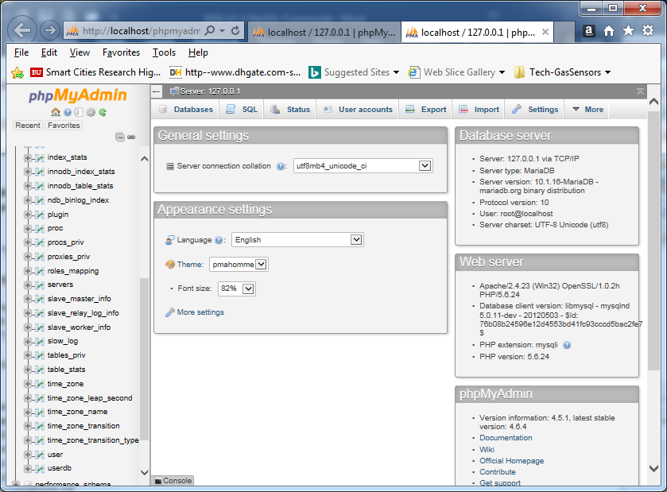

**View Data Tables from phpMyAdmin**

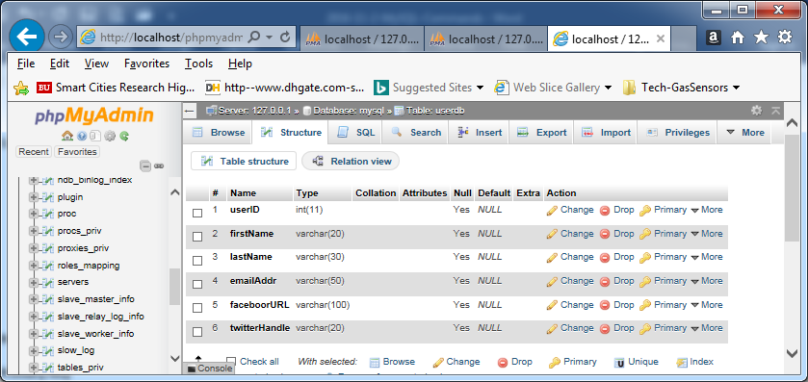

**Modification/Changes of a Table:**

* Change Filed Name **faceboorURL** => facebookURL
* userID => AUTO_INCREAMENT PRIMARY KEY

**C) phpMyAdmin Password**

* + Go to “c:\xampp\phpMyAdmin” directory and find “Config.inc.php” file
  + Open Config.inc.php with a text editor:
    - Change: $cfg[‘Servers’][$a][‘auth_type’]=’config’
    - To: $cfg[‘Servers’][$a][‘auth_type’]=’cookie’
  + Save the file
  + Open a web browser: <http://localhost/phpmyadmin/>

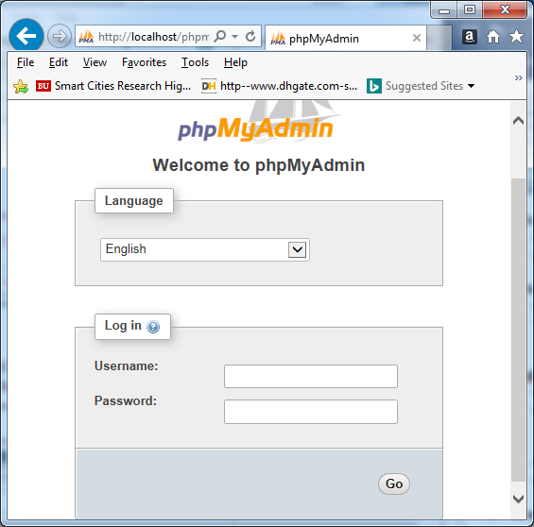

* + **Enter “root” in Username**
  + **Leave Password Null, press Go button**

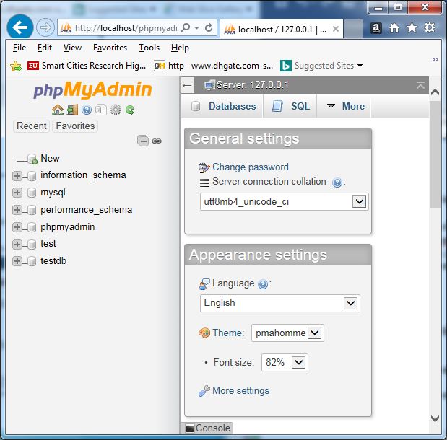

* **Click “Change password”**
* **Enter “your_new_password”, Reenter, Hit “Go”**

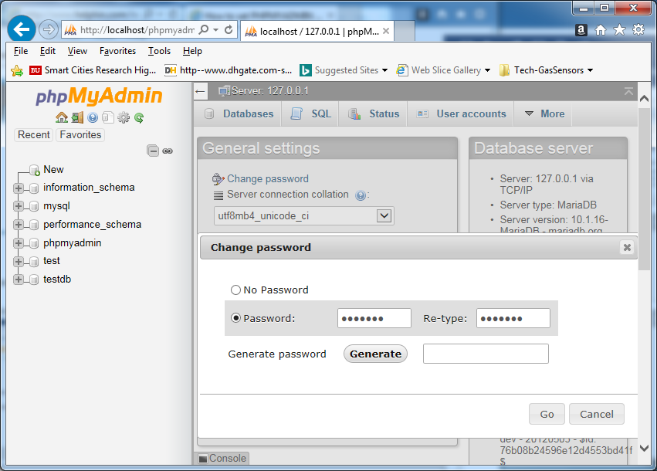

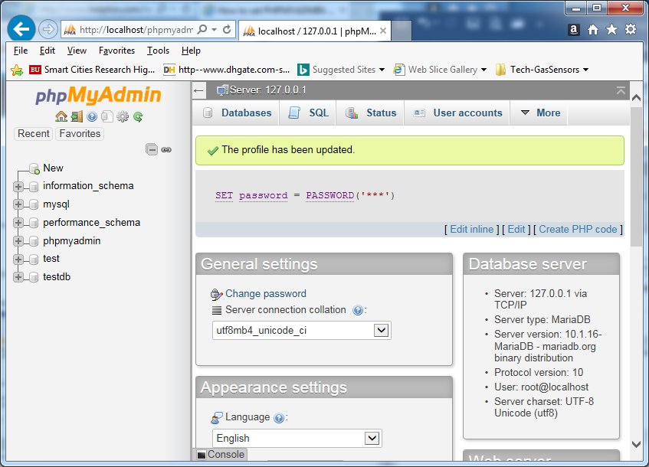

**D) MySQL Password**

* **Click on “User accounts”**
* **Click on “Edit privileges”: root 127.0.0.1**

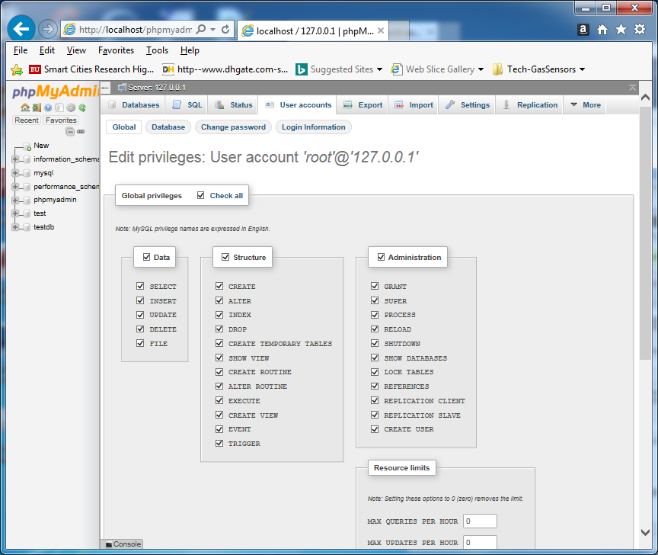

* **Under “User accounts”, Click on “Change password”, to see another Dialog box**
* **Enter “your_new_password”**
* **The password for ‘root’@’127.0.0.1’ was changed successfully**

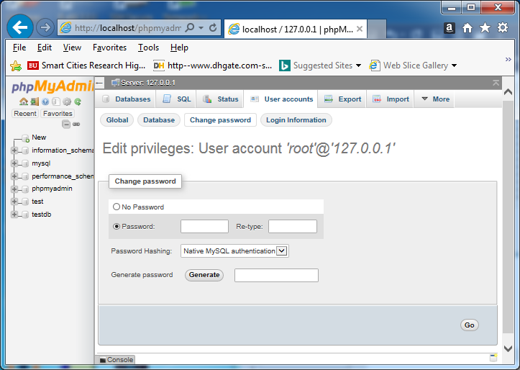

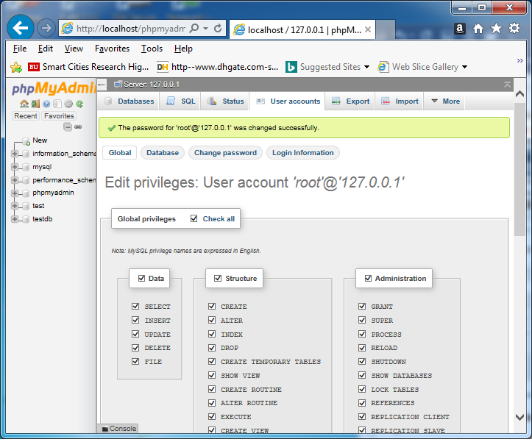

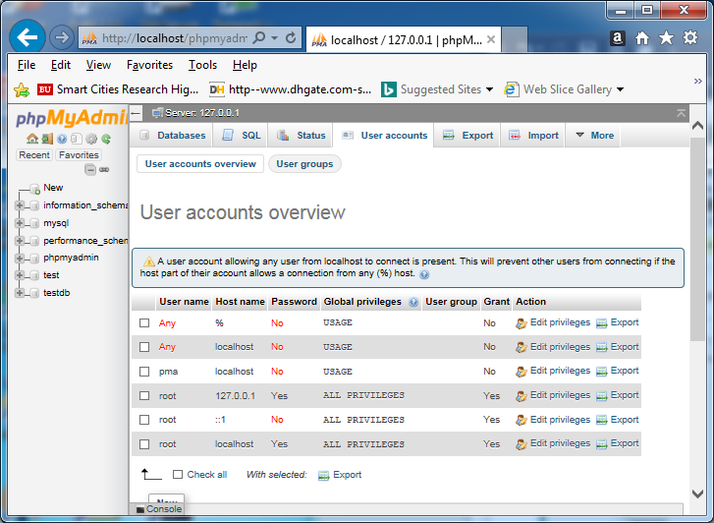

**E) Grant Other Users to Access Database**

* **From the Shell connect to MySQL as an Administrator**

**> mysql –u root –p mysql**

* **On the mysql prompt, you type**

**> grant all privileges on DATA_BASE_NAME.* to USERNAME@localhost identified by ‘PASSWORD’;**

**> flush privileges;**

**>\q**

1. **Planning Database Table**

* **Data Tables**
* **Entity of a Table**
* **ID (AUTO_INCREMENT, PRIMARY KEY)**
* **Constraints: NOT NULL**

**Customer/User Info Table**

* **User ID**
* **First Name**
* **Last Name**
* **Email Address**
* **Street Address**
* **State**
* **Country**
* **Browser Type**
* **Computer Type**

**Product Catalog (Services) Table**

**Primary Key**

**Secondary Keys**