**ITC 250/CPET 499 Web Systems**

**Nov. 3, 2016**

**Managing MySQL Database**

**Part 3 of 3**

**MySQL Topics of Discussion**

* **More Command-Line Interface**
* **phpMyAdmin**
  + **config.inc.php file : defineing a connection to the MySQL server**
* **Exporting and Importing Databases via phpMyAdmin** 
  + **http://localhost/phpmyadmin**
* **Accessing MySQL using PHP Scripts**
  + **Basic steps**
  + **Connect MySQL database with PHP scripts**
  + **Query a database using PHP script**
* **MySQL Workbench**

1. **More Command-Line Interface**

**mysql –u root password mypass; # login into root with mypass**

**mysql –u root –h; # prompt root user to enter mypass**

**Launch an interactive MySQL Command-Line Session**

* **Login to “mysql” database in the local host (-h 127.0.0.1), prompt for a password (-p)**

Administrator@LIN-PC c:\xampp

# cd mysql

Administrator@LIN-PC c:\xampp\mysql

# mysql -h 127.0.0.1 -u root mysql -p

Enter password: *******

Welcome to the MariaDB monitor. Commands end with ; or \g.

Your MariaDB connection id is 2

Server version: 10.1.16-MariaDB mariadb.org binary distribution

Copyright (c) 2000, 2016, Oracle, MariaDB Corporation Ab and others.

Type 'help;' or '\h' for help. Type '\c' to clear the current input statement.

MariaDB [mysql]>

* **SHOW TABLES**

MariaDB [mysql]> SHOW TABLES;

+---------------------------+

| Tables_in_mysql |

+---------------------------+

| column_stats |

| columns_priv |

| db |

| event |

| func |

| general_log |

| gtid_slave_pos |

| help_category |

| help_keyword |

| help_relation |

| help_topic |

| host |

| index_stats |

| innodb_index_stats |

| innodb_table_stats |

| ndb_binlog_index |

| plugin |

| proc |

| procs_priv |

| proxies_priv |

| roles_mapping |

| servers |

| slave_master_info |

| slave_relay_log_info |

| slave_worker_info |

| slow_log |

| table_stats |

| tables_priv |

| time_zone |

| time_zone_leap_second |

| time_zone_name |

| time_zone_transition |

| time_zone_transition_type |

| user |

| userdb |

+---------------------------+

35 rows in set (0.02 sec)

MariaDB [mysql]>

References

* Chapter 3 Resetting the Root Password – Windows System, <https://dev.mysql.com/doc/mysql-windows-excerpt/5.6/en/resetting-permissions-windows.html>
* 6.1.4 Server Commands Option, <http://dev.mysql.com/doc/refman/5.7/en/server-options.html>

1. **phpMyAdmin – config.inc.php file** 
   1. **Defining connection to the MySQL server**

**C:\xampp\phpMyAdmin\config.inc.php**

...

/* Authentication type and info */

$cfg['Servers'][$i]['auth_type'] = 'cookie'; //was: 'config'

$cfg['Servers'][$i]['user'] = 'root';

$cfg['Servers'][$i]['password'] = '';

$cfg['Servers'][$i]['extension'] = 'mysqli';

$cfg['Servers'][$i]['AllowNoPassword'] = true;

$cfg['Lang'] = '';

/* Bind to the localhost ipv4 address and tcp */

$cfg['Servers'][$i]['host'] = '127.0.0.1';

$cfg['Servers'][$i]['connect_type'] = 'tcp';

/* User for advanced features */

$cfg['Servers'][$i]['controluser'] = 'pma';

$cfg['Servers'][$i]['controlpass'] = '';

...

1. **Importing MySQL Databases: Using Command Line**

* **Open “art.sql” with notepad or Notepad++** 
  + **This is a phpMyAdmin SQL Dump file**
* **Login to phpMyAdmin**
  + **User name: root**
  + **Enter password: \*\*\*\*\*\*\***
* **Import “art.sql”**
  + **In phpMyAdmin, click on the Database tab.**
  + **Create a database called “art”**
  + **Click “Import”, find and chose the “art.sql”, then click “Go”**
  + **Message: Import has been successfully finished 67 queries executed (art.sql)**
* **Click “New” to create another database**
* **Import “travel.sql”**
  + **In phpMyAdmin, click on the Database tab.**
  + **Create a database called “travel”**
  + **Click “Operations” to Rename “travel” as “travels”**
  + **Click “Import”, find and chose the “travels.sql”, then click “Go”**
  + **Message: Import has been successfully finished 2867 queries executed (travels.sql)**
* **Repeat the same process to Import “bookcrm-comprehensive” database,** 
  + **…**
  + **Message: Import has been successfully finished 1090 queries executed (bookcrm-comprehensive.sql)**

**Query art.sql database via phpMyAdmin**

* **In phpMyAdmin, click on the “art”datasbae**
* **Click on “SQL”**
* **Enter the following command**
  + **SELECT * from artists;**

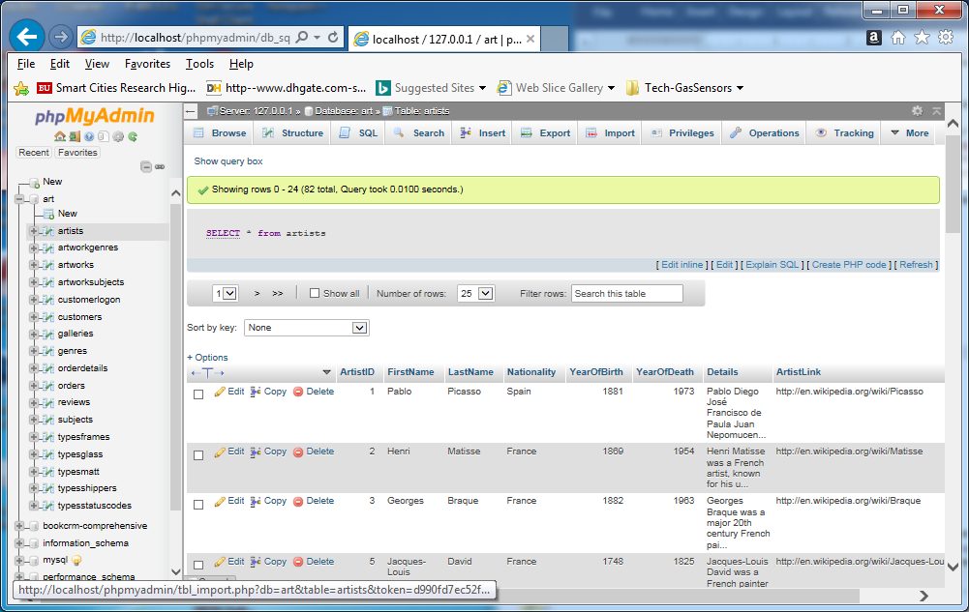

* **Enter the following new query**
  + **SELECT artworkid, title, yearofwork from artworks where yearofwork < 1600;**

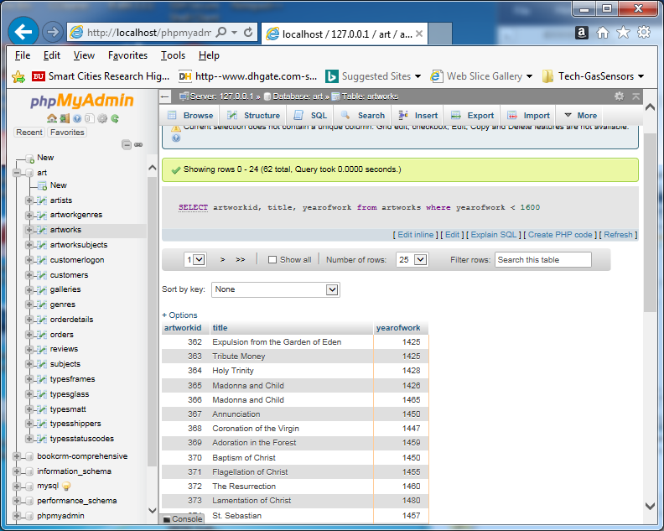

1. **Accessing MySQL with PHP Scripts for Web-based Application – basic steps**
2. **Establish a connection to the MySQL database**
3. **Check and handle connection error if exist**
4. **Execute the SQL query statements for the needed database operations**
5. **Prepare the results in the HTML page format**
6. **Free computing resources and close connection**

**An Example: Connect and disconnect MySQL Database with PHP scripts**

* **Login to MySQL Database as root user**
* **Create Database (given a database name – “experiment”)**
* **Create a Folder in Htdocs (with a database name given above – “experiment”)**
* **Create database connection file in PHP (for example db_connection.php)**
* **Include ‘db_connection.php’ in your file**
* **Create a php file (check_connection.php) to check your database connection, include check_connection.php**
* **Open browser and go to “http://localhost/phpconnecttest/check_connection.php**

**PHP-MySQL Database Connection Testing**

1. **Prepare PHP scripts**
2. **Save them c:\xampp\htdoc\phpConnectTest**
3. **Open a browser to run the scrip**

**http://localhost/phpConnectTest/check_connection.php**

<?php

/* check_connection.php*/

include "db_connect_functions.php";

$conn = openConnect();

echo "<p><b>Database Connected Successfully </b></p>";

closeConnect($conn);

echo "<p><b> Database Disconnected</b></p>";

?>

<?php

/* db_connect_functions.php */

function openConnect()

{

$DB_HOST = "localhost";

$DB_USER = "root";

$DB_PASSWORD = "yourpass"; // use your root password

$DB_NAME = "testdb"; // database name

$connHandler = new mysqli($DB_HOST, $DB_USER, $DB_PASSWORD, $DB_NAME)

or die("<p> Error connecting to database: ") . mysql_error() . "</p>";

return $connHandler;

}

function closeConnect($conn)

{

$conn -> close();

}

?>

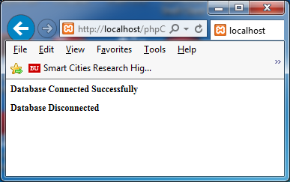

**Query “user” TBALE within mysql Database**

Functions for Executing MySQL Statements using PHP Script

* mysqli_stmt_execute(mysqli_stmt $stmt), <http://php.net/manual/en/mysqli-stmt.execute.php>
* **Prepare PHP scripts**
* **Save them c:\xampp\htdoc\phpConnectTest**
* **Open a browser to run the scrip**
* **http://localhost/phpConnectTest/userTableQuery.php**

<?php

/* rootuser_config.php */

define('DB_HOST', 'localhost');

define('DB_NAME', 'mysql');

define('DB_PASSWORD', 'givenpass');

define('DB_USER' = 'root');

?>

<?php

/* connectToDB.php */

function connectToDB($DB_HOST, $DB_USER, DB_PASSEORD, DB_NAME)

{

$connHandler = new mysqli($DB_HOST, $DB_USER, $DB_PASSWORD, $DB_NAME)

or die("<p> Error connecting to database: ") . mysql_error() . "</p>";

return $connHandler;

}

function closeConnect($conn)

{

$conn -> close();

}

?>

<?php

/* mysql Database, query "user" Table */

include('rootuser_config.php');

include("connectToDB.php");

$conn = openConnect(DB_HOST, DB_USER, DB_PASSWORD, DB_NAME)

or die("<p> Error connecting to database: ") . mysql_error() . "</p>";;

echo "<p><b>Database Connected Successfully </b></p><br/>";

/* Ref: http://php.net/manual/en/mysqli-stmt.execute.php */

$query ="SELECT Host, User, Password FROM user;";

// $stmt =mysqli_prepare($conn, $query);

// $results = mysqli_stmt_execute($stmt);

$i =0;

echo "User Table in mysql Database <br>";

echo "Host User Password<br/>";

echo "------------------------------------<br/>";

if($results = mysqli_query($conn, $query))

{

while ($row = mysqli_fetch_row($results))

{

printf("%s (%s, %s)\n", $row[0], $row[1], $row[2]);

echo "<br/>";

}

mysqli_free_result($results);

}

/* Close connection */

closeConnect($conn);

echo "<p><b> Database Disconnected</b></p>";

?>

<?php

if(!@mysql_connect('127.0.0.1', 'root', '*your default password*'))

{

echo "mysql not connected ".mysql_error();

exit;

}

echo 'great work';

?>

**Query Results Displayed on Web Browser**

