**ITC 250/CPET 499 Web Systems**

**Nov. 8, 2016**

**Lectures**

**Advanced Topics**

**Topics**

* **Enterprise Information System Modeling & Design**
  + **Enterprise Information Service – Operation Environment**
  + **Enterprise Integration: Web Server System**
  + **Web-based Databases**
  + **Mobile Sales Automation System**
  + **Data Conversion Workflow**
* **Data Analysis, Modeling and Design (Web-based System)**
  + **Data Input, Process, Store & Display**
    - **Forms, Reports, Screen of data**
  + **Data Modeling Workflow**
  + **Logical Data Structure**
    - **Graphical Data Model**
  + **Schemas**
    - **A model of the structure of a database**
    - **Describe the kinds of data as realized in specific implementation model, such as the relational model or the object-oriented model**
  + **Physical Data Storage**
  + **Business Data Processing**
    - **Data => Information**
    - **Restrictions**
      * **Constraints**
      * **Business Rules**
      * **Legal Issues**
  + **Users**
  + **Documentation**
* **Database Design, Development, Administration and Migration**

**References**

* **MySQL Workbench,** [**http://dev.mysql.com/downloads/workbench/**](http://dev.mysql.com/downloads/workbench/)
* **MySQL Topic Guides,** [**https://dev.mysql.com/doc/index-topic.html**](https://dev.mysql.com/doc/index-topic.html)
* **MySQL Workbench: Database Design, Development, Administration, and Migration,** [**https://www.mysql.com/why-mysql/white-papers/mysql-workbench-database-design-development-administration/**](https://www.mysql.com/why-mysql/white-papers/mysql-workbench-database-design-development-administration/)
* **Virtual Database Schema Design,** [**https://www.mysql.com/products/workbench/design/**](https://www.mysql.com/products/workbench/design/)

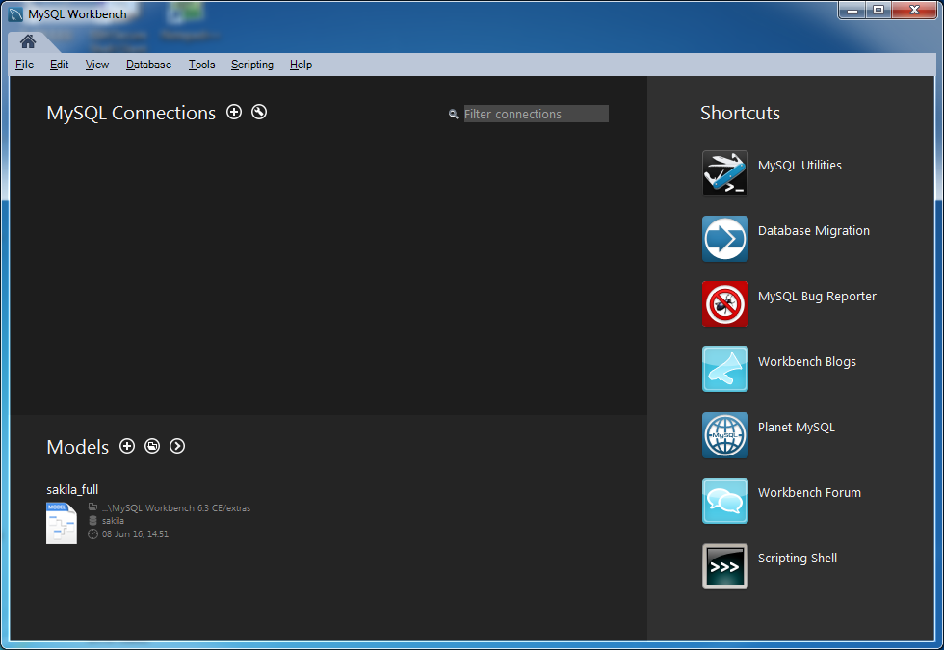

**Enterprise Information System Modeling and Design**

* + **Enterprise Information Service – Operation Environment**
  + **Enterprise Integration: Web Server System**
  + **Web-based Databases**
  + **Mobile Sales Automation System**
  + **Data Conversion Workflow**

**Enterprise Information Service – Operation Environment**



**Enterprise Integration: Web Server System**



**Web-Based Databases**



**Mobile Sales Automation System**



**Data Conversion Workflow**



**Data Analysis, Modeling and Design (Web-based System)**

* **Data Input, Process, Store & Display**
  + **Forms, Reports, Screen of data**
* **Data Modeling Workflow**
* **Logical Data Structure**
  + **Graphical Data Model**
* **Database Schema**
  + **A model of the structure of a database**
  + **Describe the kinds of data as realized in specific implementation model, such as the relational model or the object-oriented model**
* **Physical Data Storage**
* **Business Data Processing**
  + **Data => Information**
  + **Restrictions**
    - **Constraints**
    - **Business Rules**
    - **Legal Issues**
* **Users**
* **Documentation**

**Data Modeling Workflow – for Database Design & Application**



**Step 1. Requirement Analysis**

* **Inputs:** 
  + **Current business process & existing data structures**
  + **Application data requirements**
  + **Data ownership**
  + **Data dependency**
  + **Data efficiency and cost**
  + **Possible data and service reuse by other applications**
* **Outputs:**
  + **Application data requirement**
  + **Documentation**

**Step 2. Conceptual Data Modeling**

* **Inputs:**
  + **Classify entities and attributes**
  + **Defines relationships**
  + **Identify relevant data to be stored in the database**
* **Outputs:**
  + **Entity-Relationship Models/Diagrams**
  + **Data Requirements**
    - **Data objects, entities, attributes, relationships, constraints**

**Step 3. Logical Data Modeling**

* **Inputs:**
  + **Convert entity set to relation tables**
  + **How can data be created and modified**
  + **How can data be manipulated and queried**
  + **Integrity constraints**
  + **Specifying key constraints**
* **Outputs:**
  + **Relational Model/Table**
  + **DB Schema/Primary keys, foreign keys, views**

**Step 4. Schema Refinements**

* **Inputs:** 
  + **Analyze the collection of relations**
  + **Identify potential problems**
  + **Normalizing relations**
* **Outputs**

**Logical Data Structure (LDS)**

* **Vocabulary of LDS**
  + **Entity**
  + **Attribute**
  + **Relationship: one-to-one, one-to-many, many-to-one, many-to-many**
  + **Link**
  + **Descriptor**
  + **Maximum degree**
  + **Identifier**
* **Entity**
  + **Represented by a box**
  + **Examples – a COW entity with 5 attributes**
    - **COW for RFID Tracking**
      * **Cow ID**
      * **Name**
      * **Birth Place**
      * **Birth Weight**
      * **Current Weight**
  + **Instances**

|  |  |  |  |  |
| --- | --- | --- | --- | --- |
| **Cow ID** | **Name** | **Birth Place** | **Birth Weight** | **Current Weight** |
| **1254** | **Manly Bully** | **Ft Wayne** | **30** | **480** |
| **1289** | **Funny Daisy** | **New Haven** | **35** | **500** |

**MySQL Workbench**

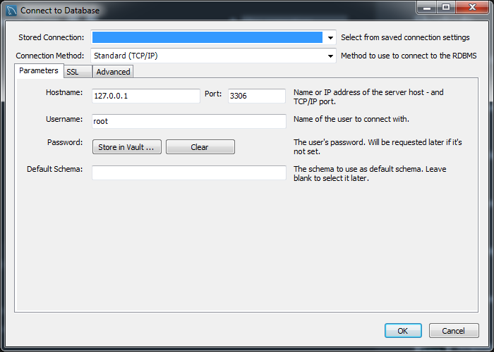

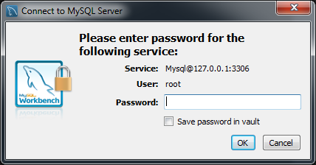

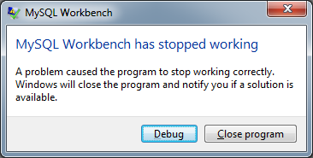

[**http://www.mandsconsulting.com/resolving-mysql-workbench-has-stopped-working-error-message-workbench-v5-2-windows-event-id-1026-and-1000**](http://www.mandsconsulting.com/resolving-mysql-workbench-has-stopped-working-error-message-workbench-v5-2-windows-event-id-1026-and-1000)

**Ch. 11 Managing MySQL Database**

**Case Study Schemas**

* Figure 11.23 Art Database Schema, p. 477
* Figure 11.24 Book CRM Database Schema, p. 478
* Figure 11.25 Travel Photo Database Schema, p. 478

**Art database tables**

* **ArtWorks**
* **Artists**
* **OrderDetails**
* **Reviews**
* **ArtWorkKeyWords**
* **Keywords**
* **ArtWorkSubjects**
* **Subjects**
* **Customers**
* **Orders**
* **CustomerLogon**
* **OrderDetails**
* **TypesFrames**
* **TypesMatt**
* **TypesGlass**

**Book CRM database tables**

* **Books**
* **Imprints**
* **BindingTypes**
* **Subcategories**
* **ProductionStatuses**
* **BookAuthors**
* **Authors**
* **CustomerBooks**
* **Customers**

**Travel Photo Sharing Database Tables**

* **GeoCounty**
* **GeoCities**
* **GeoTimeZones**
* **GeoContents**
* **TravelImageDetails**
* **TravelUser**
* **TravelImage**
* **TravelPost**
* **TravelerUserFollowing**
* **TravelImageLocations**
* **TravelImageRating**
* **TravelPostingImages**

**Simple Database Techniques**