**Tables for Tabular Data Display**

Tables can be used to represet information in a two-dimensional format. Typical table applications for displaying product catelog, inventory data, price table, financial data, calenders, etc. A two-dimensional table include caption, heading cell, row datal, and borders if needed. The elements that defined in HTML 5 for creating tables include <table>,

**Begin Tag End Tag Meaning**

<table> </table> The **table** element represents data with more than one

dimension in the form of table.

**Attributes**: BORDER, ALIGN, WIDTH, CELLSPACING,

CELLPADDING, BGCOLOR, BACKGROUND

<caption> </caption> The **caption** element represents the title of the

Table.

<colgroup> </colgroup> The **colgroup** element represents a group of one

or more columns in the table.

<tbody> </tbody> The **tbody** element represents a block of rows

that consists of a body of data.

<col> </col> The **col** (column) element represents one or more

columns in the coloum group.

<thead> </thead> The **thead** element represents the block of rows

that concists of the column lables (headers).

<tfoot> </tfoot> The **tfoot** element represents the blocj of rows

that concists of the column summaries (footers)

<tr> </tr> The tr element defines a row of ceslls in a

table.

**Attributes:** ALIGN (left, right, center), VALIGN

(top, middle, bottom)

<td> </td> The **td** element represents a data cell in a tbale.

<th> </th> The **th** element represents a header cell in a table.

**Attributes**: COLSPAN, ROWSPAN, ALIGN, VALIGN,

WIDTH, HEIGHT

Table Border Styles Examples: (Figure 4.8, pp. 157)

<style>

table { border: solid 1 pt black; }

</Style>

<style>

table {border: solid 1 pt black;}

td {border: solid 1 pt black;}

</style>

<style>

table { border: solid 1 pt black; border-collapse: collapse;}

td { border: solid 1 pt black; padding: 10 pt;}

</style>

<style>

table { border: solid 1 pt black; border-spacing: 10pt;}

td { border: solid 1pt black;}

Examples of Boxed Tables – Styles (Figure 4.9, pp. 158)

<style>

table{

font-size: 0.8 em;

font-family: Aerial, Helvertica, sana-serif;

border-collapse: collapse;

border-top: 4 px solid #DCA806;

border-bottom: 1 px solid white;

text-align: left;}

caption{

font-weight: bold;

padding: 0.25em 0 0.25 em 0;

text-align: left;

text-transform: uppercase;

border-top: 1px solid #DCA806;}

</style>

<style>

tbody tr {

background-color: #F1F1F1;

border-bottom: 1px solid white;

color: #6E6E6E;}

tbody td {padding: 0.75em;}

</style>

<style>

table {

font-family: "Lucida Sans", Verdana, Arial, sans-serif;

font-size: 1em;

}

tbody {

background-color: #F1F1F1;

}

td, th {

padding: 0.5em;

}

thead, tfoot {

background-color: #CACACA;

}

caption {

font-size: 1.2em;

font-weight: bold;

background-color: #DCA806;

padding: 0.5em;

}

tbody tr:nth-child(odd) {

background-color: white;

}

</style>

Hover Effect and Zebra Strips – Table Examples (Figure 4.10, pp. 159)

<style>

tbody tr:hover{

background-color: #9e9e9e;

color: black;

}

</style>

<style>

tbody tr:nth-child (odd){

background-color: white;}

</style>

HTML th – Table header cell, <http://www.w3.org/TR/html-markup/th.html>

**Creating HTML Forms**

A <form> tag in a HTML page contains such controls as Text box, Text Area, Check Box, Radio button, Multiple Selection, Submit Command Button, Reset button, etc., that allows a Web page to gather information from users and send them back to a Web server for further processing.

HTML 5 section 4.1, describes :   
“A form is a component of a Web page that has form controls, such as text fields, buttons, checkboxes, range controls, or color pickers. A user can interact with such a form, providing data that can then be sent to the server for further processing (e.g. returning the results of a search or calculation). No client-side scripting is needed in many cases, though an API is available so that scripts can augment the user experience or use forms for purposes other than submitting data to a server.

Writing a form consists of several steps, which can be performed in any order: writing the user interface, implementing the server-side processing, and configuring the user interface to communicate with the server.”

**Form Element and Attributes**

You will need to use the following syntax for creating a form. All controls must appear between two <form> and </form> tags. A general <form> syntax using name, action, and method attributes is as shown below:

<form ***name***= thisName ***action*** = thisAction ***method*** =thisMethod>

</form>

Where:

* The ***name*** attribute is the name or ID of form to use in the document.
* The ***action*** attribute is the name of application program, a CGI program, on the server with valid URL that will be called to process the information.
* The ***method*** attribute specifies how the controls' value will be transmitted to the server via HTTP protocol. There are two methods: POST (environment variable) and GET (no special characters; for example, 1 < ¼; a>b; or b ).

**Begin Tag End Tag Meaning**

<form> </form> Indicates a form

Attributes; ACTION, METHOD, ENCTYPE, TARGET,

NAME, ONSUBMIT, ONRESET

Global attributes defined in the HTML 5, 4.10 Forms, include

* accept-charset – Character encoding to use for form submission
* action – URL to use for form submission
* autocomplete – Default settings for autofill feature for controls in the form
* enctype – Form data set encoding type
* method – HTTP method to use for submission of form submission
* name – Name of form to use in the document.forms API
* novalidate – Bypass form control validation for form submission
* target – Browsing context for form submission

Example (Figure 4.11, Sample HTML form)

<form method=”get” action=”process.php”>

<fieldset>

<legend> Details </legend>

<p>

<label> Title: </label>

<input type+ “text” name =”title”/>

</p>

<p>

<label> Country: </label>

<select name=”where”>

<option> Choose a Country </option>

<option> Canada </option>

<option> Finland </option>

<option> United States </option>

</select>

</p>

<input type =”submit/”>

</fieldset>

</form>

**Input Tags and Attributes**

**Begin Tag End Tag Meaning**

<INPUT> Define an input element such as TEXT field,

radio button, check box, and pass word field

for a form.

Attributes: TYPE, NAME, VALUE, ALIGN, CHECKED,

MAXLENGTH, SIZE, SRC, ONCLICK, ONDBCLICK,

ONSELECT, ONCHANGE, ONFOCUS, OBBLUR

**Input Types and Variables**

Text Box for Input

<INPUT TYPE="text" NAME="lastname">

Submit and Reset Buttons

<INPUT TYPE="SUBMIT">

<INPUT TYPE="RESET">

**Text Control**

The text control is a box that the users can enter a single line of text such as name, address, and so on.

<input type= text name= "TextName" value = "DisplayInBox"> < /FONT>

**CheckBox Control**

ChekBox control is similar to check box in Visual Basic, a little square with an option checkmark. It is used to present a list of options, which the users can select more than one. The control's value can be 0 or 1; for example, checked (1) or cleared (0).

<input type = checkbox name = "check1">FirstBox < /FONT>

**RadioButton**

Control RadioButton controls are used to present lists of options, similar to the CheckBox control, but it allows one of them can be selected.

<input type = radio name ="level">Beginner<br>

<input type = radio name ="level" checked>Intermediate<br>

<input type = radio name ="level">Advanced<br>

**Command Button**

Control Comment button can perform only two actions in the browser (Submit and Reset) without Script (VBScript, JavaScript, or PerlScript). The Submit command is to submit the entered data on the controls to the server. The Reset command is to reset all control values on the Form to their original values.

<input type = submit value = "Send Data"> < /FONT >

<input type = reset value = "Reset Value"> < /FONT >

**Text Area Tags and Attributes**

The TextArea control is similar to the Text control, but it allows the entry of multiple lines of text. The TextArea control can also defined with row and column.

**Begin Tag End Tag Meaning**

<TEXTAREA> </TEXTAREA> Create a multi-line text entry area.

Attributes: NAME, ROWS, COLS, WRAP, ONSELECT,

ONCHANGE, ONFOCUS, ONBLUR, ONKEYDOWN,

ONKEYPRESS, ONKEYUP

<TEXTAREA NAME=".." ROWS=xxx, COLS=yyy>

</TEXTAREA>

**Select and Option Tags and Attributes**

**Begin Tag End Tag Meaning**

<SELECT> </SELECT> Create a combo box or a list box to let user

select among many multiple predefined options.

Attributes: NAME, SIZE, MULTIPLE, ONCLICK,

ONFOCUS, ONBLUR, ONCHANGE

<OPTION> </OPTION> Attributes: VALUE, SELECTED

Example: The following example "FormLab.htm" will help you to understand the form basics. It

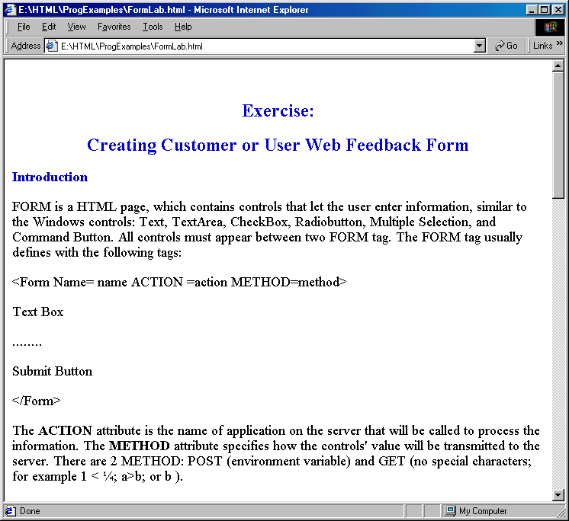

Example: A user feedback form example.

<HTML>

<!-- httpd\HtDocs\buttons\form1.html -->

<HEAD>

<TITLE>ECET/ EET 499 - Forms</TITLE>

</HEAD>

<BODY>

<H2>Form</H2>

<P>Please fill out this form to help us improve our site.</P>

<!--The code below is a method that calls cgi program or server program (ASP, perl...) in Server side when the users -->

<!-- click the Send button below-->

<!--Cgi program or server program then generates the output from the server and send the result back the client-->

<!-- This example will not work in this lab -->

<!-- Initial Form tag is needed -->

<FORM METHOD = "POST" ACTION = "/cgi-bin/formmail">

<!--A text box named "name"; it is like a text box name in Visual Basic Programming language -->

<!--Whenever the users type in the text box, the string (value) will equal to "name" -->

<!--like a variable in Programming; for example, name = " string" if the users type string in the text box. -->

<!-- When the users click the Send button, the client will send name's value to the server. -->

<!--The server will be able to retieve string from "name" and generate the result (as the program set up)-->

<!--Case Sensitive -->

<!--all tags in the form work the same way such as text box, TextArea, radio, Check, and selection-->

<!--All tags with the send button need to be in the same form tag to work together.-->

<!--Creating text box named "name", and size 25 character -->

<P><STRONG>Name: </STRONG>

<INPUT NAME = "name" TYPE = "text" SIZE = "25"></P>

<!-- Another text box name "comments" (textarea), also have row and column option-->

<P><STRONG>Comments:</STRONG>

<TEXTAREA NAME = "comments" ROWS = "4" COLS = "36"></TEXTAREA>

</P>

<!--Another text box name "email"; Type password means when the user type, * will display on screen -->

<P><STRONG>Email Address:</STRONG>

<INPUT NAME = "email" TYPE = "password" SIZE = "25"></P>

<!--Checked box selection like VB; different name will present different value -->

<P><STRONG>Things you liked:</STRONG><BR>

Site design

<INPUT NAME = "thing" TYPE = "checkbox" VALUE = "Design">

Links

<INPUT NAME = "thing1" TYPE = "checkbox" VALUE = "Links">

Ease of use

<INPUT NAME = "thing2" TYPE = "checkbox" VALUE = "Ease">

Images

<INPUT NAME = "thing3" TYPE = "checkbox" VALUE = "Images">

Source code

<INPUT NAME = "thing4" TYPE = "checkbox" VALUE = "Code">

</P>

<!-- <INPUT TYPE="radio"> creates a radio button. The -->

<!-- difference between radio buttons and checkboxes is -->

<!-- that only one radio button in a group can be selected -->

<!--Only 1 name to present radio's value -->

<P><STRONG>How did you get to our site?:</STRONG><BR>

Search engine

<INPUT NAME = "how get to site" TYPE = "radio"

VALUE = "search engine" CHECKED>

Links from another site

<INPUT NAME = "how get to site" TYPE = "radio"

VALUE = "link">

Deitel.com Web site

<INPUT NAME = "how get to site" TYPE = "radio"

VALUE = "deitel.com">

Reference in a book

<INPUT NAME = "how get to site" TYPE = "radio"

VALUE = "book">

Other

<INPUT NAME = "how get to site" TYPE = "radio"

VALUE = "other">

</P>

<!--Like a combox in VB -->

<!-- The <select> tag presents a drop down menu with -->

<!-- choices indicated by the <option> tags -->

<P><STRONG>Rate our site (1-10):</STRONG>

<SELECT NAME = "rating">

<OPTION SELECTED>Amazing:-)

<OPTION>10

<OPTION>9

<OPTION>8

<OPTION>7

<OPTION>6

<OPTION>5

<OPTION>4

<OPTION>3

<OPTION>2

<OPTION>1

<OPTION>The Pits:-(

</SELECT></P>

<!--Send button; when the users clik the Sned button, the all values in the form will be sent to the server -->

<INPUT TYPE = "submit" VALUE = "Submit Your Entries">

<!--Reset button, when it is clicked, it will reset all onformation to the defult values-->

<INPUT TYPE = "reset" VALUE = "Clear Your Entries">

</FORM> <!-- End of Form tag -->

</BODY>

</HTML>

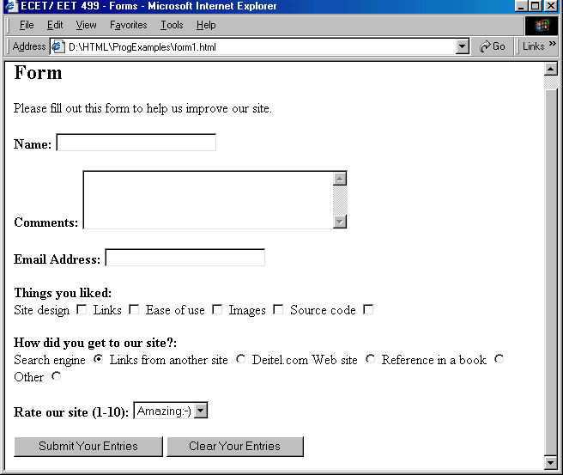

**Activities**

Add the following lines with appropriate mechanism to receive visitor or user inputs:

* The user feedback through Email to Webmater@sunxyz.com
* A form for user feedback survey
* Make the form available for access