**ITC 250/CPET 499 Web Systems**

**Oct. 26, 2017**

**phpMyAdmin Console and MySQL Database**

How to Manage MySQL using phpMyAdmin, <https://www.siteground.com/tutorials/phpmyadmin/>

* Database Management Tasks: create, alter, drop, delete, import, export MySQL database tables
* Run MySQL queries, optimize, repair and check tables, etc

**Login to phpMyAdmin:** [**http://localhost/phpmyadmin**](http://localhost/phpmyadmin)

1. If no users have been setup, use “admin”, with no password to login

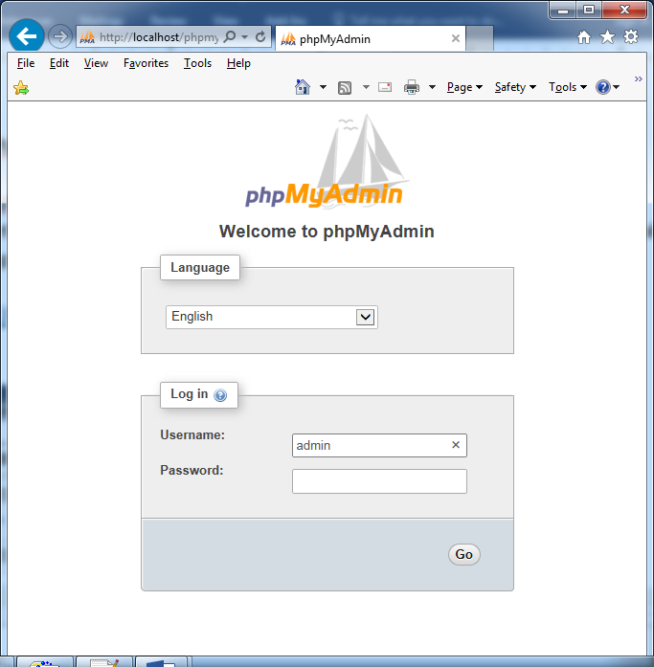

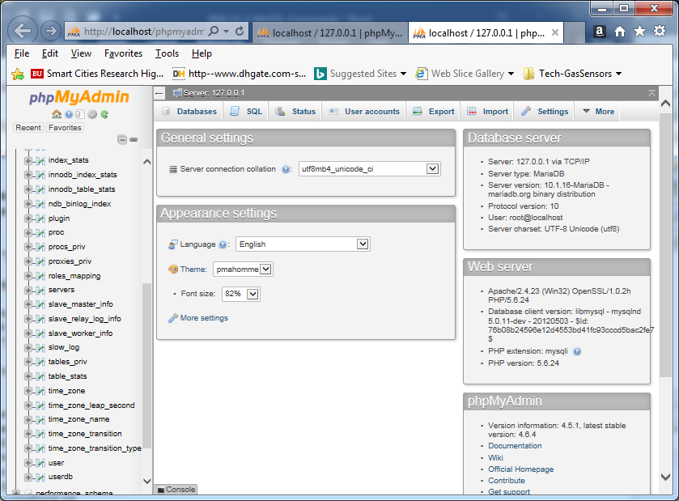

**How to set phpMyAdmin password on XAMPP server**

1. **Login to phpMyAdmin without Password:**
2. **Go to c:\xampp\phpMyAdmin” and find “config.inc.php” file**
3. **Use a text editor such as “Notepad++”**

**Change: $cfg['Servers'][$i]['auth_type'] = 'config'**

**TO: $cfg['Servers'][$i]['auth_type'] = 'cookie'**

<?php

/*

* This is needed for cookie based authentication to encrypt password in

* cookie

*/

$cfg['blowfish_secret'] = 'xampp'; /* YOU SHOULD CHANGE THIS FOR A MORE SECURE COOKIE AUTH! */

/*

* Servers configuration

*/

$i = 0;

/*

* First server

*/

$i++;

/* Authentication type and info */

**$cfg['Servers'][$i]['auth_type'] = 'cookie'; //was: 'config'**

$cfg['Servers'][$i]['user'] = 'root';

$cfg['Servers'][$i]['password'] = **''; // change it to your password**

$cfg['Servers'][$i]['extension'] = 'mysqli';

$cfg['Servers'][$i]['AllowNoPassword'] = true;

$cfg['Lang'] = '';

/* Bind to the localhost ipv4 address and tcp */

$cfg['Servers'][$i]['host'] = '127.0.0.1';

$cfg['Servers'][$i]['connect_type'] = 'tcp';

/* User for advanced features */

$cfg['Servers'][$i]['controluser'] = 'pma';

$cfg['Servers'][$i]['controlpass'] = '';

/* Advanced phpMyAdmin features */

$cfg['Servers'][$i]['pmadb'] = 'phpmyadmin';

$cfg['Servers'][$i]['bookmarktable'] = 'pma__bookmark';

$cfg['Servers'][$i]['relation'] = 'pma__relation';

$cfg['Servers'][$i]['table_info'] = 'pma__table_info';

$cfg['Servers'][$i]['table_coords'] = 'pma__table_coords';

$cfg['Servers'][$i]['pdf_pages'] = 'pma__pdf_pages';

$cfg['Servers'][$i]['column_info'] = 'pma__column_info';

$cfg['Servers'][$i]['history'] = 'pma__history';

$cfg['Servers'][$i]['designer_coords'] = 'pma__designer_coords';

$cfg['Servers'][$i]['tracking'] = 'pma__tracking';

$cfg['Servers'][$i]['userconfig'] = 'pma__userconfig';

$cfg['Servers'][$i]['recent'] = 'pma__recent';

$cfg['Servers'][$i]['table_uiprefs'] = 'pma__table_uiprefs';

$cfg['Servers'][$i]['users'] = 'pma__users';

$cfg['Servers'][$i]['usergroups'] = 'pma__usergroups';

$cfg['Servers'][$i]['navigationhiding'] = 'pma__navigationhiding';

$cfg['Servers'][$i]['savedsearches'] = 'pma__savedsearches';

$cfg['Servers'][$i]['central_columns'] = 'pma__central_columns';

$cfg['Servers'][$i]['designer_settings'] = 'pma__designer_settings';

$cfg['Servers'][$i]['export_templates'] = 'pma__export_templates';

$cfg['Servers'][$i]['favorite'] = 'pma__favorite';

/*

* End of servers configuration

**\*/**

**?>**

**View Data Tables from phpMyAdmin**

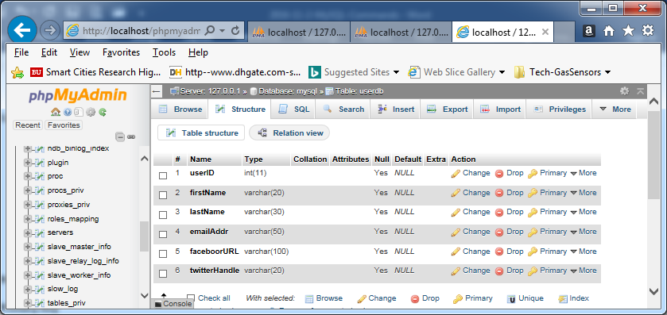

**C) phpMyAdmin Password**

* + Go to “c:\xampp\phpMyAdmin” directory and find “Config.inc.php” file
  + Open Config.inc.php with a text editor:
    - Change: $cfg[‘Servers’][$a][‘auth_type’]=’config’
    - To: $cfg[‘Servers’][$a][‘auth_type’]=’cookie’
  + Save the file
  + Open a web browser: <http://localhost/phpmyadmin/>

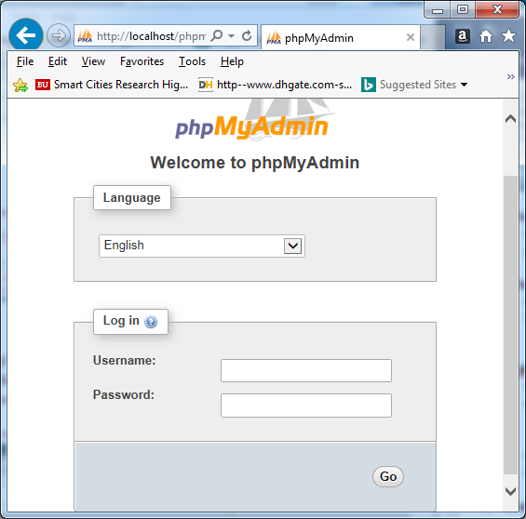

* + **Enter “root” in Username**
  + **Leave Password Null, press Go button**

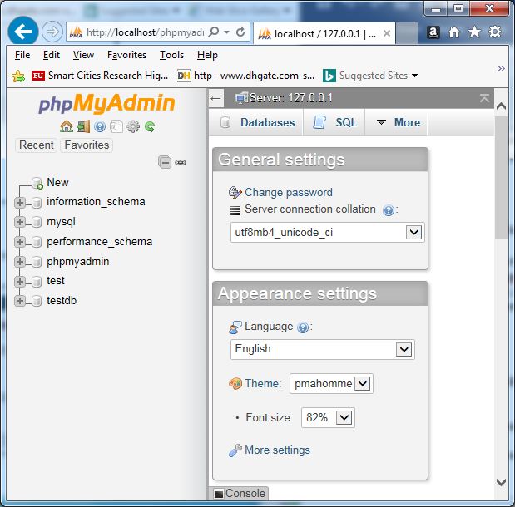

* **Click “Change password”**
* **Enter “your_new_password”, Reenter, Hit “Go”**

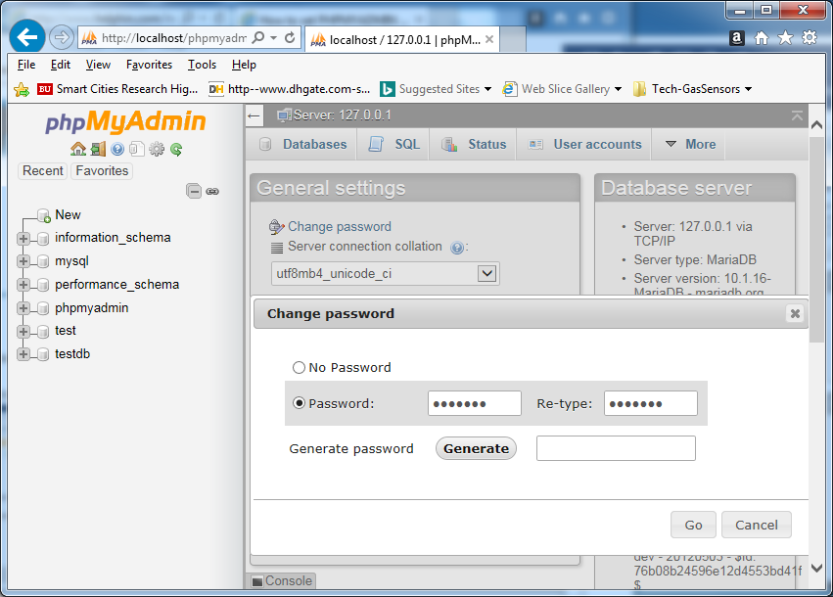

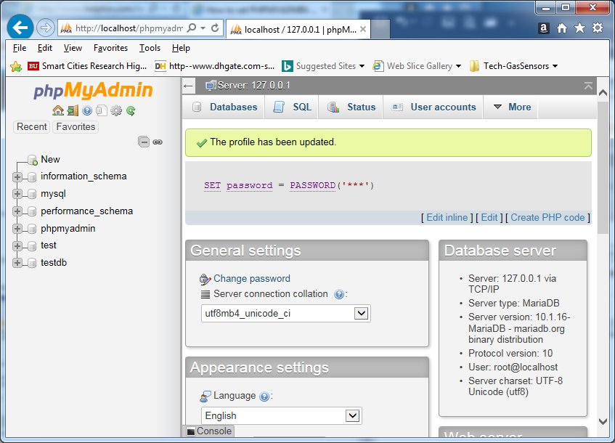

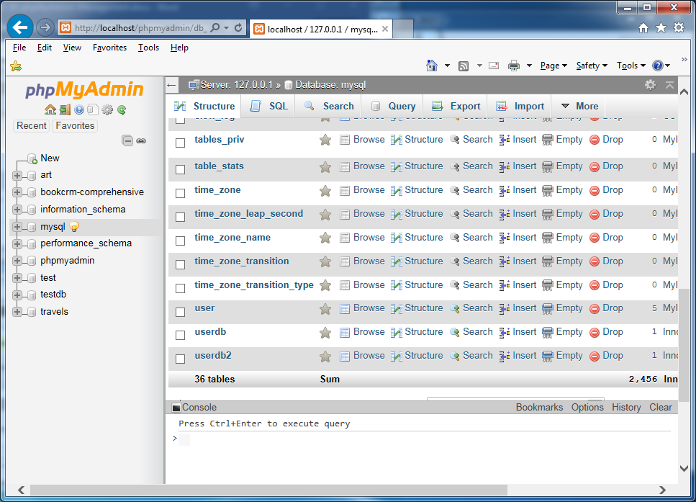

**D) MySQL Password**

* **Click on “User accounts”**
* **Click on “Edit privileges”: root 127.0.0.1**

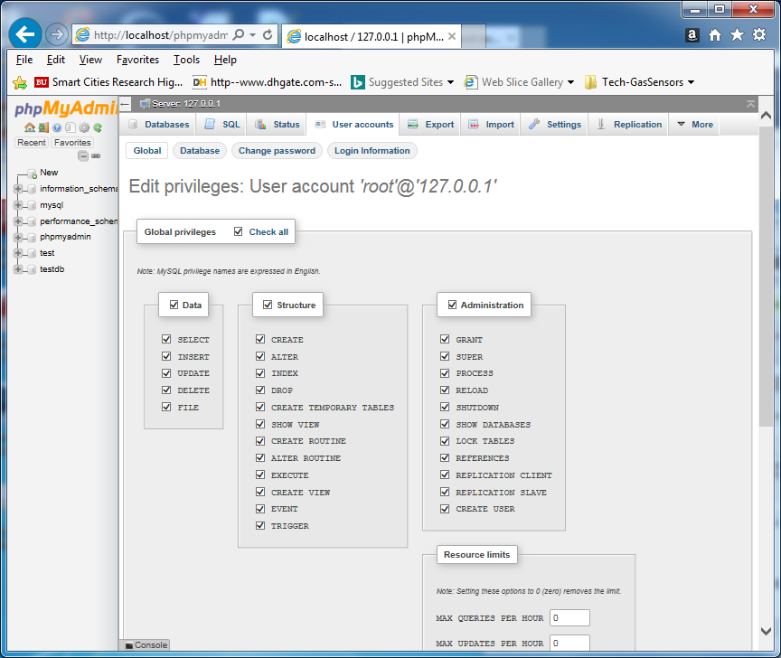

* **Under “User accounts”, Click on “Change password”, to see another Dialog box**
* **Enter “your_new_password”**
* **The password for ‘root’@’127.0.0.1’ was changed successfully**

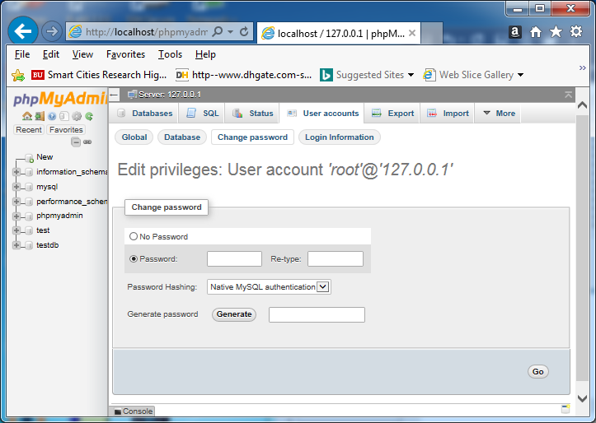

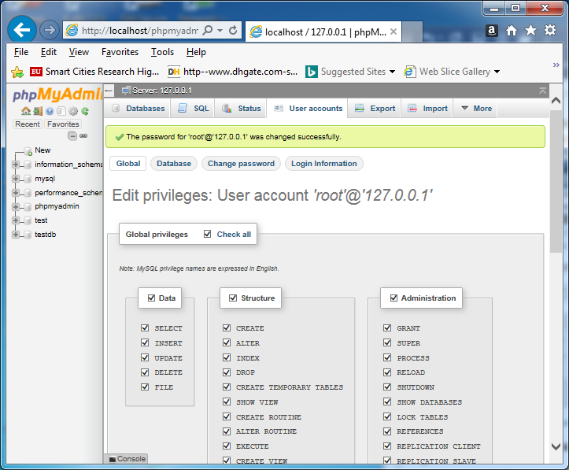

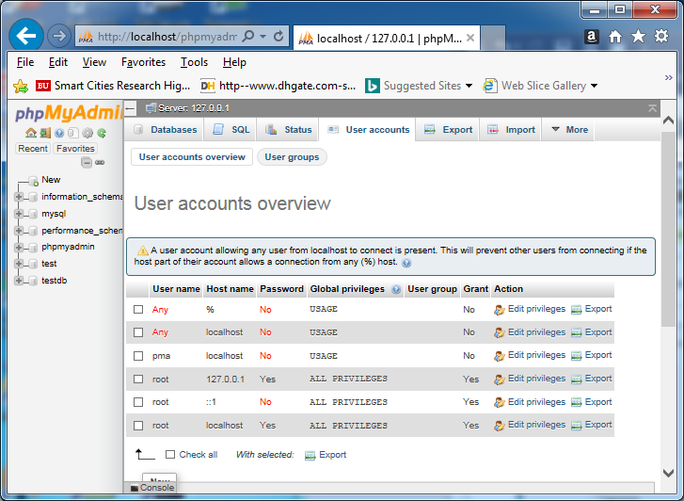

**E) Grant Other Users to Access Database**

* **From the Shell connect to MySQL as an Administrator**

**> mysql –u root –p mysql**

* **On the mysql prompt, you type**

**> grant all privileges on DATA_BASE_NAME.* to USERNAME@localhost identified by ‘PASSWORD’;**

**> flush privileges;**

**>\q**

1. **Planning Database Table**

* **Data Tables**
* **Entity of a Table**
* **ID (AUTO_INCREMENT, PRIMARY KEY)**
* **Constraints: NOT NULL**

**Customer/User Info Table**

* **User ID**
* **First Name**
* **Last Name**
* **Email Address**
* **Street Address**
* **State**
* **Country**
* **Browser Type**
* **Computer Type**