**MySQL and PHP**

Oct. 31, 2017

**Topics of Discussion**

* config.in.php file inside pHpMyAdmin directory
* Import and Export Databases using phpMyAdmin
* Managing a MySQL Database
* Command Line Exercises
* Database Index and Efficiency
* Accessing MySQL in PHP

**config.in.php File**

$cfg['blowfish_secret'] = 'xampp'; /* YOU SHOULD CHANGE THIS FOR A MORE SECURE COOKIE AUTH! */

/*

* Servers configuration

*/

$i = 0;

/*

* First server

*/

$i++;

/* **Authentication type and info** */

$cfg['Servers'][$i]['auth_type'] = 'cookie'; //was: 'config'

$cfg['Servers'][$i]['user'] = 'root';

$cfg['Servers'][$i]['password'] = '';

$cfg['Servers'][$i]['extension'] = 'mysqli';

$cfg['Servers'][$i]['AllowNoPassword'] = true;

$cfg['Lang'] = '';

/* **Bind to the localhost ipv4 address and tcp** */

$cfg['Servers'][$i]['host'] = '127.0.0.1';

$cfg['Servers'][$i]['connect_type'] = 'tcp';

/* User for advanced features */

$cfg['Servers'][$i]['controluser'] = 'pma';

$cfg['Servers'][$i]['controlpass'] = '';

/* Advanced phpMyAdmin features */

$cfg['Servers'][$i]['pmadb'] = 'phpmyadmin';

$cfg['Servers'][$i]['bookmarktable'] = 'pma__bookmark';

$cfg['Servers'][$i]['relation'] = 'pma__relation';

$cfg['Servers'][$i]['table_info'] = 'pma__table_info';

$cfg['Servers'][$i]['table_coords'] = 'pma__table_coords';

$cfg['Servers'][$i]['pdf_pages'] = 'pma__pdf_pages';

$cfg['Servers'][$i]['column_info'] = 'pma__column_info';

$cfg['Servers'][$i]['history'] = 'pma__history';

$cfg['Servers'][$i]['designer_coords'] = 'pma__designer_coords';

$cfg['Servers'][$i]['tracking'] = 'pma__tracking';

$cfg['Servers'][$i]['userconfig'] = 'pma__userconfig';

$cfg['Servers'][$i]['recent'] = 'pma__recent';

$cfg['Servers'][$i]['table_uiprefs'] = 'pma__table_uiprefs';

$cfg['Servers'][$i]['users'] = 'pma__users';

$cfg['Servers'][$i]['usergroups'] = 'pma__usergroups';

$cfg['Servers'][$i]['navigationhiding'] = 'pma__navigationhiding';

$cfg['Servers'][$i]['savedsearches'] = 'pma__savedsearches';

$cfg['Servers'][$i]['central_columns'] = 'pma__central_columns';

$cfg['Servers'][$i]['designer_settings'] = 'pma__designer_settings';

$cfg['Servers'][$i]['export_templates'] = 'pma__export_templates';

$cfg['Servers'][$i]['favorite'] = 'pma__favorite';

/*

* End of servers configuration

*/

?>

**Import and Export MySQL using phpMyAdmin**

**Import Database**

1. Login to MySQL using “root” and created password.

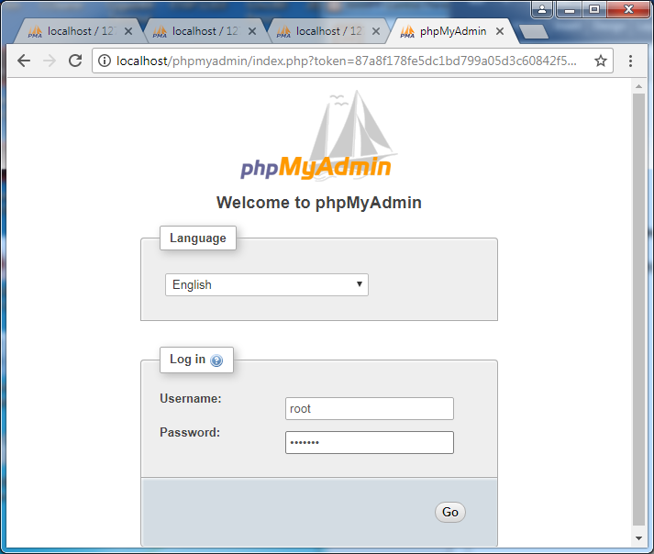

1. Click on “New” to create a new database
2. Enter the database name, in this example art2, then click Create button

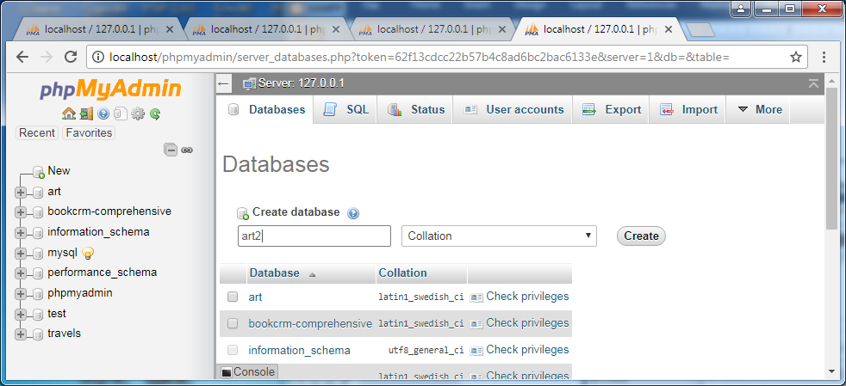

1. Click on Import tab to see the next Window:
2. Click on Choose File, then browse to load your database name with the name art2.sql, as shown in this example; then click Go to import the database.

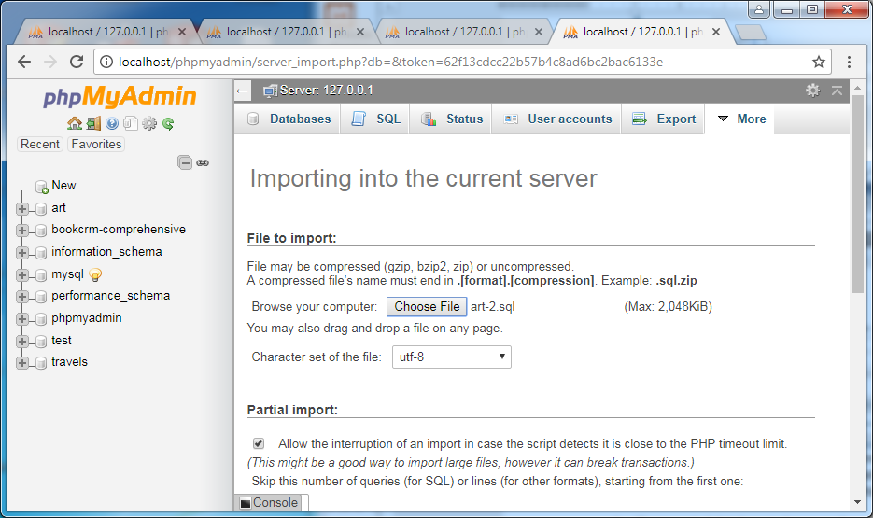

1. The imported database is shown on the screen below.

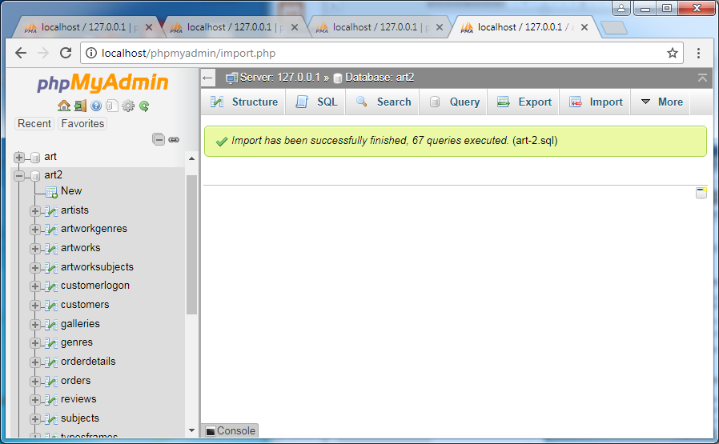

1. You can remove the created database by
   1. Click “Operations” tab
   2. Click on “Drop the database (Drop)”

**Export Database**

1. Click on Export tab
2. Under Export templates:
   1. New template: art2-example
   2. Click create
3. Click Go

You will see art2.sql is created for download, click the up arrow to save the file

MySQL Command-Line Interface

On XAMPP Control Panel, click Shell to open Microsoft command line Window.

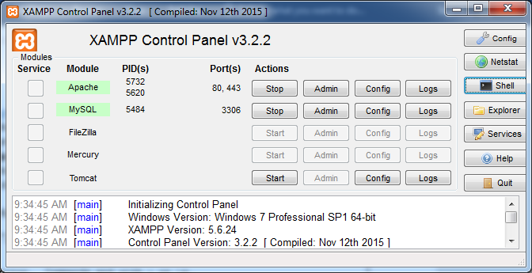

Setting environment for using XAMPP for Windows.

Lin@LIN-PC c:\xampp

# **mysql -v**

Welcome to the MySQL monitor. Commands end with ; or \g.

Your MySQL connection id is 1

Server version: 5.6.26 MySQL Community Server (GPL)

Copyright (c) 2000, 2015, Oracle and/or its affiliates. All rights reserved.

Oracle is a registered trademark of Oracle Corporation and/or its

affiliates. Other names may be trademarks of their respective

owners.

Type 'help;' or '\h' for help. Type '\c' to clear the current input statement.

mysql>

Lin@LIN-PC c:\xampp

**# cd mysql**

Lin@LIN-PC c:\xampp\mysql

# dir

Volume in drive C has no label.

Volume Serial Number is FEA5-C688

Directory of c:\xampp\mysql

08/27/2015 11:45 AM <DIR> .

08/27/2015 11:45 AM <DIR> ..

08/27/2015 11:45 AM <DIR> backup

08/27/2015 11:47 AM <DIR> bin

07/14/2015 06:34 PM 17,987 COPYING

11/03/2015 12:35 AM <DIR> data

08/27/2015 11:45 AM <DIR> docs

07/14/2015 06:41 PM 1,141 my-default.ini

03/30/2013 07:29 AM 848 mysql_installservice.bat

03/30/2013 07:29 AM 395 mysql_uninstallservice.bat

07/14/2015 06:34 PM 2,496 README

03/30/2013 07:29 AM 1,105 resetroot.bat

08/27/2015 11:45 AM <DIR> scripts

08/27/2015 11:45 AM <DIR> share

6 File(s) 23,972 bytes

8 Dir(s) 93,777,928,192 bytes free

Lin@LIN-PC c:\xampp\mysql

**# cd data**

Lin@LIN-PC c:\xampp\mysql\data

**# dir**

Volume in drive C has no label.

Volume Serial Number is FEA5-C688

Directory of c:\xampp\mysql\data

11/03/2015 12:35 AM <DIR> .

11/03/2015 12:35 AM <DIR> ..

08/12/2014 05:47 AM 56 auto.cnf

08/27/2015 11:45 AM <DIR> cdcol

11/03/2015 12:35 AM 12,582,912 ibdata1

11/03/2015 12:35 AM 5,242,880 ib_logfile0

08/12/2014 05:47 AM 5,242,880 ib_logfile1

08/27/2015 11:45 AM <DIR> mysql

11/03/2015 12:35 AM 5 mysql.pid

11/03/2015 12:40 AM 22,467 mysql_error.log

11/27/2013 01:44 PM 6 mysql_upgrade_info

08/27/2015 11:45 AM <DIR> performance_schema

08/27/2015 11:45 AM <DIR> phpmyadmin

08/27/2015 11:45 AM <DIR> test

08/27/2015 11:45 AM <DIR> webauth

7 File(s) 23,091,206 bytes

8 Dir(s) 93,777,924,096 bytes free

**Run MySQL Commands**, <http://dev.mysql.com/doc/refman/5.7/en/mysql-commands.html>

Administrator@LIN-PC c:\xampp\mysql

**# mysql -u root -p**

**Enter password: \*\*\*\*\*\*\***

Welcome to the MariaDB monitor. Commands end with ; or \g.

Your MariaDB connection id is 218

Server version: 10.1.16-MariaDB mariadb.org binary distribution

Copyright (c) 2000, 2016, Oracle, MariaDB Corporation Ab and others.

Type 'help;' or '\h' for help. Type '\c' to clear the current input statement.

MariaDB [(none)]> **show databases;**

+-----------------------+

| Database |

+-----------------------+

| art |

| art2 |

| bookcrm-comprehensive |

| information_schema |

| mysql |

| performance_schema |

| phpmyadmin |

| test |

| travels |

+-----------------------+

9 rows in set (0.01 sec)

MariaDB [(none)]> **use test;**

Database changed

MariaDB [(none)]> **show tables;**

Empty set (0.00 sec)

**MariaDB [test]> ?**

General information about MariaDB can be found at

http://mariadb.org

List of all MySQL commands:

Note that all text commands must be first on line and end with ';'

? (\?) Synonym for `help'.

clear (\c) Clear the current input statement.

connect (\r) Reconnect to the server. Optional arguments are db and host.

delimiter (\d) Set statement delimiter.

ego (\G) Send command to mysql server, display result vertically.

exit (\q) Exit mysql. Same as quit.

go (\g) Send command to mysql server.

help (\h) Display this help.

notee (\t) Don't write into outfile.

print (\p) Print current command.

prompt (\R) Change your mysql prompt.

quit (\q) Quit mysql.

rehash (\#) Rebuild completion hash.

source (\.) Execute an SQL script file. Takes a file name as an argument.

status (\s) Get status information from the server.

tee (\T) Set outfile [to_outfile]. Append everything into given outfile.

use (\u) Use another database. Takes database name as argument.

charset (\C) Switch to another charset. Might be needed for processing binlog

with multi-byte charsets.

warnings (\W) Show warnings after every statement.

nowarning (\w) Don't show warnings after every statement.

For server side help, type 'help contents'

MariaDB [test]>

MariaDB [(none)]> **use art;**

Database changed

MariaDB [art]> show tables;

+------------------+

| Tables_in_art |

+------------------+

| artists |

| artworkgenres |

| artworks |

| artworksubjects |

| customerlogon |

| customers |

| galleries |

| genres |

| orderdetails |

| orders |

| reviews |

| subjects |

| typesframes |

| typesglass |

| typesmatt |

| typesshippers |

| typesstatuscodes |

+------------------+

17 rows in set (0.01 sec)

MariaDB [art]> **SHOW COLUMNS in artworks;**

+---------------+---------------+------+-----+---------+----------------+

| Field | Type | Null | Key | Default | Extra |

+---------------+---------------+------+-----+---------+----------------+

| ArtWorkID | int(11) | NO | PRI | NULL | auto_increment |

| ArtistID | int(11) | YES | MUL | 0 | |

| ImageFileName | varchar(50) | NO | UNI | NULL | |

| Title | varchar(255) | NO | MUL | NULL | |

| Description | longtext | YES | | NULL | |

| Excerpt | longtext | YES | | NULL | |

| ArtWorkType | int(11) | YES | | 1 | |

| YearOfWork | int(11) | YES | MUL | 0 | |

| Width | int(11) | YES | | NULL | |

| Height | int(11) | YES | | NULL | |

| Medium | varchar(255) | YES | | NULL | |

| OriginalHome | varchar(255) | YES | | NULL | |

| GalleryID | int(11) | YES | MUL | NULL | |

| Cost | decimal(19,4) | YES | | 0.0000 | |

| MSRP | decimal(19,4) | YES | | 0.0000 | |

| ArtWorkLink | varchar(255) | YES | | NULL | |

| GoogleLink | varchar(255) | YES | | NULL | |

+---------------+---------------+------+-----+---------+----------------+

17 rows in set (0.00 sec)

MariaDB [art]>

MariaDB [art]> SELECT artworkid, title, yearofwork from artworks where yearofwo

k < 1600;

+-----------+--------------------------------------------+------------+

| artworkid | title | yearofwork |

+-----------+--------------------------------------------+------------+

| 440 | Lamentation of Christ | 1305 |

| 441 | Madonna Enthroned | 1310 |

| 362 | Expulsion from the Garden of Eden | 1425 |

| 363 | Tribute Money | 1425 |

| 365 | Madonna and Child | 1426 |

| 364 | Holy Trinity | 1428 |

| 442 | Arnolfini Portrait | 1434 |

| 368 | Coronation of the Virgin | 1447 |

| 367 | Annunciation | 1450 |

| 370 | Baptism of Christ | 1450 |

| 371 | Flagellation of Christ | 1455 |

| 375 | Presentation at the Temple | 1455 |

| 374 | St. Sebastian | 1457 |

| 369 | Adoration in the Forest | 1459 |

| 372 | The Resurrection | 1460 |

| 366 | Madonna and Child | 1465 |

| 386 | Annunciation | 1472 |

| 387 | Ginevra de' Benci | 1474 |

| 380 | Adoration of the Magi | 1475 |

| 373 | Lamentation of Christ | 1480 |

| 381 | Delivery of the Keys | 1481 |

| 376 | Primavera | 1482 |

| 378 | Venus and Mars | 1483 |

| 377 | The Birth of Venus | 1486 |

| 445 | The Garden of Earthly Delights | 1490 |

| 443 | Portrait of the Artist Holding a Thistle | 1493 |

| 383 | Portrait of Francesco delle Opere | 1494 |

| 379 | The Mystical Nativity | 1500 |

| 382 | Madonna in Glory with the Child and Saints | 1500 |

| 389 | Mona Lisa | 1503 |

| 384 | Virgin of the Rocks | 1505 |

| 394 | Madonna in the Meadow | 1505 |

| 398 | Madonna of the Goldfinch | 1505 |

| 397 | Portrait of Maddalena Doni | 1506 |

| 391 | Doni Tondo | 1507 |

| 395 | The Deposition | 1507 |

| 396 | Portrait of a Young Woman | 1507 |

| 388 | The Virgin and Child with St. Anne | 1508 |

| 406 | A Man with a Quilted Sleeve | 1509 |

| 393 | Libyan Sibyl | 1510 |

| 399 | Alba Madonna | 1510 |

| 400 | The School of Athens | 1510 |

| 392 | The Creation of Adam | 1512 |

| 401 | Sistine Madonna | 1512 |

| 402 | The Triumph of Galatea | 1514 |

| 403 | Madonna of the Chair | 1514 |

| 444 | Melencolia I | 1514 |

| 404 | The Veiled Woman | 1515 |

| 405 | Portrait of Bindo Altoviti | 1515 |

| 407 | Flora | 1515 |

| 390 | St. John the Baptist | 1518 |

| 408 | Bacchus and Ariadne | 1520 |

| 409 | Venus of Urbino | 1538 |

| 449 | Madonna with the Long Neck | 1540 |

| 450 | Portrait of Eleanor of Toledo | 1545 |

| 451 | Venus, Cupid, Folly and Time | 1545 |

| 446 | Landscape with the Fall of Icarus | 1558 |

| 447 | Netherlandish Proverbs | 1559 |

| 448 | The Peasant Wedding | 1567 |

| 452 | The Burial of the Count of Orgaz | 1586 |

| 410 | The Cardsharps | 1594 |

| 411 | The Calling of St Matthew | 1599 |

+-----------+--------------------------------------------+------------+

62 rows in set (0.00 sec)

MariaDB [art]>

**Database Index and Efficiency**

Computer Algorithm – Complexity

* O (n) -- Order n
* O(Log 2 n) – balanced binary tree
* O(1) – Hash table data structure

**Database Index**

MySQL Optimization and Indexes, <https://dev.mysql.com/doc/refman/5.5/en/optimization-indexes.html> [[+/-](https://dev.mysql.com/doc/refman/5.5/en/optimization-indexes.html)]

[8.3.1 How MySQL Uses Indexes](https://dev.mysql.com/doc/refman/5.5/en/mysql-indexes.html)

[8.3.2 Using Primary Keys](https://dev.mysql.com/doc/refman/5.5/en/optimizing-primary-keys.html)

[8.3.3 Using Foreign Keys](https://dev.mysql.com/doc/refman/5.5/en/optimizing-foreign-keys.html)

[8.3.4 Column Indexes](https://dev.mysql.com/doc/refman/5.5/en/column-indexes.html)

[8.3.5 Multiple-Column Indexes](https://dev.mysql.com/doc/refman/5.5/en/multiple-column-indexes.html)

[8.3.6 Verifying Index Usage](https://dev.mysql.com/doc/refman/5.5/en/verifying-index-usage.html)

[8.3.7 InnoDB and MyISAM Index Statistics Collection](https://dev.mysql.com/doc/refman/5.5/en/index-statistics.html)

[8.3.8 Comparison of B-Tree and Hash Indexes](https://dev.mysql.com/doc/refman/5.5/en/index-btree-hash.html)

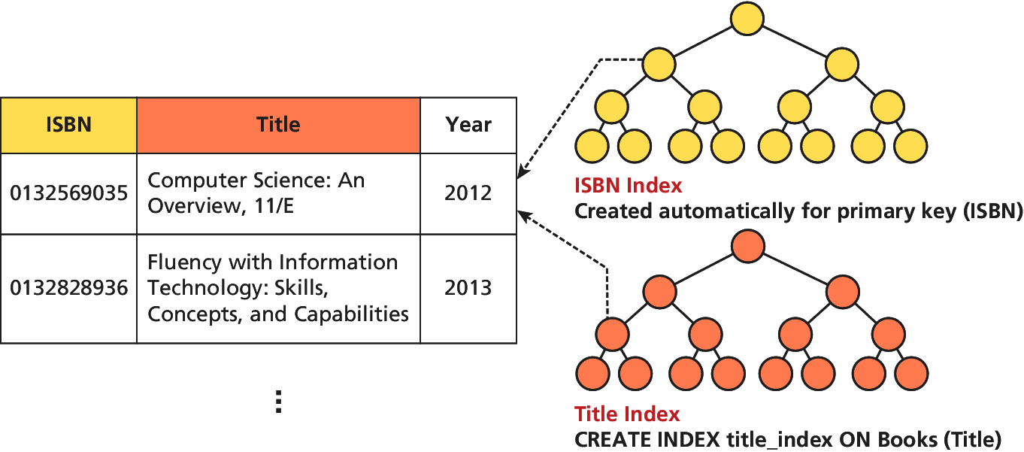

Figure 11.16 Visualization of a database index for our Book Table

**Database APIs**

**PHP MySQL APIs**

Choosing an API, <http://php.net/manual/en/mysqlinfo.api.choosing.php>

* **mysql Extension** – should only be used with versions of MySQL older than 4.1.3
* **mysqli Extension** – provides both a procedure and object-oriented approach
* **PDOs (PHP Data Objects)** – the object-oriented API has been available since PHP 5.1 and provides an abstraction layer that with the appropriate drivers can be used with any databases, and not just MySQL databases.

**Accessing MySQL in PHP**

**Basic Steps**

1. Connect to the database
2. Handle connection errors
3. Execute the SQL query
4. Process the results
5. Free resources and close connection

**//Listing 11.2 Excerpt from a config.inc.php file for a phpMyAdmin installation**

$cfg['Servers'][$i]['host'] = 'localhost';

$cfg['Servers'][$i]['controluser'] = 'DBUsername';

$cfg['Servers'][$i]['controlpass'] = 'DBPassword';

$cfg['Servers'][$i]['extension'] = 'mysqli';

// use the mysqli extension

?>

<?php

**//Listing 11.3 modify these variables for your installation**

// Connecting to a database with mysqli (procedural)

$host = "localhost";

$database = "bookcrm";

$user = "testuser";

$pass = "mypassword";

$connection = mysqli_connect($host, $user, $pass, $database);

?>

<?php

**//Listing 11.5 Defining connection details via constants in a separate file (config.php)**

define('DBHOST', 'localhost');

define('DBNAME', 'bookcrm');

define('DBUSER', 'testuser');

define('DBPASS', 'mypassword');

?>

<?php

**//Listing 11.6 Using the connection constants**

require_once('Listing10.05.php'); //equivalent for this distribution

//require_once('protected/config.php'); //original from text

$connection = mysqli_connect(DBHOST, DBUSER, DBPASS, DBNAME);

?>

<?php

**//Listing 11.7 Handling connection errors with mysqli (version 1)**

$connection = mysqli_connect(DBHOST, DBUSER, DBPASS, DBNAME);

// mysqli_connect_error returns string description of the last

// connect error

$error = mysqli_connect_error();

if ($error != null) {

$output = "<p>Unable to connect to database<p>" . $error;

// Outputs a message and terminates the current script

exit($output);

}

?>

<?php

**//Listing 11.8 Handling connection errors with mysqli (version 2)**

$connection = mysqli_connect(DBHOST, DBUSER, DBPASS, DBNAME);

// mysqli_connect_errno returns the last error code

if ( mysqli_connect_errno() ) {

die( mysqli_connect_error() ); // die() is equivalent to exit()

}

?>

**Execution the Query**

<?php

**//Listing 11.11 Executing a SELECT query (mysqli)**

$sql = "SELECT * FROM Categories ORDER BY CategoryName";

// returns a mysqli_result object

$result = mysqli_query($connection, $sql);

?>

<?php

**//Listing 11.13 Executing a query that doesn't return data (mysqli)**

$sql = "UPDATE Categories SET CategoryName='Web' WHERE CategoryName='Business'";

if ( mysqli_query($connection, $sql) ) {

$count = mysqli_affected_rows($connection);

echo "<p>Updated " . $count . " rows</p>";

}

?>

**Process the Query Results**

<?php

**//Listing 11.17 Using a prepared statement (mysqli)**

// retrieve parameter value from query string

$id = $_GET['id'];

// construct parameterized query – notice the ? parameter

$sql = "SELECT Title, CopyrightYear FROM Books WHERE ID=?";

// create a prepared statement

if ($statement = mysqli_prepare($connection, $sql)) {

// Bind parameters s - string, b - blob, i - int, etc

mysqli_stmt_bindm($statement, 'i', $id);

// execute query

mysqli_stmt_execute($statement);

// learn in next section how to access the returned data

//...

}

?>

<?php

**//Listing 11.20 Looping through the result set (mysqli—not prepared statements)**

$sql = "select * from Categories order by CategoryName";

// run the query

if ($result = mysqli_query($connection, $sql)) {

// fetch a record from result set into an associative array

while($row = mysqli_fetch_assoc($result))

{

// the keys match the field names from the table

echo $row['ID'] . " - " . $row['CategoryName'] ;

echo "<br/>";

}} ?>

<?php

**//Listing 11.21 Looping through the result set (mysqli—using prepared statements)**

$sql = "SELECT Title, CopyrightYear FROM Books WHERE ID=?";

if ($statement = mysqli_prepare($connection, $sql)) {

mysqli_stmt_bindm($statement, 'i', $id);

mysqli_stmt_execute($statement);

// bind result variables

mysqli_stmt_bind_result($statement, $title, $year);

// loop through the data

while (mysqli_stmt_fetch($statement)) {

echo $title . '-' . $year . '<br/>';

}

}

?>

**Free Resources and Closing Connection**

<?php

**//Listing 11.25 Closing the connection**

// mysqli approach

$connection = mysqli_connect($host, $user, $pass, $database);

//...

// release the memory used by the result set. This is necessary if

// you are going to run another query on this connection

mysqli_free_result($result);

//...

// close the database connection

mysqli_close($connection);

?>