**Web Systems**

**Nov. 2, 2017**

**Topics of Discussion**

* Using MySQL as a Calculator
* Command Line: Create a Database, a Table, Insert Values into Table, Query Database
* Using PhP API to Interact with MySQL
  + Check_connection.php
* Using PhP API to query Customer Database: CustomerInfo Table
* Lab 11 Exercise 08

**Use MySQL as a Calculator**

MariaDB [(none)]> select 2 + 2;

+-------+

| 2 + 2 |

+-------+

| 4 |

+-------+

1 row in set (0.00 sec)

MariaDB [customer]> select 10 * 2;

+--------+

| 10 * 2 |

+--------+

| 20 |

+--------+

1 row in set (0.02 sec)

MariaDB [(none)]> SELECT version(), now();

+-----------------+---------------------+

| version() | now() |

+-----------------+---------------------+

| 10.1.16-MariaDB | 2017-11-01 21:21:09 |

+-----------------+---------------------+

1 row in set (0.00 sec)

MariaDB [(none)]>

**MySQL Command Line Practice:**

Create a Customer Database “Customer”

#mysql > CREATE DATABASE Customer;

#mysql > USE Customer;

Create a Table “CustomerInfo” with the following fields:

* firstName (VARCHAR 20), lastName (VARCHAR 20), emailAddr (VARCHAR 30)

#mysql > CREATE TABLE CustomerInfo(firstName VARCAHR(20), lastName VARCHAR(20), emailAddr(VARCHAR 30);

Show Properties of the “CustomerInfo”:

#mysql > DESCRIBE CustomerInfo;

#mysql > SHOW DATABSES;

Insert Three Customer Info into the table “Customer”

MariaDB [(none)]> CREATE DATABASE Customer;

Query OK, 1 row affected (0.00 sec)

MariaDB [(none)]> USE Customer;

Database changed

MariaDB [Customer]> CREATE TABLE CustomerInfo(firstName VARCHAR(20), lastName VA

RCHAR(20), emailAddr VARCHAR(30));

Query OK, 0 rows affected (0.02 sec)

MariaDB [Customer]> DESCRIBE CustomerInfo;

+-----------+-------------+------+-----+---------+-------+

| Field | Type | Null | Key | Default | Extra |

+-----------+-------------+------+-----+---------+-------+

| firstName | varchar(20) | YES | | NULL | |

| lastName | varchar(20) | YES | | NULL | |

| emailAddr | varchar(30) | YES | | NULL | |

+-----------+-------------+------+-----+---------+-------+

3 rows in set (0.00 sec)

MariaDB [Customer]> SHOW DATABASES;

+-----------------------+

| Database |

+-----------------------+

| art |

| art2 |

| bookcrm-comprehensive |

| customer |

| information_schema |

| mysql |

| performance_schema |

| phpmyadmin |

| test |

| travels |

+-----------------------+

10 rows in set (0.02 sec)

MariaDB [Customer]> INSERT INTO CustomerInfo VALUES("Paul", "Lin", "pilin@purdue

.edu");

Query OK, 1 row affected (0.02 sec)

MariaDB [Customer]> INSERT INTO CustomerInfo VALUES("John", "Paul", "jp@yourcom.

com");

Query OK, 1 row affected (0.00 sec)

MariaDB [Customer]> INSERT INTO CustomerInfo VALUES("Peter", "Long", "plong@long

Inc.com");

Query OK, 1 row affected (0.02 sec)

MariaDB [Customer]> SELECT * FROM CustomerInfo;

+-----------+----------+-------------------+

| firstName | lastName | emailAddr |

+-----------+----------+-------------------+

| Paul | Lin | pilin@purdue.edu |

| John | Paul | jp@yourcom.com |

| Peter | Long | plong@longInc.com |

+-----------+----------+-------------------+

3 rows in set (0.00 sec)

MariaDB [Customer]> SELECT emailAddr FROM CustomerInfo;

+-------------------+

| emailAddr |

+-------------------+

| pilin@purdue.edu |

| jp@yourcom.com |

| plong@longInc.com |

+-------------------+

3 rows in set (0.00 sec)

MariaDB [Customer]> SELECT lastName FROM CustomerInfo ORDER by lastName DESC;

+----------+

| lastName |

+----------+

| Paul |

| Long |

| Lin |

+----------+

3 rows in set (0.00 sec)

**Example 1.** Using PhP API to Interact with MySQL **customer** database created from above activities

* db_connection_functions.php
* check_connection.php

**PhP API:**

mysql_result, <http://php.net/manual/en/function.mysql-result.php>

**Procedure**

1. Create the **db_connect_functions.php** file
2. Create the **check_connection.php** file
3. Create a directory under htdocs, called phpconnecttest.
4. Move the both **db_connec_functions.php** and **check_connection.php** files to phpconnecttest folder.
5. Run check_connection,php
   1. Open a browser and enter the address: localhost/phpconnecttest/check_connection.php
   2. See the return result

<?php

/* db_connect_functions.php */

function openConnect()

{

$DB_HOST = "localhost";

$DB_USER = "root";

$DB_PASSWORD = "secrete"; // use your root password

$DB_NAME = "customer"; // database name

$connHandler = new mysqli($DB_HOST, $DB_USER, $DB_PASSWORD, $DB_NAME)

or die("<p> Error connecting to database: ") . mysql_error() . "</p>";

return $connHandler;

}

function closeConnect($conn)

{

$conn -> close();

}

?>

<?php

/* check_connection.php*/

include "db_connect_functions.php";

$conn = openConnect();

echo "<p><b>Database Connected Successfully </b></p>";

closeConnect($conn);

echo "<p><b> Database Disconnected</b></p>";

?>

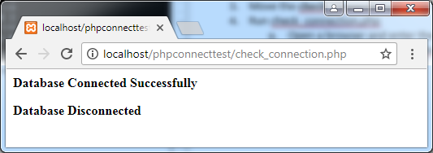

**Example 2.** Using PhP API to query CustomerInfo Table inside MySQL **customer** database created from above activities

* root_customerDB_config
* db_connection_functions.php
* check_connection.php

**mysqli APIs:**

* mysqli_fetch_row(), <http://php.net/manual/en/mysqli-result.fetch-row.php>
* musqli_query(), <http://php.net/manual/en/mysqli.query.php>

<?php

/* root_customerDB_config.php */

define('DB_HOST', 'localhost');

define('DB_NAME', 'customer');

define('DB_PASSWORD', 'secrete');

define('DB_USER', 'root');

?>

<?php

/* db_connect_functions.php */

function openConnect()

{

$connHandler = new mysqli(DB_HOST, DB_USER, DB_PASSWORD, DB_NAME)

or die("<p> Error connecting to database: ") . mysql_error() . "</p>";

return $connHandler;

}

function closeConnect($conn)

{

$conn -> close();

}

?>

<?php

/* customerTableQuery.php */

/* mysql Database, query "customer" Table */

include("root_customerDB_config.php");

include("connectToDB.php");

$conn = openConnect(DB_HOST, DB_USER, DB_PASSWORD, DB_NAME)

or die("<p> Error connecting to database: ") . mysql_error() . "</p>";

echo "<p><b>Customer Database Connected Successfully </b></p></br>";

/* Ref: http://php.net/manual/en/mysqli-stmt.execute.php */

/* http://php.net/manual/en/mysqli-result.fetch-row.php */

$query ="SELECT * FROM customerinfo";

// $stmt =mysqli_prepare($conn, $query);

// $results = mysqli_stmt_execute($stmt);

$i =0;

echo "CustomerInfo Table in mysql Customer Database </br></br>";

echo "FirstName LastName Email </br>";

echo "----------------------------------------------</br>";

if($results = mysqli_query($conn, $query))

{

while ($row = mysqli_fetch_row($results))

{

printf("[%s,%s] [%s]\n", $row[0], $row[1], $row[2]);

echo "<br/>";

//echo %row[0]; echo[1]; echo[2];

}

}

mysqli_free_result($results);

/* Close connection */

closeConnect($conn);

echo "<p><b> Database Disconnected ... BYE!</b></p>";

?>

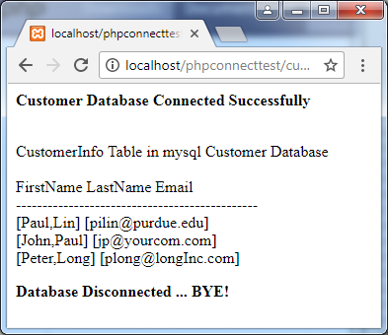

**Example 3: Lab 11 Exercise08**

* **Database: art.sql**
* **Table: genres**

**PhP API:**

* **mysqli_fetch_assoc(),** [**http://php.net/manual/en/function.mysql-fetch-assoc.php**](http://php.net/manual/en/function.mysql-fetch-assoc.php)

MariaDB [(none)]> use art;

Database changed

MariaDB [art]> show tables;

+------------------+

| Tables_in_art |

+------------------+

| artists |

| artworkgenres |

| artworks |

| artworksubjects |

| customerlogon |

| customers |

| galleries |

| genres |

| orderdetails |

| orders |

| reviews |

| subjects |

| typesframes |

| typesglass |

| typesmatt |

| typesshippers |

| typesstatuscodes |

+------------------+

17 rows in set (0.00 sec)

MariaDB [art]> DESCRIBE genres;

+-------------+--------------+------+-----+---------+----------------+

| Field | Type | Null | Key | Default | Extra |

+-------------+--------------+------+-----+---------+----------------+

| GenreID | int(11) | NO | PRI | NULL | auto_increment |

| GenreName | varchar(50) | NO | UNI | NULL | |

| Era | int(11) | YES | | NULL | |

| Description | longtext | YES | | NULL | |

| Link | varchar(255) | YES | | NULL | |

+-------------+--------------+------+-----+---------+----------------+

5 rows in set (0.02 sec)

<?php

//**config_root.php**

define('DBHOST', 'localhost');

define('DBNAME', 'art');

define('DBUSER', 'root');

define('DBPASS', 'secrete');

define('DBCONNSTRING','mysql:host=localhost;dbname=art');

?>

<?php

//**lab11-exercise08-mysqli.php**

require_once('config_root.php');

?>

<!DOCTYPE html>

<html>

<body>

<h1>Database Tester (mysqli)</h1>

Genre:

<select>

<?php

$connection = mysqli_connect(DBHOST, DBUSER, DBPASS, DBNAME);

if ( mysqli_connect_errno() ) {

die( mysqli_connect_error() );

}

$sql = "select * from Genres order by GenreName";

if ($result = mysqli_query($connection, $sql)) {

// loop through the data

while($row = mysqli_fetch_assoc($result))

{

echo '<option value="' . $row['GenreID'] . '">';

echo $row['GenreName'];

echo "</option>";

}

// release the memory used by the result set

mysqli_free_result($result);

}

// close the database connection

mysqli_close($connection);

?>

</select>

</body>

</html>

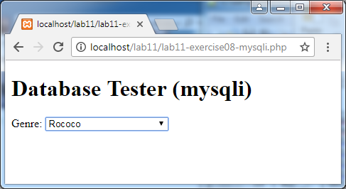

**//View web page generated by lab11-exercise08-mysql.php**

<!DOCTYPE html>

<html>

<body>

<h1>Database Tester (mysqli)</h1>

Genre:

<select>

<option value="50">Abstract Expressionism</option>

<option value="66">American Scene</option>

<option value="39">Art Nouveau</option>

<option value="84">Baroque</option>

<option value="48">Bauhaus</option>

<option value="63">Blaue Reiter (Blue Rider)</option>

<option value="1">Cubism</option><option value="46">Dada</option><option value="56">Expressionism</option><option value="40">Fauvism</option><option value="43">Futurism</option><option value="79">High Renaissance</option><option value="35">Impressionism</option><option value="81">International Gothic</option><option value="80">Mannerism</option><option value="54">Nabis</option><option value="76">Neoclassical</option><option value="77">Northern Renaissance</option><option value="36">Post-Impressionism</option><option value="34">Realism</option><option value="78">Renaissance</option><option value="83">Rococo</option><option value="33">Romanticism</option><option value="55">Sculpture, Early Modern</option><option value="47">Surrealism</option><option value="64">Symbolism</option></select>

</body>

</html>