**CPET 499/ITC 250 Web Systems**

**Web Server Configuration and Trouble Shooting**

**References**

* Apache HTTP Server Project, <http://httpd.apache.org/>
  + Apache httpd 2.4.23 Released, 2016-07-5
* XAMPP Server, <https://www.apachefriends.org/index.html>
  + XAMPP, open source package, is a PHP development environment containing MariaDB, PHP, and Perl
  + XAMPP for Windows v5.6.23 (PHP 5.6.23) 2016-06-28, , XAMPP for Linux v5.6.23 (PHP 5.6.23), XAMPP for OS X v5.6.23 (PHP 5.6.23),
* Wamp Server, <http://www.wampserver.com/en/>
* Apache HTTP Server 2.2 Server Administration Vol. I, 2010, by The Apache Software Foundation
* Apache – The Definitive Guide, 2003, by Ben Laurie & Peter Laurie, published by O’REILLY
* Apache Cookbook, 2008, by Ken Coar & Rich Bowen, published by O’REILLY
* IIS, <http://www.iis.net/>

**Topics on HTTP Web Server**

* Configuration
* Virtual Hosts
* Authentication
* Content Description and Modification
* Indexing
* Redirection
* Proxying
* Logging
* Security
* Running a Big Web Site
* Building Applications
* Server-Side Includes
* PHP
* CGI and Perl
* mod_perl
* mod_jserv and Tomcat
* The Apache API
* Writing Apache Modules

**Server Administration Knowledge/Skills**

* Building, Installation, Upgrading
* Configuration
  + Configuration Files
  + Configuration Sections
* Starting, Stopping, Restarting
* Adding common modules
* Logging
* Virtual Hosts
* Aliases, Redirecting, and Rewriting
* Security
* Installing SSL
* Dynamic Content
  + Enabling CGI scripts, PHP, Perl, Python
* Error Handling
* Proxies
* Performance
* Directory Listings

**Apache Web Server**

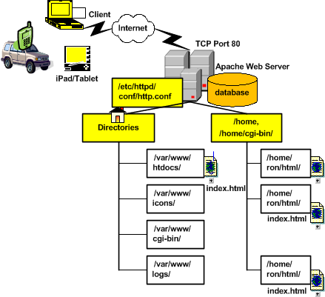

**Apache or XAMPP Startup Problem**

**See what’s Using Port 80:  
1) start => command OR from XAMPP Control panel: Shell**

**2) netstat –ao**

* **TCP 0.0.0.0:80 PID 4**

Setting environment for using XAMPP for Windows.

Administrator@LIN-PC c:\xampp

# **netstat -ao**

Active Connections

Proto Local Address Foreign Address State PID

TCP 0.0.0.0:80 lin-PC:0 LISTENING 4

TCP 0.0.0.0:135 lin-PC:0 LISTENING 848

TCP 0.0.0.0:445 lin-PC:0 LISTENING 4

TCP 0.0.0.0:1309 lin-PC:0 LISTENING 2668

TCP 0.0.0.0:1332 lin-PC:0 LISTENING 3684

TCP 0.0.0.0:1947 lin-PC:0 LISTENING 2492

TCP 0.0.0.0:2002 lin-PC:0 LISTENING 5076

TCP 0.0.0.0:2343 lin-PC:0 LISTENING 2692

TCP 0.0.0.0:2869 lin-PC:0 LISTENING 4

…

3) Task Manager

Kill the process from Task Manager (but unsuccessful)

NT Kernel & System?

4) from Windows Control Panel => Administrative Tools => Services

**Problem (A) Web Development Agent Service is using port 80**

* Opening Up Port 80 for Apache to Use on Windows,

<http://www.devside.net/wamp-server/opening-up-port-80-for-apache-to-use-on-windows>

* Control Panel > System and Security > Administrative Tools => Service > Web Deployment Agent Service (STOP this service)
* Then restart the XAMPP

**Problem (B) NI System Web Server is using port 80**

* **Click on “Stop the Service”**
* **Then restart the XAMPP**

**Problem (C) SQL Server Reporting Services (SQLEXPRESS)**

**Yet NOT ABLE to solve the problem:**

**Using NET STOP HTTP command to stop HTTP service**

Administrator@LIN-PC c:\xampp

# NET Stop HTTP

The following services are dependent on the HTTP service.

Stopping the HTTP service will also stop these services.

UPnP Device Host

SSDP Discovery

Print Spooler

Do you want to continue this operation? (Y/N) [N]: y

The UPnP Device Host service is stopping.

The UPnP Device Host service was stopped successfully.

The SSDP Discovery service is stopping.

The SSDP Discovery service was stopped successfully.

The Print Spooler service is stopping.

The Print Spooler service was stopped successfully.

The HTTP service is stopping........

The HTTP service could not be stopped.

**Restart XAMPP Control Panel**

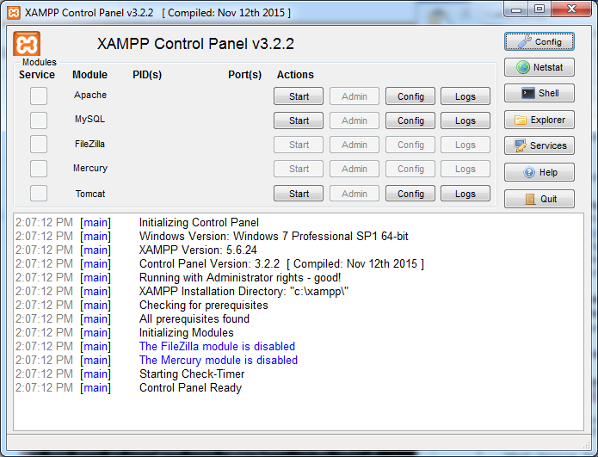

**Start Service Modules**

* **Apache – using PID(s): 8128, 3300; PORT 80, 443**
* **MySQL – using PID(s) 10112; PORT 3306**

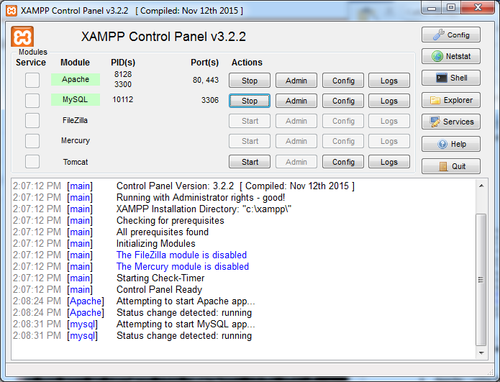

**Apache Folders/Subdirectories (XAMPP example)**

* apache
  + /bin/
  + /conf/httpd.conf …… the configuration file
    - Listening port 80 (default)
    - LoadModule
    - ServerName localhost:80
    - DocumentRoot “C:/xampp/htdocs”
    - <Directory “C:/xampp/htdocs”> … </Directory>
    - <Directory “C:/xampp/cgi-bin”> … </Directory>
  + /conf/exta
  + /conf/original
  + /conf/ssl.crt
  + /conf/ssl.csr
  + /conf/ssl.key
  + /error
  + /icons
  + /include
  + /lib
  + /logs
  + /manual
  + /modules
  + /scripts
* htdocs
* cgi-bin
* php
* perl
* phpMyAdmin

**XAMPP Configuration & Trouble Shooting**

Port 80 in use with PID4

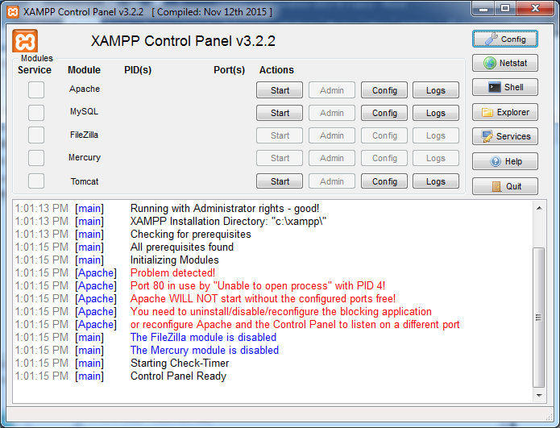

**Finding Your Windows Process ID**

* Finding Process ID, <https://docs.microsoft.com/en-us/windows-hardware/drivers/debugger/finding-the-process-id>
* PID number in Task Manager can’t be found, <https://superuser.com/questions/191416/pid-number-in-task-manager-cant-be-found>
* 10 Windows Task Manager Tricks you Didn’t Know, by Joel Lee, 2016/2/12 <http://www.makeuseof.com/tag/10-windows-task-manager-tricks-didnt-know/>
* Ctrl, Shift+ESC key to start your Task Manager

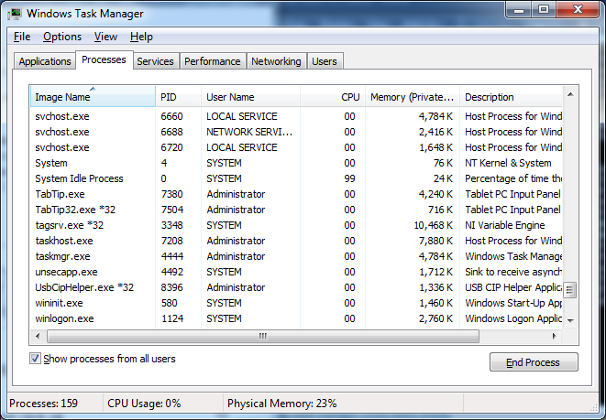

Unable to kill System process with PID 4 which uses Port 80

<https://stackoverflow.com/questions/1430141/port-80-is-being-used-by-system-pid-4-what-is-that>

XAMPP Configuration

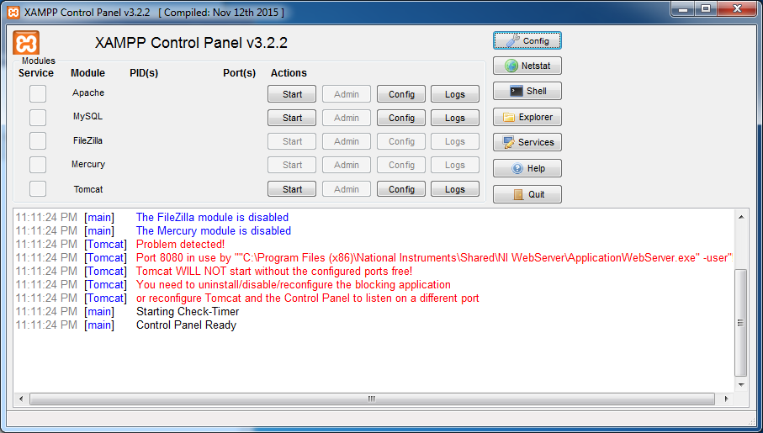

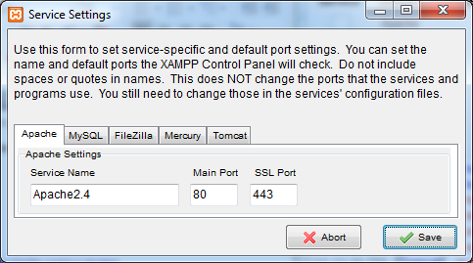

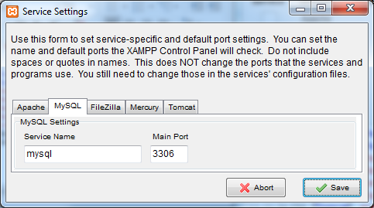

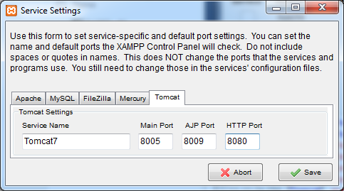

Change HTTP Port to 8090

Discussion Forum:

* <http://stackoverflow.com/questions/34495137/tomcat-shutdown-unexpectedly>
* net stop http -- stop the services on port 80
* netstat –abno -- to see who else is using port