Chapter 13 Project 2: Share Your Travel Photos -2

list.php

* Include travel-data-classes.php INCLUDE
  + Location.class.php
    - __construct()
    - public function lat()
    - public function lng()
  + TravelPhoto.class.php
    - __construct($filename, $title, $description, $latitude)
    - __toString()
    - public function nearest($allPhotos)
    - public function distanceTo($photo)
    - public function path()
    - public function lat()
    - public function lng()
    - public function title()
    - public function location()
    - public function description()
    - public function id()
    - public function city()

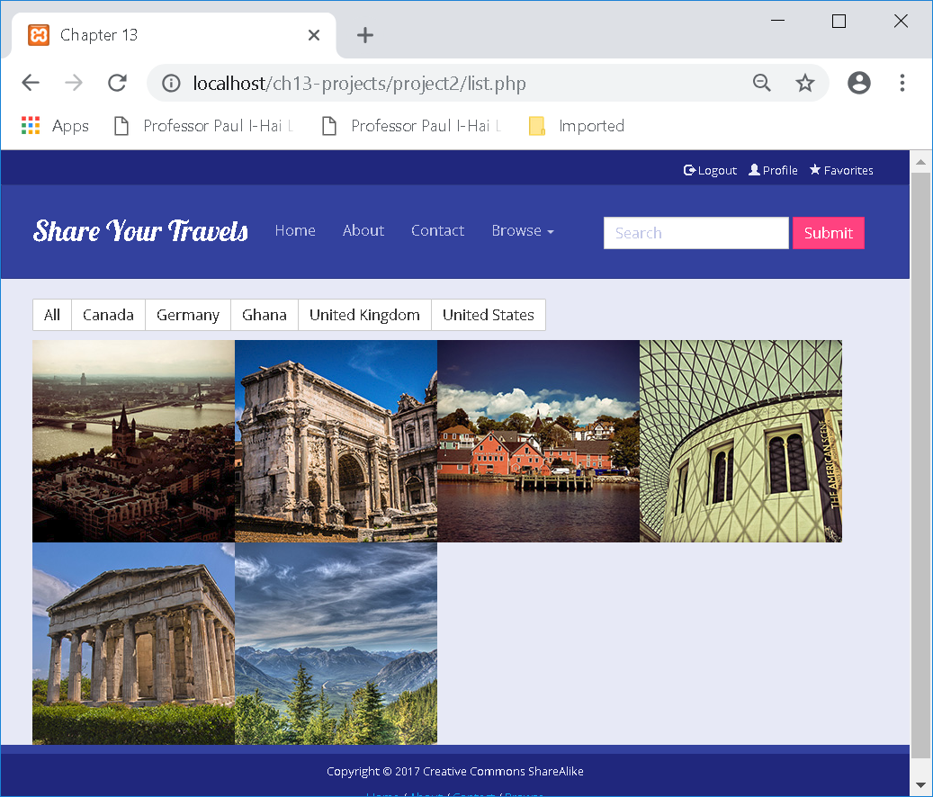

<?php

/*

Represents a Location on the earth

*/

//Location.class.php

class Location

{

private $latitude;

private $longitude;

private $city;

// constructor is

function __construct($latitude, $longitude, $city) {

$this->latitude = $latitude;

$this->longitude = $longitude;

$this->city = $city;

}

public function lat(){

return $this->latitude;

}

public function lng(){

return $this->longitude;

}

}

?>

<?php

//travel-data-classes.php

include('Location.class.php');

include('TravelPhoto.class.php');

$continents = array("Asia","Africa","Europe","North America","South America", "Oceania");

$countries = array();

$countries["US"] = "United States";

$countries["DE"] = "Germany";

$countries["GH"] = "Ghana";

$countries["CA"] = "Canada";

$countries["GB"] = "United Kingdom";

$images = array();

$images[] = new TravelPhoto("6114850721.jpg", "View of Cologne", "View of Cologne from atop the Cologne Cathedral", 50.941149, 6.957358 );

$images[] = new TravelPhoto("9495574327.jpg", "Arch of Septimus Severus", "In the Roman Forum", 41.892949, 12.484972);

$images[] = new TravelPhoto("5856697109.jpg", "Lunenburg Port", "On board a small sailing ship leaving Lunenburg", 44.373257, -64.307249);

$images[] = new TravelPhoto("5855729828.jpg", "British Museum", "The library in the British Museum in London", 51.519148, -0.126826);

$images[] = new TravelPhoto("8711645510.jpg", "Temple of Hephaistos", "Located on western perimeter of Agora in Athens. Built in 460-415 BCE, it is the best preserved temple of antiquity.", 37.975579, 23.721526);

$images[] = new TravelPhoto("6114907897.jpg", "At the top of Sulpher Mountain", "At top of Sulpher Mountain near Banff", 51.144571, -115.57467);

?>

/*

Represents a single travel photo

*/

class TravelPhoto

{

static private $photoID = 0;

private $ID;

private $date;

private $fileName;

private $description;

private $title;

private $latitude;

private $longitude;

// constructor is

function __construct($filename, $title, $description, $latitude, $longitude) {

$this->fileName = $filename;

$this->title = $title;

$this->description = $description;

$this->location = new Location($latitude,$longitude,"");

self::$photoID++;

$this->ID = self::$photoID;

}

public function __toString() {

$tag = '<a href="detail.php?id=' . $this->ID . '" class="img-responsive">';

$tag .= '<img src="images/square/' . $this->fileName . '" title="' . $this->title . '" alt="' . $this->title . '" >';

$tag .= '<div class="caption"><div class="blur"></div><div class="caption-text"><h1>' . $this->title .

'</h1></div></div></a>';

return $tag;

}

//function to get the nearest travel photo from a passed in array.

function nearest($allPhotos) {

$smallest=999999;

foreach ($allPhotos as $onePhoto) {

if ($onePhoto->path() == $this->path()) {

continue;//same photo.

}

//Now calculate distance.

//Note - This calculation works roughly. The correct calcualtion uses the haversine formula - beyond the scope of this project and left as an exercise.

$distance = sqrt(pow(abs($onePhoto->lat()-$this->lat()),2) + pow(abs($onePhoto->lng()-$this->lng()),2));

//echo $distance."<br>";

if ($distance < $smallest) {

$smallest = $distance;

$nearestID = $onePhoto->id();

}

}

return $nearestID;

}

public function distanceTo($photo) {

$distance = sqrt(square(abs($photo->lat()-$this->lat())) + square(abs($photo->lng()-$this->lng())));

}

public function path() {

return $this->fileName;

}

public function lat(){

return $this->location->lat();

}

public function lng(){

return $this->location->lng();

}

public function title(){

return $this->title;

}

public function location(){

return $this->location;

}

public function description(){

return $this->description;

}

public function id(){

return $this->ID;

}

public function city(){

return "";//to be completed ina later exercise.

}

}

?>

<?php

//travel-data.classes.php

include('Location.class.php');

include('TravelPhoto.class.php');

$continents = array("Asia","Africa","Europe","North America","South America", "Oceania");

$countries = array();

$countries["DE"] = "Germany";

$countries["GR"] = "Greece";

$countries["IT"] = "Italy";

$countries["CA"] = "Canada";

$countries["GB"] = "United Kingdom";

$countries["US"] = "United States";

$images = array();

$images[1] = array("id"=>1,"title" => "View of Cologne", "description" => "View of Cologne from atop the Cologne Cathedral", "country" => "Germany", "city" => "Cologne", "user" => "Joao Fernandes", "path" => "6114850721.jpg", "taken" => "August 8, 2017", "tags" => array("cathedral","high","birds-eye"));

$images[2] = array("id"=>2,"title" => "Arch of Septimus Severus", "description" => "In the Roman Forum", "country" => "Italy", "city" => "Rome", "user" => "Ellie Sullivan", "path" => "9495574327.jpg", "taken" => "August 15, 2017", "tags" => array("rome","ruins","ancient","assassinated"));

$images[3] = array("id"=>3,"title" => "Lunenburg Port", "description" => "On board a small sailing ship leaving Lunenburg", "country" => "Canada", "city" => "Lunenburg", "user" => "Mark Taylor", "path" => "5856697109.jpg", "taken" => "August 28, 2017", "tags" => array("maritimes","nova scotia","yacht","port"));

$images[4] = array("id"=>4,"title" => "British Museum", "description" => "The library in the British Museum in London", "country" => "United Kingdom", "city" => "London", "user" => "Mark Taylor", "path" => "5855729828.jpg", "taken" => "September 3, 2017", "tags" => array("museum","karl marx","reading room","shadows","yellow"));

$images[5] = array("id"=>5,"title" => "Temple of Hephaistos", "description" => "Located on western perimeter of Agora in Athens. Built in 460-415 BCE, it is the best preserved temple of antiquity.", "country" => "Greece", "city" => "Athens", "user" => "Ellie Sullivan", "path" => "8711645510.jpg", "taken" => "October 10, 2017", "tags" => array("ancient","garden","ruins","sunshine"));

$images[6] = array("id"=>6,"title" => "At the top of Sulpher Mountain", "description" => "At top of Sulpher Mountain near Banff", "country" => "Canada", "city" => "Banff", "user" => "Frantisek Wichterlova", "path" => "6114907897.jpg", "taken" => "October 15, 2017", "tags" => array("mountain","banff","valley"));

$images[7] = array("id"=>7,"title" => "Pazzi Chapel at Santa Croce", "description" => "By Filippo Brunelleschi, the chapel is considered to be one of the masterpieces of Renaissance architecture. It is located in the first cloister of the Basilica di Santa Croce.", "country" => "Italy", "city" => "Florence", "user" => "Frantisek Wichterlova", "path" => "9504609042.jpg", "taken" => "October 23, 2017", "tags" => array("florence","cathedral","church","brunelleschi"));

?>

<?php

//List.php - Ch 13. Project 2

include 'travel-data-classes.php';

asort($countries);

// we will display the filtered array

$filtered = array();

// first see if we should filter the countries

if (isset($_GET['country'])) {

// loop thru each image in dataset and see if its country matches request

foreach ($images as $img) {

if ($img['country'] == $_GET['country']) {

// we have a match so add that image to filtered array

$filtered[$img['id']] = $img;

}

}

}

else {

// no filter was specified so show all images in dataset

$filtered = $images;

}

?>

<!DOCTYPE html>

<html lang="en">

<head>

<meta charset="utf-8">

<title>Chapter 13</title>

<meta name="viewport" content="width=device-width, initial-scale=1">

<link href='http://fonts.googleapis.com/css?family=Lobster' rel='stylesheet' type='text/css'>

<link href='http://fonts.googleapis.com/css?family=Open+Sans' rel='stylesheet' type='text/css'>

<link rel="stylesheet" href="css/bootstrap.min.css" />

<link rel="stylesheet" href="css/bootstrap-theme.css" />

<link rel="stylesheet" href="css/captions.css" />

</head>

<body>

<?php include 'header.inc.php'; ?>

<!-- Page Content -->

<main class="container">

<div class="btn-group countryButtons" role="group" aria-label="...">

<a role="button" class="btn btn-default" href="list.php">All</a>

<?php foreach ($countries as $key => $value) { ?>

<a href="#" role="button" class="btn btn-default"> <?php echo $value; ?></a>

<?php } ?>

</div>

<ul class="caption-style-2">

<?php foreach ($filtered as $img) { ?>

<li>

<?php echo $img; ?>

</li>

<?php } ?>

</ul>

</main>

<footer>

<div class="container-fluid">

<div class="row final">

<p>Copyright &copy; 2017 Creative Commons ShareAlike</p>

<p><a href="#">Home</a> / <a href="#">About</a> / <a href="#">Contact</a> / <a href="#">Browse</a></p>

</div>

</div>

</footer>

<script src="https://code.jquery.com/jquery-2.2.4.min.js" integrity="sha256-BbhdlvQf/xTY9gja0Dq3HiwQF8LaCRTXxZKRutelT44=" crossorigin="anonymous"></script>

<script src="https://maxcdn.bootstrapcdn.com/bootstrap/3.3.6/js/bootstrap.min.js" integrity="sha384-0mSbJDEHialfmuBBQP6A4Qrprq5OVfW37PRR3j5ELqxss1yVqOtnepnHVP9aJ7xS" crossorigin="anonymous"></script>

</body>

</html>