**Chapter 14 Project 2 Share Your Travel Photos**

Retrieve information from database and display it

Search Criteria

* Select lists populated using data from the Countries and Continents tables
* Filter area is used to filter the image displayed

Filter settings are sent via query string parameters

chapter1-project2.php

testdb-classes.php

**includes**

* travel-config.inc.php
* left.inc.php
* travel-conf.inc.php

**lib**

* ContinentDB.class.php
* CountryDB.class.php
* DatabaseHelper.class.php
* ImageeDB.class.php

Retrieve three tables

* **Continents**
* **Countries**
* **ImageDetails**

Display every image (use the version from the **square-medium** folder in the **ImageDetails** table.

* **Path** field – contains the filename of the image
* Each lmage should be a link to **detail.php** (not supplied) with the **ImageID** field passes as a query string
* The Filter will be used to filter/reduce the number of images from a specific continent, country or images whose **Title** filed contains a search word after clicks the Filter button.

<http://localhost/ch14-projects/project2/testdb-classes.php>

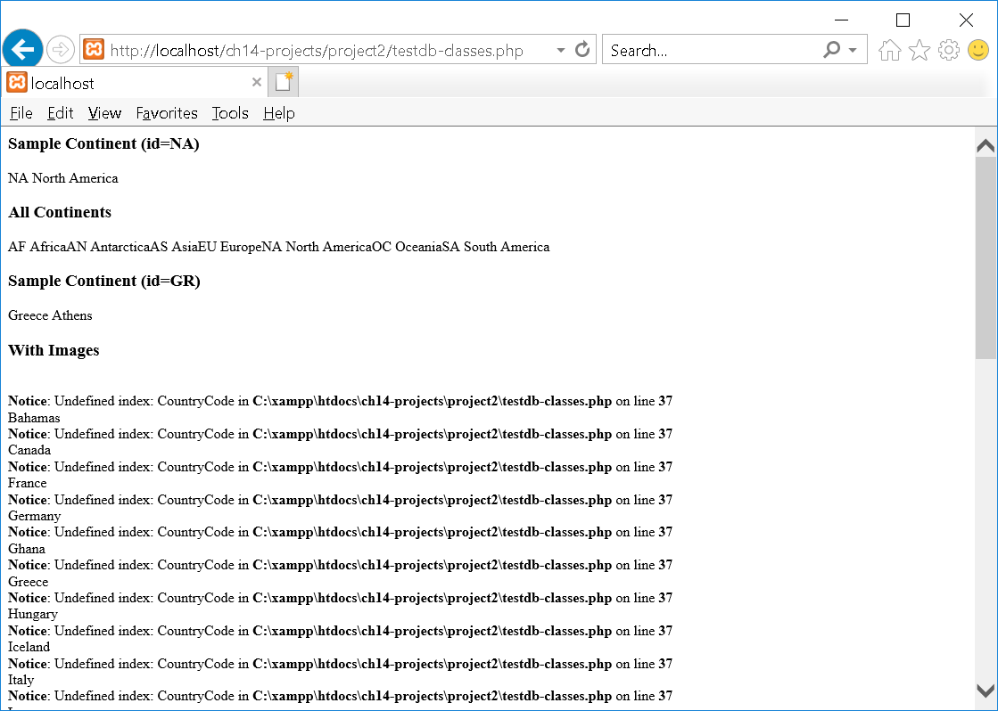

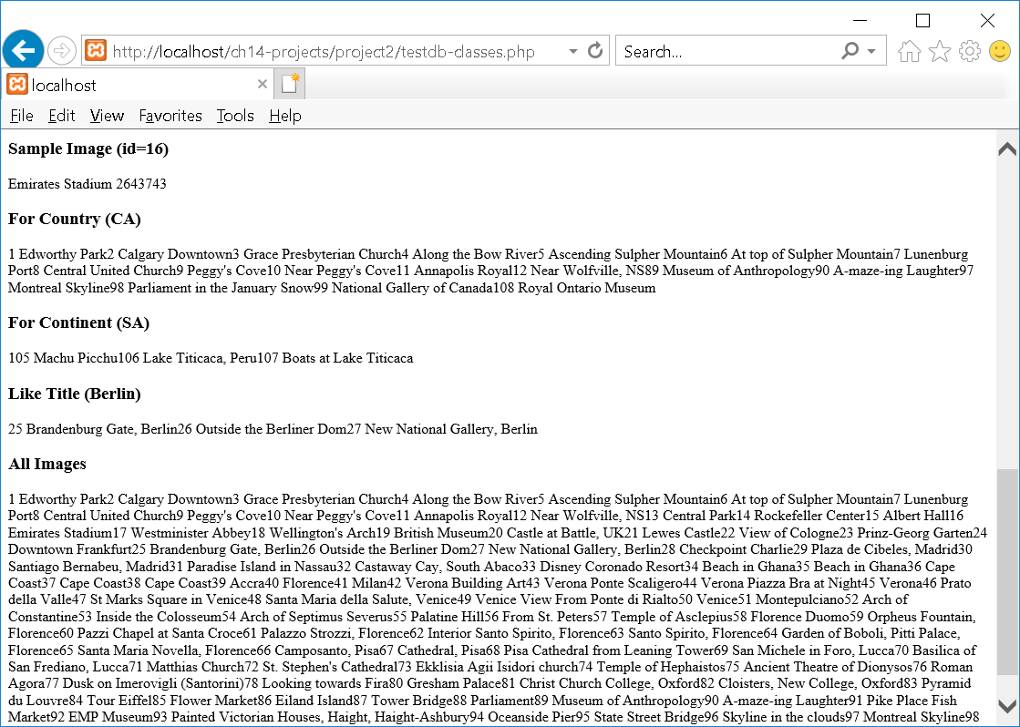

Filter Selection:

* Continent - None
* Country – Greek
* Title - None

<http://localhost/ch14-projects/project2/chapter14-project2.php?continent=0&country=GR&title=>

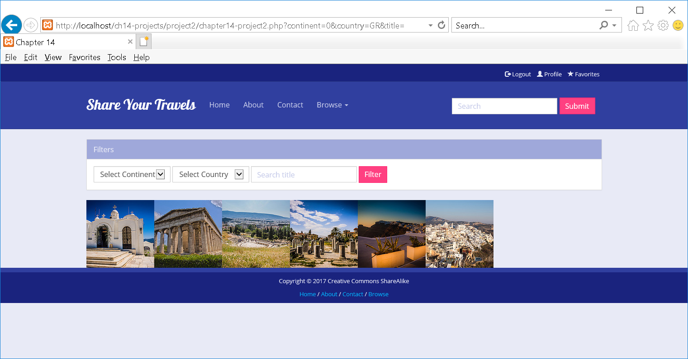

Filter Selection:

* Continent – North America
* Country – None
* Title - None

<http://localhost/ch14-projects/project2/chapter14-project2.php?continent=NA&country=0&title=>

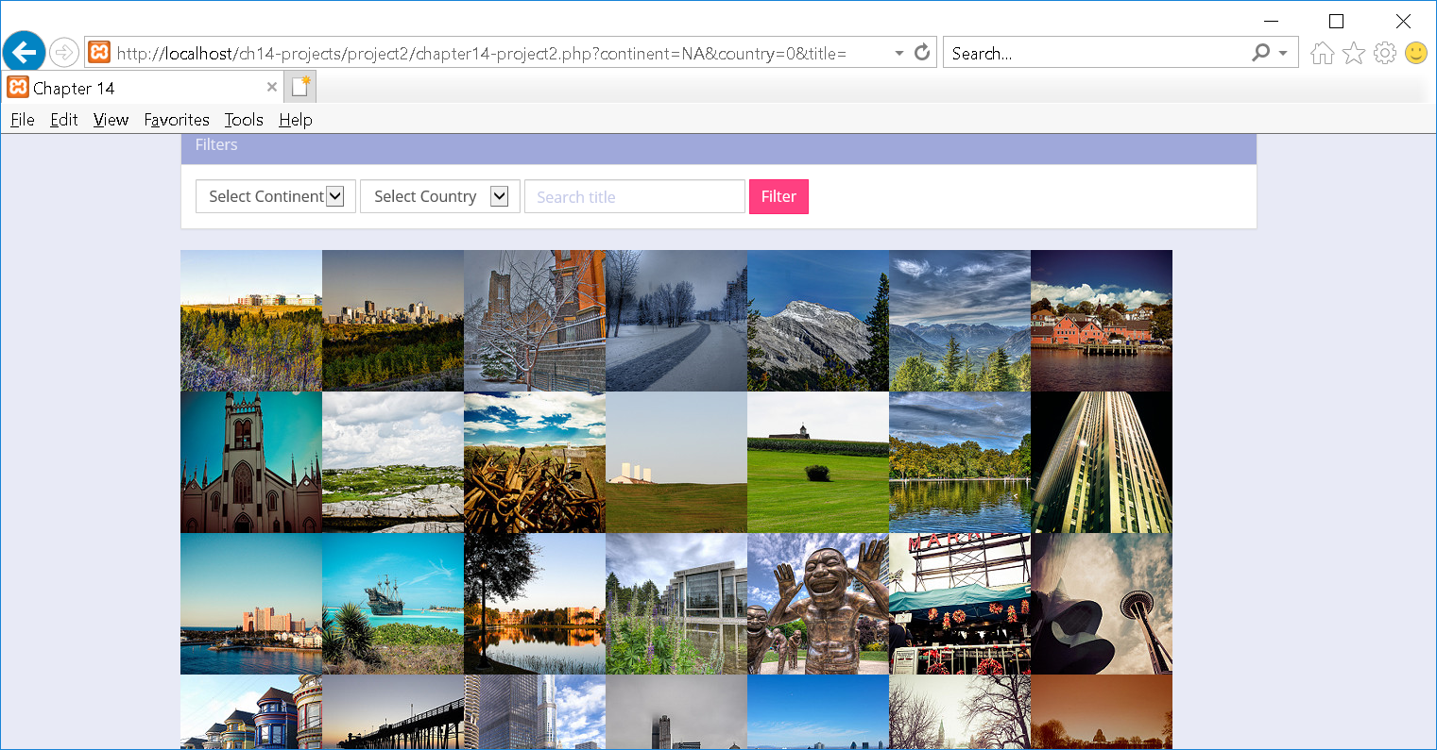

**travel-config.inc.php**

<?php

define('DBCONNECTION', 'mysql:host=localhost;dbname=travel');

define('DBUSER', 'DB USERNAME HERE');

define('DBPASS', 'DB PASSWORD HERE');

spl_autoload_register(function ($class) {

$file = 'lib/' . $class . '.class.php';

if (file_exists($file))

include $file;

});

/* cloud9 database connect */

$ip = getenv('IP');

$port = '3306';

$user = getenv('C9_USER');

$connection = "mysql:host=$ip;port=$port;dbname=travel";

$pdo = DatabaseHelper::setConnectionInfo(array(DBCONNECTION, $user, ''));

/* localhost database connect */

//$pdo = DatabaseHelper::setConnectionInfo(array(DBCONNECTION, DBUSER, DBPASS));

?>

**ContinentDB.class.php**

<?php

/* Handles database access for the Continent table. */

class ContinentDB {

private $pdo = null;

private static $baseSQL = "SELECT * FROM Continents";

private static $constraint = ' order by ContinentName';

public function __construct($connection) {

$this->pdo = $connection;

}

public function findById($id)

{

$sql = self::$baseSQL . ' WHERE ContinentCode=? ';

$statement = DatabaseHelper::runQuery($this->pdo, $sql, Array($id));

return $statement->fetch();

}

public function getAll()

{

$sql = self::$baseSQL . self::$constraint;

$statement = DatabaseHelper::runQuery($this->pdo, $sql, null);

return $statement;

}

}

?>

**CountryDB.class.php**

<?php

/* Handles database access for the Country table. */

class CountryDB {

private $pdo = null;

private static $baseSQL = "SELECT * FROM Countries";

private static $constraint = ' order by CountryName';

public function __construct($connection) {

$this->pdo = $connection;

}

public function findById($id)

{

$sql = self::$baseSQL . ' WHERE ISO=? ';

$statement = DatabaseHelper::runQuery($this->pdo, $sql, Array($id));

return $statement->fetch();

}

public function getAll()

{

$sql = self::$baseSQL . self::$constraint;

$statement = DatabaseHelper::runQuery($this->pdo, $sql, null);

return $statement;

}

public function getWithImages()

{

$sql = "SELECT CountryName, CountryCodeISO FROM Countries INNER JOIN ImageDetails ON Countries.ISO = ImageDetails.CountryCodeISO GROUP BY Countries.CountryName, ImageDetails.CountryCodeISO" . self::$constraint;

$statement = DatabaseHelper::runQuery($this->pdo, $sql, null);

return $statement;

}

}

?>

**ImageDB.class.php**

<?php

/* Handles database access for the Image Details table. */

class ImageDB {

private $pdo = null;

private static $baseSQL = "SELECT * FROM ImageDetails";

private static $constraint = ' ORDER BY ImageID';

public function __construct($connection) {

$this->pdo = $connection;

}

public function findById($id)

{

$sql = self::$baseSQL . ' WHERE ImageID=? ';

$statement = DatabaseHelper::runQuery($this->pdo, $sql, Array($id));

return $statement->fetch();

}

public function getAll()

{

$sql = self::$baseSQL . self::$constraint;

$statement = DatabaseHelper::runQuery($this->pdo, $sql, null);

return $statement;

}

public function findByCountry($country)

{

$sql = self::$baseSQL . ' WHERE CountryCodeISO=? ';

$statement = DatabaseHelper::runQuery($this->pdo, $sql, Array($country));

return $statement;

}

public function findByContinent($continent)

{

$sql = self::$baseSQL . ' WHERE ContinentCode=? ';

$statement = DatabaseHelper::runQuery($this->pdo, $sql, Array($continent));

return $statement;

}

public function findLikeTitle($title)

{

$sql = self::$baseSQL . ' WHERE Title LIKE ? ';

$filter = '%' . $title . '%';

$statement = DatabaseHelper::runQuery($this->pdo, $sql, Array($filter));

return $statement;

}

}

?>

**DatabaseHelper.class.php**

<?php

class DatabaseHelper {

public static function setConnectionInfo($values=array()) {

$connString = $values[0];

$user = $values[1];

$password = $values[2];

$pdo = new PDO($connString,$user,$password);

$pdo->setAttribute(PDO::ATTR_ERRMODE, PDO::ERRMODE_EXCEPTION);

return $pdo;

}

public static function runQuery($pdo, $sql, $parameters=array()) {

// Ensure parameters are in an array

if (!is_array($parameters)) {

$parameters = array($parameters);

}

$statement = null;

if (count($parameters) > 0) {

// Use a prepared statement if parameters

$statement = $pdo->prepare($sql);

$executedOk = $statement->execute($parameters);

if (! $executedOk) {

throw new PDOException;

}

} else {

// Execute a normal query

$statement = $pdo->query($sql);

if (!$statement) {

throw new PDOException;

}

}

return $statement;

}

}

?>

**testdb-classes.php**

<?php

include 'includes/travel-config.inc.php';

?>

<html>

<body>

<?php

try {

$db = new ContinentDB($pdo);

$result = $db->findById('NA');

echo '<h3>Sample Continent (id=NA)</h3>';

echo $result['ContinentCode'] . ' ' . $result['ContinentName'];

$result = $db->getAll();

echo '<h3>All Continents</h3>';

while ($row = $result->fetch()) {

echo $row['ContinentCode'] . ' ' . $row['ContinentName'];

}

$db = new CountryDB($pdo);

$result = $db->findById('GR');

echo '<h3>Sample Continent (id=GR)</h3>';

echo $result['CountryName'] . ' ' . $result['Capital'];

$result = $db->getWithImages();

echo '<h3>With Images</h3>';

while ($row = $result->fetch()) {

echo $row['CountryCode'] . ' ' . $row['CountryName'];

}

$db = new ImageDB($pdo);

$result = $db->findById(16);

echo '<h3>Sample Image (id=16)</h3>';

echo $result['Title'] . ' ' . $result['CityCode'];

$result = $db->findByCountry('CA');

echo '<h3>For Country (CA)</h3>';

while ($row = $result->fetch()) {

echo $row['ImageID'] . ' ' . $row['Title'];

}

$result = $db->findByContinent('SA');

echo '<h3>For Continent (SA)</h3>';

while ($row = $result->fetch()) {

echo $row['ImageID'] . ' ' . $row['Title'];

}

$result = $db->findLikeTitle('Berlin');

echo '<h3>Like Title (Berlin)</h3>';

while ($row = $result->fetch()) {

echo $row['ImageID'] . ' ' . $row['Title'];

}

$result = $db->getAll();

echo '<h3>All Images</h3>';

while ($row = $result->fetch()) {

echo $row['ImageID'] . ' ' . $row['Title'];

}

}

catch (PDOException $e) {

die( $e->getMessage() );

}

?>

</body>

</html>

**chapter14-project2.php**

<?php

include 'includes/travel-config.inc.php';

$continentdb = new ContinentDB($pdo);

$continents = $continentdb->getAll();

$countrydb = new CountryDB($pdo);

$countries = $countrydb->getWithImages();

$imagedb = new ImageDB($pdo);

// see if we should filter by continent

if (isset($_GET['continent']) && ! empty($_GET['continent']) ) {

$images = $imagedb->findByContinent($_GET['continent']);

}

// see if we should filter by a country

else if (isset($_GET['country']) && ! empty($_GET['country'])) {

$images = $imagedb->findByCountry($_GET['country']);

}

else if (isset($_GET['title']) && ! empty($_GET['title'])) {

$images = $imagedb->findLikeTitle($_GET['title']);

}

else {

$images = $imagedb->getAll();

}

?>

<!DOCTYPE html>

<html lang="en">

<head>

<meta charset="utf-8">

<title>Chapter 14</title>

<meta name="viewport" content="width=device-width, initial-scale=1">

<link href='http://fonts.googleapis.com/css?family=Lobster' rel='stylesheet' type='text/css'>

<link href='http://fonts.googleapis.com/css?family=Open+Sans' rel='stylesheet' type='text/css'>

<link rel="stylesheet" href="css/bootstrap.min.css" />

<link rel="stylesheet" href="css/captions.css" />

<link rel="stylesheet" href="css/bootstrap-theme.css" />

</head>

<body>

**<?php include 'includes/header.inc.php'; ?>**

<!-- Page Content -->

<main class="container">

<div class="panel panel-default">

<div class="panel-heading">Filters</div>

<div class="panel-body">

<**form action="chapter14-project2.php" method="get"** class="form-horizontal">

<div class="form-inline">

<select name="continent" class="form-control">

<option value="0">Select Continent</option>

**<?php while ($con = $continents->fetch())** {

echo '<option value=' . $con['ContinentCode'] . '>' . $con['ContinentName'] . '</option>';

} ?>

</select>

<select name="country" class="form-control">

<option value="0">Select Country</option>

**<?php while ($country = $countries->fetch())** {

echo '<option value=' . $country['CountryCodeISO'] . '>' . $country['CountryName'] . '</option>';

} ?>

</select>

<input type="text" placeholder="Search title" class="form-control" name=title>

<button type="submit" class="btn btn-primary">Filter</button>

</div>

</form>

</div>

</div>

<ul class="caption-style-2">

<?**php while ($img = $images->fetch())** { ?>

<li>

**<a href="detail.php?id=<?php echo $img['ImageID'];** ?>" class="img-responsive">

<img src="images/square-medium/<**?php echo $img['Path']; ?>**" alt="<?**php echo $img['Title']**; ?>">

<div class="caption">

<div class="blur"></div>

<div class="caption-text">

<p><?php echo $img['Title']; ?></p>

</div>

</div>

</a>

</li>

<?php } ?>

</ul>

</main>

<footer>

<div class="container-fluid">

<div class="row final">

<p>Copyright &copy; 2017 Creative Commons ShareAlike</p>

<p><a href="#">Home</a> / <a href="#">About</a> / <a href="#">Contact</a> / <a href="#">Browse</a></p>

</div>

</div>

</footer>

<script src="https://code.jquery.com/jquery-2.2.4.min.js" integrity="sha256-BbhdlvQf/xTY9gja0Dq3HiwQF8LaCRTXxZKRutelT44=" crossorigin="anonymous"></script>

<script src="https://maxcdn.bootstrapcdn.com/bootstrap/3.3.6/js/bootstrap.min.js" integrity="sha384-0mSbJDEHialfmuBBQP6A4Qrprq5OVfW37PRR3j5ELqxss1yVqOtnepnHVP9aJ7xS" crossorigin="anonymous"></script>

</body>

</html>