**Ch 15 Project 2. Art Store: Client-side Validation through JavaScript and Regular Expression**

1. Examine and test **register.php** in the browser
   1. Add validation checks for the first and last name (they must be non-blank)
   2. The phone number must follow North American Format of ###.###.####
   3. The email (must have a valid format)
   4. The passwords must be identical and between 6 and 18 characters long
   5. The agreement to terms and conditions (must be checked)
2. In **validation.js**, attach an event handler for the click event of the register button.
   1. The listener will need to make use of regular expressions to test the phone number, email, and password fields.
   2. Regular conditional logic will be needed to validate the
      * Names
      * Password equality
      * The term agreement checkbox
3. In the event there is an error, prevent the form from submitting
   1. Add a relevant error message to the <div> with id=”errors”
   2. Then toggle the visibility of the <div>
   3. you can also add the class errors to the container element (e.g. email container) for the field that generated the error; this will change the color of the input element to red.

**First Screen**

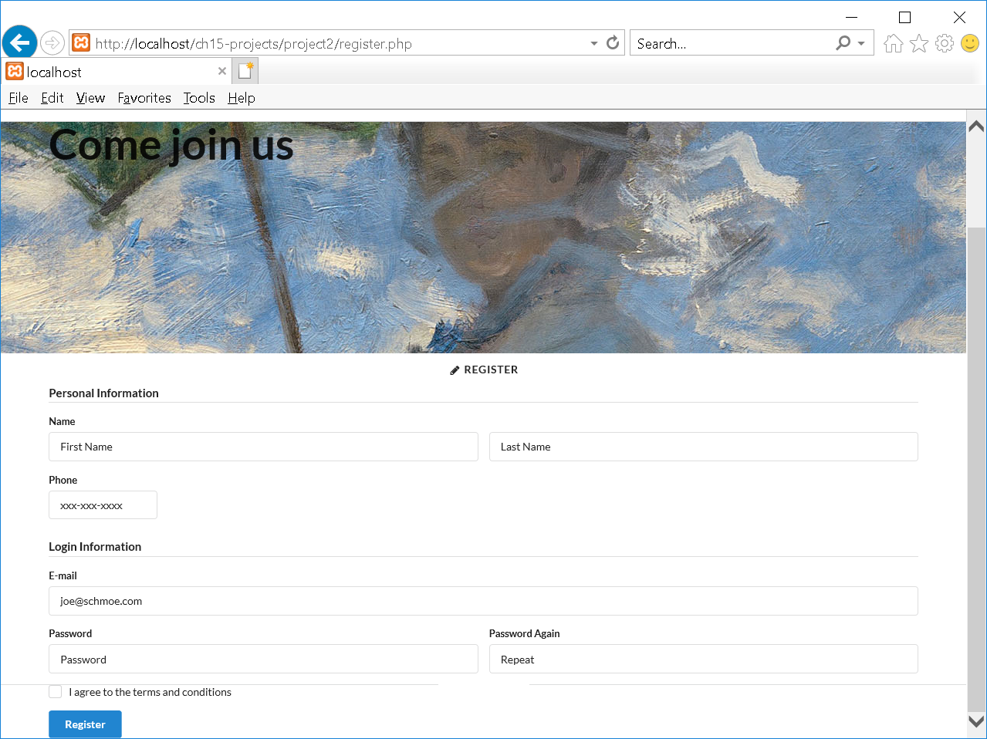

**Error Screens**

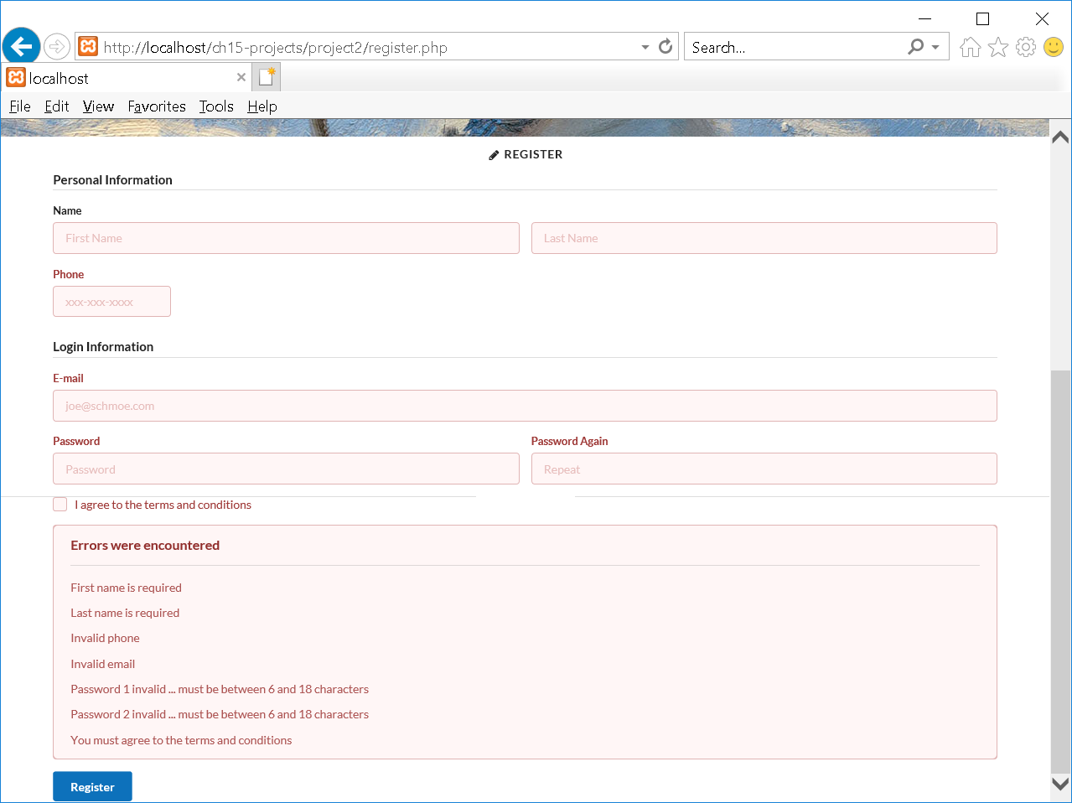

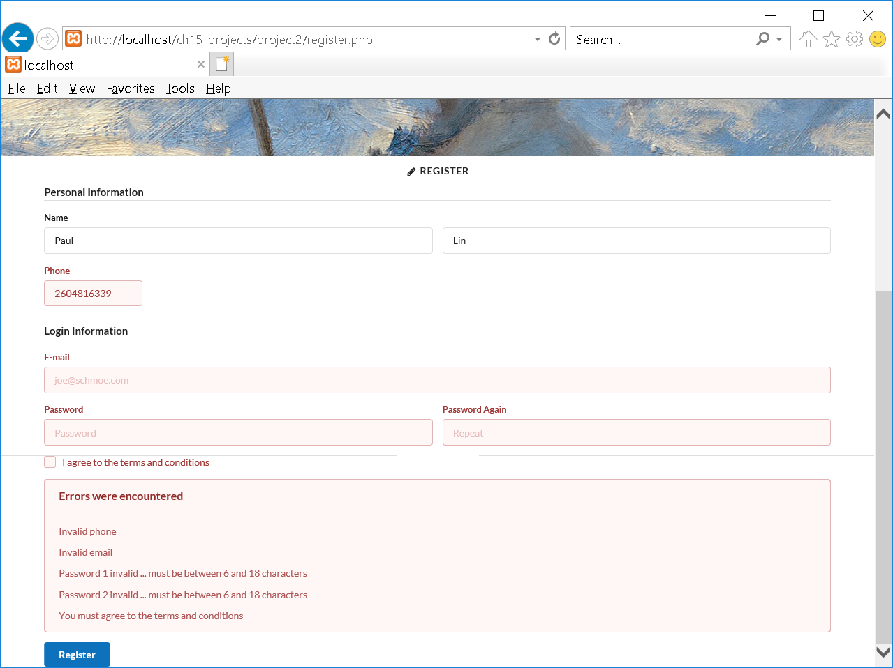

**Successfully Registered**

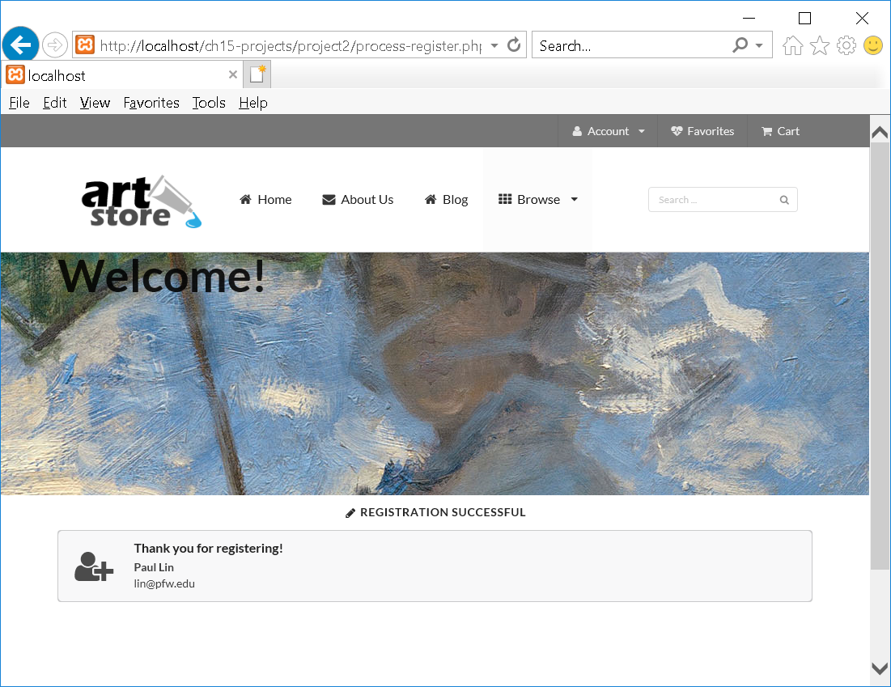

<?php

**//register.php**

?>

<!DOCTYPE html>

<html lang=en>

<head>

<meta charset=utf-8>

<link href='https://fonts.googleapis.com/css?family=Merriweather' rel='stylesheet' type='text/css'>

<link href='https://fonts.googleapis.com/css?family=Open+Sans' rel='stylesheet' type='text/css'>

<script src="https://ajax.googleapis.com/ajax/libs/jquery/3.1.0/jquery.min.js"></script>

<script src="css/semantic.js"></script>

<script src="js/misc.js"></script>

<script src="js/validation.js"></script>

<link href="css/semantic.css" rel="stylesheet" >

<link href="css/icon.css" rel="stylesheet" >

<link href="css/styles.css" rel="stylesheet">

</head>

<body >

<**?php include 'includes/art-header.inc.php'; ?**>

<div class="banner-container">

<div class="ui sizer container">

<h1 class="ui huge header">Come join us</h1>

</div>

</div>

<h2 class="ui horizontal divider"><i class="write icon"></i> Register</h2>

<main>

<section class="ui stackable container">

<form class="ui form" method="post" action="**process-register.php**">

<h4 class="ui dividing header">Personal Information</h4>

<div class="field" >

<label>Name</label>

<div class="two fields">

<div class="field" id="firstnamecontainer">

<input type="text" name="firstname" placeholder="First Name" id="firstname">

</div>

<div class="field" id="lastnamecontainer">

<input type="text" name="lastname" placeholder="Last Name" id="lastname">

</div>

</div>

</div>

<div class="two wide field" id="phonecontainer">

<label>Phone</label>

<input type="text" name="phone" placeholder="xxx-xxx-xxxx" id="phone" >

</div>

<h4 class="ui dividing header">Login Information</h4>

<div class="field" id="emailcontainer">

<label>E-mail</label>

<input type="email" placeholder="joe@schmoe.com" name="email" id="email">

</div>

<div class="fields">

<div class="eight wide field" id="password1container">

<label>Password</label>

<input type="password" name="password1" maxlength="16" placeholder="Password" id="password1">

</div>

<div class="eight wide field" id="password2container">

<label>Password Again</label>

<input type="password" name="password2" maxlength="16" placeholder="Repeat" id="password2">

</div>

</div>

<div class="inline field" id="agreecontainer">

<div class="ui checkbox">

<input type="checkbox" tabindex="0" name="agree" id="agree">

<label>I agree to the terms and conditions</label>

</div>

</div>

<div id="errors" class="ui negative message">

<h3 class="header">Errors were encountered</h3>

<div class="ui divider"></div>

<div id="errorMessages"> </div>

</div>

<button type="submit" class="ui primary button" tabindex="0" id="register">Register</div>

</form>

</section>

</main>

</body>

</html>

======++++==============

<?php

**//process-register.php**

?>

<!DOCTYPE html>

<html lang=en>

<head>

<meta charset=utf-8>

<link href='https://fonts.googleapis.com/css?family=Merriweather' rel='stylesheet' type='text/css'>

<link href='https://fonts.googleapis.com/css?family=Open+Sans' rel='stylesheet' type='text/css'>

<script src="https://ajax.googleapis.com/ajax/libs/jquery/3.1.0/jquery.min.js"></script>

<**script src="css/semantic.js**"></script>

<**script src="js/misc.js"**></script>

<**script src="js/validation.js**"></script>

<link href="css/semantic.css" rel="stylesheet" >

<link href="css/icon.css" rel="stylesheet" >

<link href="css/styles.css" rel="stylesheet">

</head>

<body >

**<?php include 'includes/art-header.inc.php'; ?>**

<div class="banner-container">

<div class="ui sizer container">

<h1 class="ui huge header">Welcome!</h1>

</div>

</div>

<h2 class="ui horizontal divider"><i class="write icon"></i> Registration Successful</h2>

<main>

<section class="ui stackable container">

<div class="ui icon message">

<i class="add user icon"></i>

<div class="content">

<div class="header">

Thank you for registering!

</div>

**<?php**

**if ($_SERVER["REQUEST_METHOD"] == "POST") {**

**echo "<p><strong>" . $_POST['firstname'] . " " . $_POST['lastname'] . "</strong><br>";**

**echo $_POST['email'] . "</p>";**

**}**

**?>**

</div>

</div>

</section>

</main>

</body>

</html>

======++++==============

**//misc.js**

$(function() {

// initialize semanticUI components

$('.ui.menu .ui.dropdown').dropdown({

on: 'hover'

});

$('.ui.menu a.item')

.on('click', function() {

$(this).addClass('active')

.siblings()

.removeClass('active');

});

$('.menu .item').tab();

$('.event.example .image').dimmer({

on: 'hover'

});

$('#artwork').on('click', function () {

$('.ui.fullscreen.modal').modal('show');

});

});

======++++==============

**//validation.js**

$(function() {

$('#errors').hide();

$("#register").on("click", function (e) {

var valid = true;

var messages = "";

$('#errors').hide();

$("#errorMessages").empty();

$('#emailcontainer').removeClass('error');

$('#password1container').removeClass('error');

$('#password2container').removeClass('error');

$('#firstnamecontainer').removeClass('error');

$('#lastnamecontainer').removeClass('error');

$('#phonecontainer').removeClass('error');

$('#agreecontainer').removeClass('error');

if ($('#firstname').val().length === 0 ) {

makeInvalid("First name is required", '#firstnamecontainer');

}

if ($('#lastname').val().length === 0 ) {

makeInvalid("Last name is required", '#lastnamecontainer');

}

var phoneRegex = new RegExp('^(\([0-9]{3}\) |[0-9]{3}-)[0-9]{3}-[0-9]{4}$');

if (**! phoneRegex.test($('#phone').val())**) {

makeInvalid("Invalid phone", '#phonecontainer');

}

var emailRegex = new RegExp('^[A-z0-9._%+-]+@[A-z0-9.-]+\.[A-z]{2,4}$');

if (**! emailRegex.test($('#email').val())**) {

makeInvalid("Invalid email", '#emailcontainer');

}

var passwordRegex = new RegExp('^[a-z0-9_-]{6,18}$');

if (**! passwordRegex.test($('#password1').val())**) {

makeInvalid("Password 1 invalid ... must be between 6 and 18 characters", '#password1container');

}

if (**! passwordRegex.test($('#password2').val())**) {

makeInvalid("Password 2 invalid ... must be between 6 and 18 characters", '#password2container');

}

if (**$('#password1').val() != $('#password2').val()**) {

makeInvalid("Passwords must match", '#password1container');

$('#password2container').addClass('error');

}

if (**! $('#agree').is(':checked'))** {

makeInvalid("You must agree to the terms and conditions", '#agreecontainer');

}

if (! valid) {

$('#errors').show();

$("#errorMessages").prepend(messages);

e.preventDefault();

}

function makeInvalid(msg, container) {

valid = false;

messages += '<p>' + msg + '</p>';

$(container).addClass('error');

}

});

});