References

* MySQL Workbench, <http://dev.mysql.com/downloads/workbench/>
  + Microsoft.NET Framework 4 Client Profile download, <http://www.microsoft.com/en-us/download/details.aspx?id=17113> (Same or higher version)
  + Visual C++ Redistributable Package for Visual Studio, <http://www.microsoft.com/en-us/download/details.aspx?id=40784>
* How do I use MySQL through XAMPP? <http://stackoverflow.com/questions/17823189/how-do-i-use-mysql-through-xampp>
* Apache Friends, FAQ, <https://www.apachefriends.org/faq_windows.html>
  + How can I set a root password in MySQL
    - Security console: <http://localhost/security/>
    - Mysqladmin.exe –u root password secret
  + How do I fix a connection error to MySQL server.
    - Php.ini

Connector/ODBC Driver 5.3.4, <http://dev.mysql.com/downloads/connector/odbc/>

Microsoft Data Source (ODBC):

* Control Panel => System and Security => Administrative Tools => Data Source (ODBC)

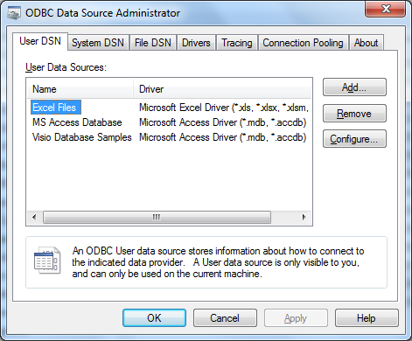

Start XAMPP Control Panel

Shell Commands

C:\xampp\mysql\

#mysql localhost paullin

phpMyAdmin application

* XAMPP for Windows, <http://localhost:5555/xampp/>
* <http://localhost:5555/phpmyadmin/#PMAURL-0:index.php?db=&table=&server=1&target=&token=aef40d721114d4e81fbd87840c66ff19>

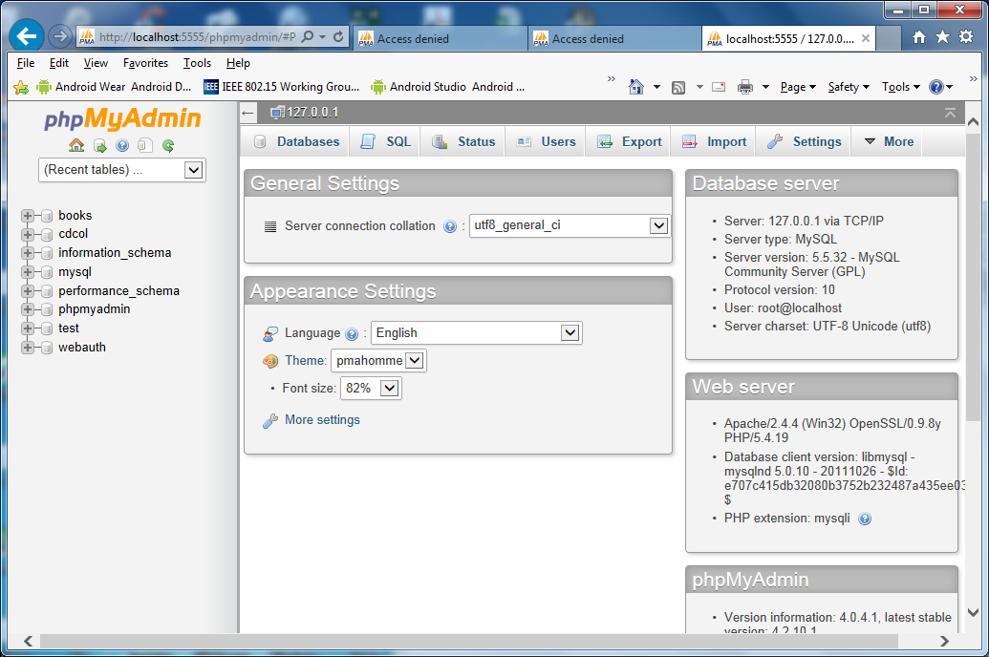

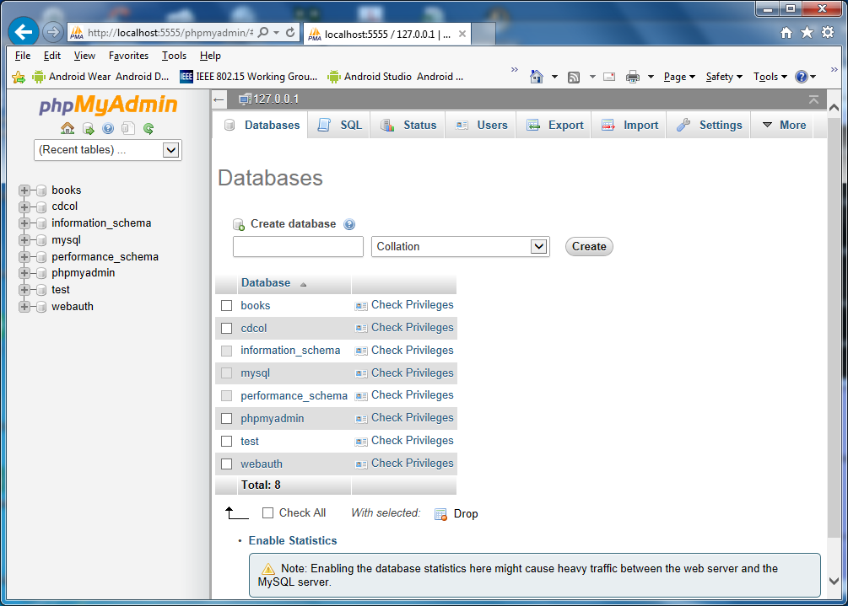

* Tools
  + phpMyAdmin, <http://localhost:5555/phpmyadmin/#PMAURL-0:index.php?db=&table=&server=1&target=&token=aef40d721114d4e81fbd87840c66ff19>
  + FileZilla FTP
  + Weblizer
  + Mail
* Databases
  + Book
  + Cdcol
  + Information_schema
  + Mysql
    - Edit privileges: User ‘root’@localhost’ Database table
    - Data: Select, Insert, Update, Delete, File
    - Structure
      * Create, Alter, Index, Drop, Create Temporary Tables
      * Show Views, Create Routine, Alter Routine
      * Execute, Create View, Event, Trigger
    - Administration
      * Grant, Super, process, Reload, Shutdown
      * Show Databases, Lock Tables
      * References
      * Replication Client, Replication Slave, Create User
    - Resource Limits: (Set to zero remove limits)
      * Max Queries per hour: 0
      * Max Updates per hour: 0
      * Max Connection per Hour: 0
      * Max User_Connection: 0
    - New: Add user
      * Login Information
        + User name: pilin
        + Host: Localhost
        + Password: Nopassword
  + Performance_schema
  + Phpmyadmin
  + Webauth

