**ITC 250/CPET 499 Web Systems**

**Lecture/Demo**

Oct. 9, 2014

1. After you successfully installed the XAMPP for Windows, the Welcome to XAMPP for Windows! is shown in Figure 1.

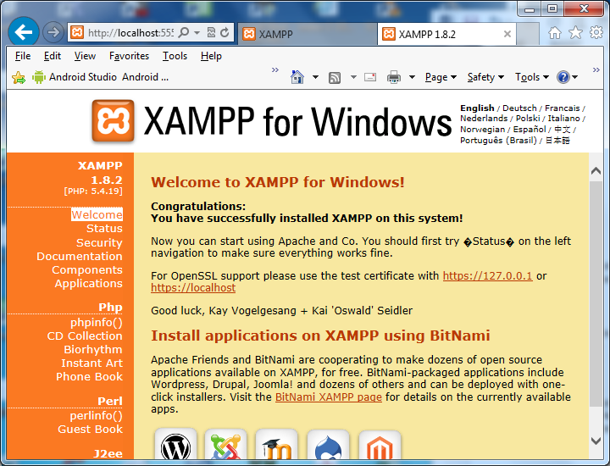

1. Examine the XAMPP installed folder
   * The home pages and other web document should be in the following folder
   * The first splash page is in the following director/folder
     + C:\xampp\htdocs\xampp\splash.php
   * Your home page is to be at this folder
2. Right click on “XAMPP Control Panel” icon, and chose “Run as Administrator” to ensure all XAMPP functionality are available
3. Start Apache Module and MySQL Module

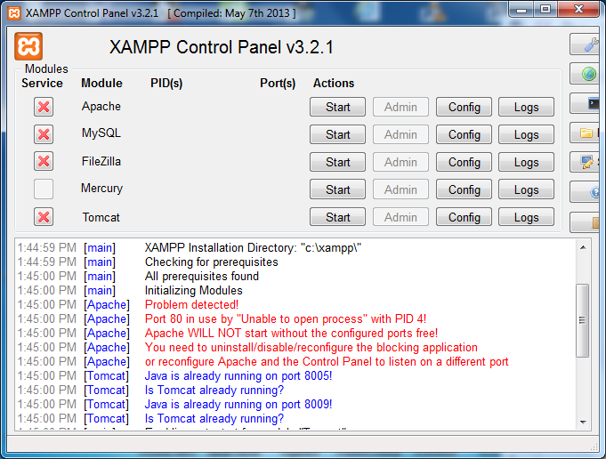

1. Looking for Red Color error messages such as the following and try to correct them either through “Config => Apache httpd.conf” etc
   * Examine httpd.conf Configuration file
   * ServerRoot “C:/xampp/apache”
   * Listen 12.34.56.78:80 => Listen 80
   * Listen 5555
   * ServerName localhost:80 => ServerName localhost:5555
2. Web pages
   * http://localhost:5555/xampp/index.php
   * http://localhost:5555/xampp/index-10092014.html