5. JavaScript Basics

5.1 An Introduction to JavaScript
- A Programming language for creating active user interface on Web pages
- JavaScript script is added in an HTML page, browser independent
- Add interactivity to Web pages and browser (dynamic, interactive)
- Provide instant feedback without CGI scripts and languages (client-side computing)

5.1.1 Integrating JavaScript and HTML
- Provide active user interface to browsers
- User input information validation (checking FORM data) without using complex server-side scripts
- Display alert boxes and accept user input
- Display custom message
- Support object controls: forms, forms, buttons, and check boxes
- Generate clocks, calendars, timestamps
- Redirect Web page
- Interact with a Java applet on a Web page
- Handle window events
- Check types of browsers
- Open new windows
- Manage frames

5.1.2 Object-Oriented JavaScript
- Object-Oriented Language
  - Methods (actions: subroutines, procedures, functions)
  - Properties (attributes: variables)

- Have states, behavior, and identity
- Instances of classes
- Examples of real-world objects:
- Person objects: Jack, Paul, Jim; age, owner, job; change_job()
- File object: file_name, size_in_bytes, last_up_date; print()
- Controller object: DCMotorController, ACMotorController, PLC
- Window, browser

Role of an object
Actor (active object), or
Server (never operates upon other object), or
Agent (both actor and server)

JavaScript Client-Side Object Hierarchy
The Current Window (main object)
- Various window objects: self, window, parent, top
- Navigator object: navigator
  - Array of plug-in objects (version 1.1): plugins[ ]
  - Array of MIME type objects(version 1.1): mimeTypes[ ]
- Arrays of Window objects: frame[ ]
- Location object: location
- History object: history
- Document object: document
  - Array of form objects: forms[ ]
    - Array of HTML form element objects: elements[ ]
      - Button
      - Checkbox
      - FileUpload (version 1.1)
      - Hidden
      - Password
      - Radio
      - Reset
      - Select
        - Array of option objects: options[ ]
      - Submit
      - Text
      - Textarea
  - Array of anchor objects; anchor[ ]
    - Examples:
    - document.anchors[n]
    - document.anchors.length
  - Array of link objects: links[ ]
  - Array of image objects (version 1.1): images[ ]
  - Array of applet objects (version 1.1): applets[ ]
    - Examples:
    - document.applets[n]
    - document.appletName
  - Array of embedded objects (version 1.1): embeds[ ]

5.1.3 Features of JavaScript
- Case sensitive
- White space
- Semicolons termination (optional)
- Comments
  - /* This is a comment. */
  - // This is a comment.
- Keywords are all lower case
- Identifiers: variables, functions and label names
- Variables: declared and optionally initialized, with the "var" element
- Function names must be typed with a consistent capitalization
- Data types:
  - Numbers
  - Booleans
  - Strings
  - Objects
  - Arrays
  - Function and methods
  - Null and undefined
- Operators (C/C++/Java style): math, assignment, relational
- Statements: a sequence of statements to form a program
  - Declaration: var, function
  - Expression statements: formed by combining literal values and variables
    - 10+2
    - (n1 + n2)/2
    - Name = "Hello World"
    - x = Math.sqrt(10);
    - y++
  - Compound statements
  - Empty statements
  - Label statements
  - Other statements
    - break
    - Decision making (if/else)
    - Control structure (break, continue, for, for/in, with, while, do/while, switch, case, default)
    - function, return
    - import, export
- Regular expressions support (matching and searching techniques defined in UNIX environment)

5.1.4 Language Rules

<SCRIPT> tag
Attributes:
LANGUAGE
Specifies the scripting language "JavaScript"

SRC
Gives the URL of an external script to be loaded and executed

ARCHIVE
Specifies the URL of a JAR file that contains the script specified by the SRC attributes

Where to place JavaScript Codes:
1. Place <SCRIPT> </SCRIPT> tags and code within <BODY> and </BODY> tags

2. Define JavaScript Functions and Variables within <HEAD> </HEAD> tags and invoke functions through event handler.
Functions
- Defining a function
- Calling a function

3. Include external JavaScript code for reusability

<HTML>
<SCRIPT language = "javascript" SRC = "src.js">
</SCRIPT>

<HTML>
<!-- firstjavacript.htm -->
<HEAD>
<TITLE> First JavaScript </TITLE>
</HEAD>
<BODY BGCOLOR=WHITE>
<H1>
<SCRIPT LANGUAGE=JAVASCRIPT TYPE="TEXT/JAVASCRIPT">

document.write("Hello, JavaScript")

</SCRIPT>
</H1>

</BODY>
</HTML>

Example 5-1: Say "Hello, World" using JavaScript code.

<HTML>
<!-- helloworld.html -->
<HEAD>
<TITLE>Hello World</TITLE>
</HEAD>
<BODY BGCOLOR=WHITE>
<H1>
<SCRIPT LANGUAGE=JAVASCRIPT TYPE="TEXT/JAVASCRIPT">
document.write("Hello, World!")
// C++ style comment
/* C style comment */
// Display a pop up window to alert the user
alert("Hello, World!")
</SCRIPT>
</H1>
</BODY>
</HTML>

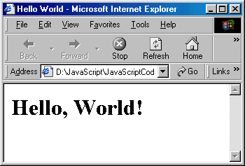

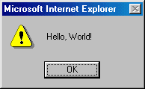

Example 5-2: Embed JavaScript in <A HREF> link.

<HTML>
<!-- redirect_link.html
Embed JavaScript in the HREF link tag
1. If the browser does not suppport JavaScript it loads
hello.html.html, otherwise, it loads helloworld.html which
use alert() function to display a pop up window.
2. if the browser support Javascript, the pop up window displays,
then close click "OK" to close the alert window, finally
it loads the hello.html.
-->
<HEAD>
<TITLE>Paul Lin -- New Site </TITLE>
</HEAD>
<BODY BGCOLOR=WHITE>
<H2 ALIGN=CENTER> <A HREF="hello.html" onClick="window.location='helloworld.html';
return false" > Click Here to Go to the New Site!</A></H2>
</BODY>
</HTML>

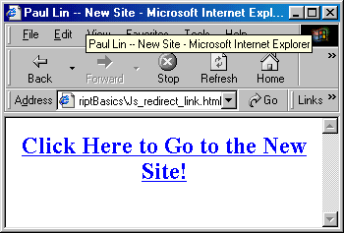

Example 5-3; Redirect the user to another site using JavaScript window.location() function.

<HTML>
<!-- redirect.html -->
<HEAD>
<TITLE>Redirection Using Javascript</TITLE>
<SCRIPT LANGUAGE="JAVASCRIPT1.2" TYPE="TEXT/JAVASCRIPT">
<!-- Hide script from old browsers
window.location = "http://www.ipfw.edu"
//window.location = "http://www.etcs.ipfw.edu/~lin"
//window.location = "http://www.microsoft.com"
//window.location="linhome.html"
// End hiding script from old browsers -->
</SCRIPT>
</HEAD>
<BODY BGCOLOR=WHITE>
<H2>Upgrade to require your Web Browser to have the latest version of JavaScript!</H2>
</BODY>
</HTML>


Example 5-4: Create and use JavaScript functions

<HTML>
<!-- Jsfunction.html -->
<HEAD>
<TITLE> Define JavaScript Functions </TITLE>
<SCRIPT LANGUAGE ="JavaScript">
function Greeting(){alert("Hello World!");}
function Say(message){alert(message)}:
</SCRIPT>
</HEAD>
<H1 ALIGN = "CENTER"> Define and Use JavaScript Function </H1>
<DIV ALIGN ="CENTER">
<FORM>
<INPUT TYPE="BUTTON" VALUE = "Click Here" onClick="Greeting()">
<INPUT TYPE="BUTTON" VALUE = "ECET" onClick="Say('Electrical and Computer Engineering Technology')">
</FORM>
</DIV>
<SCRIPT>
document.write("Last modified on: " + document.lastModified);
</SCRIPT>
</BODY>
</HTML>

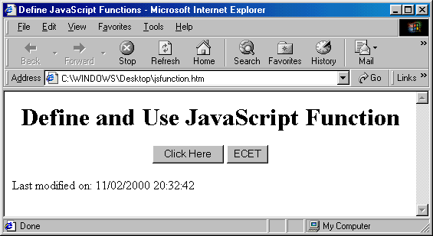

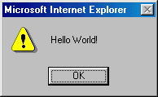

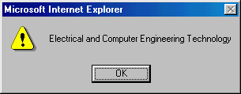

Include external JavaScript code for reusability

<HTML>
<SCRIPT language = "javascript" SRC = "src.js">
</SCRIPT>

<HEAD>
<SCRIPT> </SCRIPT>
</HEAD>

// Non-script Option:

<BODY>
<SCRIPT>
Statements
</SCRIPT>

<NOSCRIPT>
[JavaScript is not supported]
</BODY>

