5.2 JavaScript Keywords, Variables, and Operators

5.2.1 JavaScript Keywords

break case continue default delete
do else export false for
function if import in new
null return switch this true
typeof var void while with

Reserved Keywords for future extensions
catch class const debugger
enum extends finally super
throw try

5.2.2 Variables and Values
Value Types
Type Description Example
Number Any numeric value 10.145
String Character inside quotation marks "Web Prog"
Single quotes or double quotes 'testing'
Boolean True or False false
NULL Empty value
Objects Compound data types that contains methods and properties

Examples of Number
10
3.1416
0.003
6.20E3
0377 // Octal number; or 255 in decimal
0xFF // Hex number; or 255 in decimal

Examples of String
'ECET Dept'
"3.14
16"
'Name = "thisform"'

Variable Declaration
var n, m; // uninitialized
var x = 100, message = 'Hello you';

Escape Sequence
\b Backspace
\f Form feed
\n New line
\r Carriage return
\t Tab
\' Apostrophe or single quote
\" Double quote
\\ Back slash
\ddd Three octal digits (d: 0,1, through 7)
\xdd Two hexadecimal digits (d;0, 1,2,..,9, A,B,C,D,E,F)
\udddd Unicode encoding by four hex degits

Arrays
var n = new Array(); // Empty array
var b = new Array(20); // 20 elements
var k = new Array(1, 2, 3); // Initialized with three elements
JavaScript 1.2
var k = [1, 2, 3];
var anyobjet = [1, true, [1,2], {x:1, y:2}, "Hello"];

Null and Undefined
null - no value

5.2.3 Operators

Conditional Operator (? : )
Math.abs(x) or
x < 0? -x: x

typeof operator
Evaluate the type of object: "number", "string", or "boolean"

new operator
Creating new objects

delete operator
Delete existing objects

Arithmetic Operators
+ x + y Add and assign
+ x + y String concatenation
- x - y Subtraction
* x * y Multiplication
/ x / y Division
% x%y Modulus of x and y (remainder operation)
++ x++, ++x Increment
-- x--, --x Decrement
- -x Negate (change sign)

Bitwise Operators
& x & y bitwise AND; both x and y are unsigned integer
| x | y bitwise OR; both x and y are unsigned integer
^ x ^ y bitwise XOR; both x and y are unsigned integer
~ ~x bitwise NOT
<< x << 2 Shift left 2 bit (times 4)
>> x >> 2 Shift right 2 bit (div by 4)
>> x >> 2 Shift right zero fill (div 4)

Assignment Operators
= x = y Assignment, copy value
+= x += y Add and assign; x = x +y
-= x -= y Sub and assign; x = x -y
*= x *= y Multiply and assign; x = x * y
/= x /= y Divide and assign; x = x / y
%= x %= y Modulus and assign; x = x % y
<<= a <<= b a = a << b
>>= a >>= b a = a >> b
>>>= a >>>= b a >>>= b
&= a & b a = a & b
|= a |= b a = a | b
^= a ^= b a = a ^ b

Relational Operators
== x == y Equal to; return true if x and y are equal
!= x != y Not equal; return true if x and y are not equal
> x > y Greater than; return true if x is greater than y
>= x >= y Greater than or equal to ; return true if x is greater
than or equal to y
< x < y Less than; return true if x is less than y
<= x <= y Less than or equal to; return true if x is less than or
equal to y
&& x && y Logical AND; Return true if both x and y are true
|| x || y Logical OR; return true if either x or y is true
! !x Logical NOT; return true if x is false

Global Constant
Infinity
NaN - not a number
Global Functions
escape(s)
- Encode a string for transmission
unescape(s)
- Decode an escaped string
eval(code)
- Execute JavaScript code from a string
getClass(javaobj)
- Return JavaClass of a JavaObject
isFinite(n)
- Determine if a number is finite
isNaN(x)
- Determine if a number is defined
parseFloat(s)
- Convert a string to a floating poit number
parseInt(s, radix)
- Convert a string to an integer

Example 5-5: Declare and use JavaScript variables.

<HTML>
<!-- variable.htm
-->
<HEAD>
<TITLE>Example of Using Variables</TITLE>
<SCRIPT language=JavaScript>
var num1 = 10; // a number variable
var num2 = 212.00;// a float number
var lastName ="Lin"; // a string variable
var phoneNo ='481-6339'; // a string variable
var outOfJob = false; // a boolean variable

document.write("num1 = "+ num1 + "<BR>");
document.write("num2 = "+ num2 + "<BR>");
document.write("lastName = "+ lastName + "<BR>");
document.write("phoneNo = "+ phoneNo + "<BR>");
document.write("outOfJobn = "+ outOfJob + "<BR>");
</SCRIPT>

</HEAD>
<BODY>
</BODY>

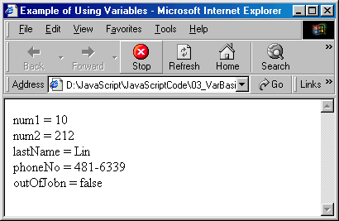

Example 5-6: Enter two numbers and make a comparison.

<html>
<!-- twonums.htm -->
<Head>
<Title>Comparing Two Numbers</title>
<Script Language="JavaScript">
<!--
var num1Str, num2Str; // Desine varaibels
var num1Int; //first integer value
var num2Int; //second integer value

//read first number from user as string
num1Str = window.prompt ("Enter first integer","0");
num1Int = parseInt(num1Str); //Convert string to integer

//read second number from user as string
num2Str = window.prompt ("Enter second integer","0");
num2Int = parseInt(num2Str); //Convert string to integer

document.writeln("<H1>"+ "First Numebr = " + num1Str +"</H1>");
document.writeln("<H1>"+ "Second Numebr = " + num2Str +"</H1>");
// Comparing two numbers
if (num1Int > num2Int)
document.writeln("<H1>"+ num1Str + " is larger</H1>");
if (num1Int < num2Int)
document.writeln("<H1>"+ num2Str+ " is larger</H1>");
if (num1Int == num2Int)
document.writeln("<H1>Two numbers are equal</H1>");
//-->
</Script>
</head>
<body>
<p>Click refresh (or reload) to run the script again</p>
</body>
</html>

Output:

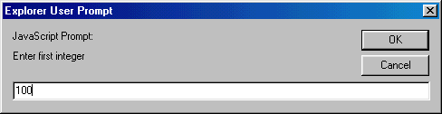

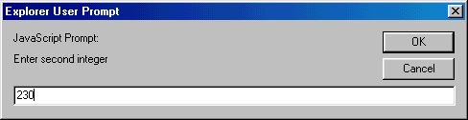

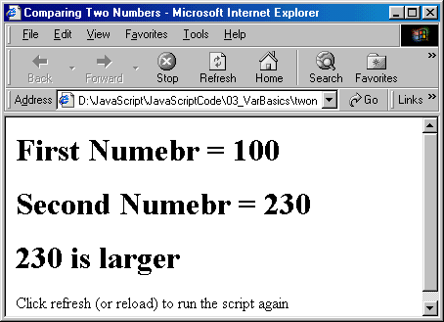

Example 5-7: Use while loop to generate a series of numbers and determine the even or odd number properties using decision making statement - if.

<HTML>
<!-- while_if.htm
-->
<HEAD>
<TITLE>Control: while, if, and continue</TITLE>
</HEAD>
<BODY>
<SCRIPT LANGUAGE="JavaScript">
<!--
var numVar = 0;

while (numVar < 7)
{
numVar = numVar + 1;
if ((numVar % 2)== 0 )
{
document.write("Number is even.<BR>");
continue;
}
document.write("The number is " + numVar + ".<BR>");
}
-->
</SCRIPT>
</BODY>
</HTML>

Output:

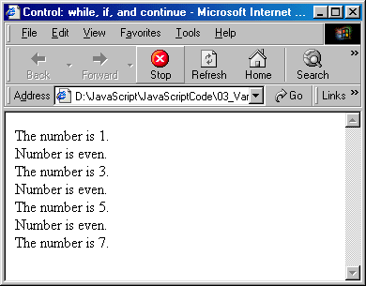

Example 5-8: Create a number table with four columns and 5 rows.

<html> <Head>
<!-- numtable.htm -->
<Title>Number Table</title>
<Script Language="JavaScript">
// Define variables
var num = 0; //num variable
var num10 = 0; //10* num
var num100 = 0; //100* num
var num1000 = 0; //1000*num
//create a table and print headings
document.writeln("<H2 ALIGN = 'center'>Number Table</H2>");
document.writeln("<Table border='1' ALIGN = 'center' width='60%'>");
document.writeln("<TR><TD><U>N</U></TD><TD><U>10*N</U></TD><TD><U>100*N</U></TD><TD><U>1000*N</U></TD></TR>");
num =1; //initialize number to its first value in the
while (num <=5)
{
num10 = 10 * num;
num100 = 100 * num;
num1000 = 1000 * num;
document.writeln("<TR><TD>"+ num + "</TD><TD>" + num10 + " </TD><TD>" + num100 + " </TD><TD>" + num1000 + "</TD></TR>");
//print entries
num++;
}
document.writeln("</TABLE>");
</Script> </head>
<body></body>
</html>

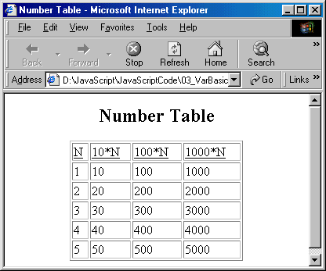

Example 5-9: Customer account and credit evaluation example.

<html>
<!-- account.htm -->
<head>

<title>Customer Account Info</title>

<Script Language="JavaScript">
// Define string variables
var acctNumber; //customer's account number
var balance;
var charge; // total of all items charged by this customer
// for this month
var credit; //total of all credits applied to this customer
var creditLimit;

//Define variables for holding numerical value
var valBalance; // balance as a Number
var valCharge;
var valCredit;
var valCreditLimit;

// Read inputs
acctNumber=window.prompt("Enter customers account number","0");
balance=window.prompt("Enter begining balance","0");
valBalance=parseInt(balance);
charge=window.prompt("Enter total charge amount for this customer","0");
valCharge=parseInt(charge);
credit=window.prompt("Enter total credit amount for this customer","0");
valCredit=parseInt(credit);
creditLimit=window.prompt("Enter total credit limit for this customer","0");
valCreditLimit=parseInt(creditLimit);
valBalance += (valCharge - valCredit);

document.writeln("<H1>New balance for customer # " + acctNumber+ " = $"
+ valBalance + "</H1>");

if (valBalance > valCreditLimit)
document.writeln("<H1>Credit Limit Exceeded</H1>");
</script>
</head>
<body>
<p>Click Refresh (or Reload) to run the script again</p>
</body>
</html>

