5.3 JavaScript Functions

5.3.1 Defining Functions
- For creating reusable modules
- Creating function
  - Function constructor
  - Input Arguments
  - return value
- Function call
  - Call by value
  - Call by reference
  - Recursive function - a function calls itself
- Examples of functions:

function multiplyf(x, y) { return x*y; }

// Using Function Object
var multiply = new Function("x", "y", "return x* y");

function add(x, y) { return x + y; }
function sub(x, y) { return x - y; }
function mul(x, y) { return x * y; }
function div(x, y) { return x / y; }

5.3.2 Anchor and Link
- Can be used with event handler to to invoke JavaScript functions

<A HREF="javascript:void(0)" onClick="someF1()">HERE</A> An example of onClick event handler.<BR>
<A HREF="javascript:void(0)" onDblClick="fsomeF2()">HERE</A> An example of DblClick event handler.<BR>

<A HREF="javascript:void(0)"
onMouseOver="return someF3( )"
onMouseDown="return someF4( )"
onMouseUp="return someF5( )"
onMouseOut="return someF6( )"
>
<IMG NAME="ImgName" SRC="somePic.gif" HEIGHT=16 WIDTH=16 BORDER=0></A>
Example 5-10: An average function that accepts three numbers, calculate the average of three numbers and return the computed average value.

<HTML>
<HEAD>
<TITLE>Functions</TITLE>
<SCRIPT LANGUAGE="JavaScript">
<!--
function averageAge(age1, age2, age3)
{
var totalAge;

totalAge = age1 + age2 + age3;
return (totalAge / 3);
}
-->
</SCRIPT>
</HEAD>
<BODY>
<SCRIPT LANGUAGE="JavaScript">
<!--
var result; // define a variable
// Call averageAge() function and receive
// a return value for "result" variable
result = averageAge(25, 26, 22);

document.write("The avearge of (25, 26, 22) is " + result +
"." + "<BR>");
-->
</SCRIPT>
</BODY>
</HTML>

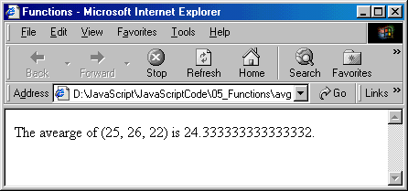

Example 5-11: An average function that can accept N different, calculate the average of the N numbers and return the computed average value.

<HTML>
<!-- avg_x.htm -->
<HEAD>
<TITLE>Function With Variable Number of Parameters</TITLE>
<SCRIPT LANGUAGE="JavaScript">
<!--
function averageAge(ages)
{
var totalAge = 0;
var thisArguments = averageAge.arguments;

for ( var i = 0; i < thisArguments.length; i++)
totalAge += averageAge.arguments[i];
return (totalAge / thisArguments.length);
}
-->
</SCRIPT>
</HEAD>
<BODY>
<SCRIPT LANGUAGE="JavaScript">
<!--
document.write("The average age is " + averageAge(22, 25, 26) , ".");
-->
</SCRIPT>
</BODY>
</HTML>

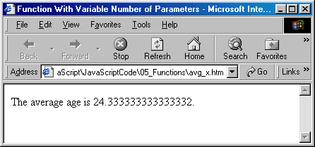

Example 5-12: Create a print function for reuse.

<HTML>
<!-- print_name1.htm -->
<HEAD>
<TITLE>Functions</TITLE>
<SCRIPT LANGUAGE="JavaScript">
<!--
function printCityName(Name)
{
document.write("<BR>", Name, "<BR>");
document.write("<HR>");
}
-->
</SCRIPT>
</HEAD>
<BODY>
<SCRIPT LANGUAGE="JavaScript">
<!--
printCityName("Boston, MA")
printCityName("Fort Wayne, IN")
printCityName("New York City, NY")
printCityName("Washington, D.C.");
-->
</SCRIPT>
</BODY>
</HTML>

