5.4 JavaScript Objects and Methods

JavaScript Objects and Properties
- Aggregate real world data types
- An object has properties and methods
  - Constructors for creating objects at run time
  - Accessing object properties
  - Accessing object methods

5.4.1 JavaScript Predefined Objects
images
arrays
strings
functions
documents
forms
frames
image
image.width
image.height

document.thisform.button

Creating Objects
var obj = new Object();
var today = new Date();
var point = new Object();
point.x = 10;
point.y = -10;
var rectangle = {upperLeftPoint: {x:1, y:1},
lowerRightPoint: {x:4, y:4}};

Global objects
- Object Object
- Navigator object
- Number object
- String object
- Screen object
- event object
- Event object
- RegExp object – pattern matching in strings

Object
- A primitive JavaScript object type
- The constructor -- Object()
- Methods:
eval() … JavaScript 1.1, 1.2
toString() … JavaScript 1.1, 1.2
valueOf () … JavaScript 1.1, 1.2
handleEvent() … JavaScript 1.2
watch() … JavaScript 1.2
unwatch() … JavaScript 1.2

Navigator Object
- Getting the name of the Browser Language
- Getting the Name of the Platform
- Methods
preference()
- Properties
navigator.appCodeName
navigator.appName
navigator.appVersion
navigator.language
navigator.platform
navigator.userAgent

5.4.2 Number Object

- Implemented in the JavaScript 1.1 release (Navigator 3.0) and fix some minor things in JavaScript 1.2
- Properties
  - MAX_VALUE
  - MIN_VALUE
  - NaN
  - NEGATIVE_INFINITY
  - POSITIVE_INFINITY
  - prototype
- Methods
  - toString()
  - toString(radix))

5.4.3 document object
- Browser's document object
- Referencing to documnet object:
  - window.document
  - document
- It represents the HTML document currently displayed in the browser
- Has methods or functions
  - document.close() // Close an output stream
  - document.open(mimetype) // Begin a new document
  - write(value, ...) // Append data to a document
  - writeln(value, ...) // Append data and a new line to a document
- Has attributes, properties, or variables
  - document.bgColor // The document background color
  - document.alinkColor // The color of active links
  - document.vlinkColor // The color of visited links
  - document.linkColor // The color of unfollowed links
  - document.lastModified // The modification date of a document
  - document.URL // The URL of the current document
  - document.referer // The URL of the linked-from document
  - document.title // The title of the current document
  - document.cookie
  - document.fgColor // the default text color
  - document.form[ ]
  - document.images[ ]
- Pass argument to a method within the pair of parentheses

document.write()
- write() method
- No new line character is issued
- Examples:
  - document.write("FONT COLOR = 'red'><H1>ECET ")
  - document.write("string for display")
  - document.write("<B>Hello World! </B><BR>")
  - document.write("<B>Hello World! </B>\r")
  - document.writeln("<B>Hello World!</B>")

document.writeln()
- writeln() method for writing text
- A new line character is added
- Examples
  - document.writeln(" Department Welcomes You!</H1></FONT>")

The document object

Synopsis
window.document
document

Properties

alinkColor
The color of activated links.

bgColor
The document background color

fgColor
The default text color.

linkColor
The color of unfollowed links.

vlinkColor
The color of visited links.

lastModifies
The modification date of a document.

location
The URL of the current document.

title
The title of the document.

URL
The Uniform Resource Locator of the current document.

referrer
The URL of the linked-from document.

cookie
The cookie(s) of the document.

domain
The security domain of the document

form[ ]
The forms in a document

images[ ]
The images embedded in a document.

link[ ]
The link objects in a document

anchors[ ]
The Anchors array in a document.

applets[ ]
The applet array in a document.

plugins[ ]
The object embed in a document.

embeds[ ]
The objects embedded in a document.

Navigator 4 and above Properties
classes
Define style classes.

height
The height of a document.

width
The width of a document.

ids
Define styles for individual tags.

layers
The layers contained in a document

tags
Define styles for HTML tags

Internet Explorer 4 and above Properties

activeElement
The input element that has the focus.

charset
The character set in use.

defaultCharset
The default character set of a document

expando
Disallow new property creation.

parentWindow
The window of a document

readyState
The loading status of a document.

all[]
All HTML elements in a document.

Methods

close()
Close an output stream.

open(mimitype)
Create a new document

write(datavalue,..)
Append data to a document.

writeln(datavalue)
Append a document and a new line to a document.

Methods for Netscape 4 and above

captureEvents(eventmask)
Specify the event types to be captures

releaseEvents(eventmask)
Stop capturing events

routeEvents(event)
Pass a captured event to the next handler

getSelection()
Return selected text

Methods for IE 4 and above

elementFromPoint(x, y)
Determine which HTML element is at a given point.

Example 5-13: Change background color properties through document object.

<HTML>
<!-- bgolor.htm
-->
<HEAD>
<TITLE>Back Ground Color</TITLE></HEAD>
<BODY>
<H1>Click Button to Change Back Ground Color</H1>
<FORM>
<P>
<INPUT TYPE="BUTTON" NAME="blcak" VALUE="Black00" ONCLICK='document.bgColor="black"'>
<INPUT TYPE="BUTTON" NAME="brown" VALUE="Brown01" ONCLICK='document.bgColor="brown"'>
<INPUT TYPE="BUTTON" NAME="red" VALUE="Red0002" ONCLICK='document.bgColor="red"'>
<INPUT TYPE="BUTTON" NAME="orange" VALUE="Orange3" ONCLICK='document.bgColor="orange"'>
</P>
<P>
<INPUT TYPE="BUTTON" NAME="yellow" VALUE="Yellow4" ONCLICK='document.bgColor="yellow"'>
<INPUT TYPE="BUTTON" NAME="green" VALUE="Green05" ONCLICK='document.bgColor="green"'>
<INPUT TYPE="BUTTON" NAME="blue" VALUE="Blue006" ONCLICK='document.bgColor="blue"'>
<INPUT TYPE="BUTTON" NAME="violet" VALUE="Violet7" ONCLICK='document.bgColor="violet"'>
</P>
<P>
<INPUT TYPE="BUTTON" NAME="gray" VALUE="Gray008" ONCLICK='document.bgColor="gray"'>
<INPUT TYPE="BUTTON" NAME="white" VALUE="White09" ONCLICK='document.bgColor="white"'>
<INPUT TYPE="BUTTON" NAME="gold" VALUE="Gold" ONCLICK='document.bgColor="gold"'>
<INPUT TYPE="BUTTON" NAME="silver" VALUE="Silver" ONCLICK='document.bgColor="silver"'>
</P>
</FORM>
</BODY>
</HTML>

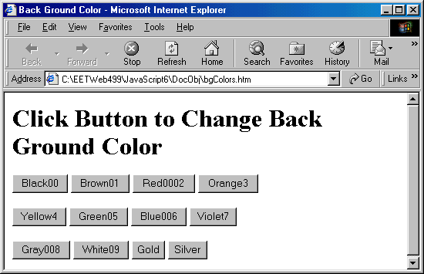
5.4.4 Window Objects

Basic Window Operations
- Opening a window
- Scrolling a window
- Loading a content into a window
- Updating one window from another
- Creating new pages with JavaScript
- Closing a window
- Creating a control panel
- Positioning a window on the screen
- Displaying an alert when a window is loaded

Properties and Methods of the window() object
- Create another new window outside the browser
- Referencing to a window
  - self
  - window
  - window.frame[n]
- window properties
  - self // the window itself
  - window // the window itself
  - window.document // document of the window
  - window.name // name of the window
  - window.location // URL of the window
  - window.status // specify a line of status message
  - window.history // the history of the window
  - window.length // the number of frames in the window
  - window.screen // information about the screen
  - window.frames[] // List of frames within a window
- window methods
  - alert(message) // Display message through dialog box
  - prompt(message, defaultValue) // Receive input through dialog box
  - confirm(question) // Ask to confirm a yes-no question
  - close() // close a browser window
  - open(url, name,features,replace) // open a new window
  - setInterval(code, interval) // Repeatedly execute the code at a specific time interval
  - setTimeout(code, delay) // Defer execution of code
- window event handlers
  - onblur // invoked when the window loses keyboard focus
  - ondragdrop // invoked when the user drops items in the window
  - onerror // invoked when Javascript
  - onfocus // invoked when window is given a focus
  - onload // invoked when browser completed the loading
  - onmove // invoked when window is moved
  - onresize // invoked when window is resized
  - onunload // invoked when the browser leaves a page

window.alert()
- alert() method for creating a dialog box
- OK button
- window.alert("Thank you!\nTry Again!")

window.prompt()
- prompt() is a dialog control
- Examples:
  - firstNum = window.prompt("Enter the first integer number", "0");
  - secondNum = window.prompt("Enter the second integer number", "0");
window.open()
- open a new window
newWindow1 = window.open(URL, "nameOfWindow", "toolbar=no, width=350, height=400, status=no, scrollbar=yes, resize=no, menubar=no");

newWindow2 = window.open('bulbon.gif', 'bulbWin', 'wdith=330, height=250, scrollbars=yes')

newWindow3 = window.open('book.html', 'bookWin', 'wdith=330, height=250, scrollbars=yes')

window.confirm()
- Display a message in a dialog box
- Click "OK" button to return a true value
- Click "Cancel" button to return a false value
- confirm("message")

A basic window creation example

<HTML>
<!-- newwin1.htm -->
<HEAD>
<TITLE>Open a New Window </TITLE>
</HEAD>

<BODY>
<SCRIPT LANGUAGE="Javascript">
window.open(URL, "thisWindow", "toolbar=no, width=350, height=400, status=n0, scrollbras=yes, resize=no, menubar=no")
</SCRIPT>
</BODY>
</HTML>

Example 5-14: Create a new window for displaying a animated airplane.gif graphics file.

HTML>
<!-- newplane.htm -->
<HEAD>
<TITLE>Open a New Window </TITLE>
<SCRIPT LANGUAGE="Javascript">
window.open("airplane.gif", "SUNWindow", "toolbar=no, width=350, height=400, status=n0, scrollbras=yes, resize=no, menubar=no")
</SCRIPT>
</HEAD>
<BODY>
</BODY>
</HTML>

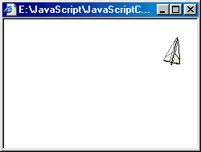

Example 5-15: Create a new window for showing web camera. The newly window will stay open even if the browser is closed.

<HTML>
<!-- newlivecam.htm -->
<HEAD>
<TITLE>Open a New Window </TITLE>
<SCRIPT LANGUAGE="Javascript">
// window.open("http://149.164.36.19", "LiveCam", "toolbar=no, width=780, height=600, status=yes, scrollbras=yes, resize=yes, menubar=yes")
//window.open("http://149.164.36.19", "LiveCam", "width=320, height=240")
window.open("http://149.164.36.19", "LiveCam", "width=480, height=330")
</SCRIPT>
</HEAD>
<BODY>
</BODY>
</HTML>

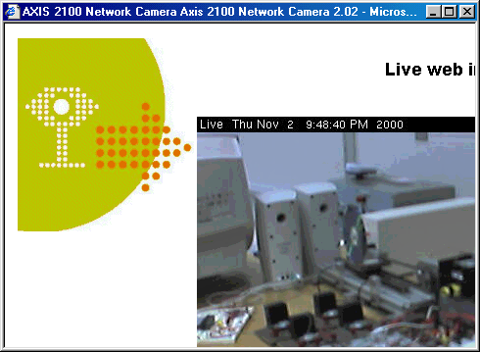

Example 5-16: Create a new window for Web camera, and close the newly created window. Javascript with functions are considered in the program.

<HTML>
<!-- Webcam.htm -->
<HEAD>
<TITLE>Open a New Window </TITLE>
<SCRIPT LANGUAGE="Javascript">
function webCamera(URL){
newWindow = window.open(URL, "LiveCam", "toolbar=no, width=780, height=600, status=n0, scrollbras=yes, resize=no, menubar=no")
}
function closeWindow() {if(newWindow && !newWindow.closed) newWindow.close(); }
</SCRIPT>
</HEAD>
<BODY>
<H3> <A HREF="javascript:webCamera('http://149.164.36.19')"> Click Here To See WebCam <A>&nbsp; &nbsp; <BR> <BR>
<A HREF="javascript:closeWindow()"> Close the Window <A>
</H3>
</BODY>
</HTML>

