5. Advanced JavaScript Programming

5.5 JavaScript Forms and Events

A form can contain most of GUI elements including
- Text entry fields
  - For entering names, street address, zip
  - For entering comments
  - Email address
- Password fields
  - For entering password and PIN numbers
- Radio buttons
  - Allowing user pick one (and only one) choice within a group of options
  - Selecting preferred color option: red, blue, green, etc
  - Example: two-door or four-door car
- Submit button
- Reset button
- Check boxes
- Pop-up menus
  - Select-and-go menu for long list of choices such as States
- Entry lists

Activities:
- A user fills the given form
- Client side form validation (faster and efficient)
  - Verifying passwords
  - Verifying zip codes
  - Validating Email addresses
  - Verifying empty fields
- Click the "Submit" button to send the form to the Web server
- CGI program interprets the data and acts on it
- Send back a thank you note to the user

Button
<INPUT TYPE=button>
Event handler: onClick

Examples:

Make a button with a name called "gray", when clicked, it changes the back ground color to white:
<FORM>
<INPUT TYPE = "Button" VALUE = "Gray" onClick ="document.bgColor='gray' ">
</FORM>
Checkbox
<INPUT TYPE=checkbox>
Event handler: onClick

FileUpload
<INPUT TYPE=file>
Event handler: onChange

Hidden
<INPUT TYPE=hidden>
A nonvisual data field
Event handler: none

Option
<OPTION>

Password (for sensitive data)
<INPUT TYPE=password>
Event handler: onChange

Radio
<INPUT TYPE=radio>
Event handler: onClick

Reset (a button for resetting the form)
<INPUT TYPE=reset>
Event handler: onClick

Select (a drop-down menu for selecting Option items)
<SELECT [multiple]> .. </SELECT>
Event handler: onChange
Submit (a button for submitting a form)
<INPUT TYPE=submit>
Event handler: onClick

Text (creating a single line of text)
<INPUT TYPE=text>
Event handler: onChange

TextArea (creating a multilane text entry field)
<INPUT TYPE=textarea>
Event handler: onChange

Events and Event Handlers
onAbort
- User aboard the page loading
- Image (JavaScript 1.1)

OnFocus, onBlur
- Text elements
- User left the object

onChange
- Select, text input elements
- User changed the object

onClick
- Button elements, Link
- User clicked the object
- Examples
Create a button, name it SubmitText, display Submit on the top of the button; when clicked, it calls SendText() function:
<INPUT TYPE = "Button" NAME="SubmitText" VALUE="Submit" onClick="SendText()">

onDblClick
- Document, Link, Image, Button elements
- User double clicked the object

onError
- Image, Window (1.1)
- The script encounter an error

OnKeyDown, onKeyPress, onKeyUp
- Document, Image, Link, text elements
- Key board related

onLoad, onUnload
- The object is loaded; the user left the window
- Window; Image
- Examples
Load and run the timeTest() function when the browser is loaded:
<BODY bgColor = "white" onload = "timeTest()">

onMouseDown, onMouseUp
- Document, Link, Image, Button elements

onMouseover, onMouseout
- Link; Image and Layer
- The mouse moved over the object; the mouse moved off an object

onReset, onSubmit
- Form reset; form submission
- Triggered onreset; onsubmit event when the button is clicked

onSelect - The user selected the contents of an object

onSubmit - The user submit a form

Example 5-5-1: A simple text field input form.

<HTML>
<!-- form_object.htm -->
<HEAD>
<TITLE>Javascript and Form Object Data Type</TITLE>
<BODY>
Enter text or number.
<FORM name=Form1>
<INPUT name=textT1 value= ****>
<SCRIPT language=JavaScript>
// Document objecthas many forms:
// form[0], form[1], form[2],..
// - the form[0] is the first form.
// - the form[0] is also the same object as "Form1"
//
// Elements included in the Form1 are:
// INPUT element0 -- textfiled called "textT1"
// INPUT element1 -- button

formObj =document.forms[0].elements[0]

</SCRIPT>
<!--
<INPUT onclick=alert(formObj.value) TYPE = "button" value="Click Me to Display"
-->
<INPUT onclick=alert(document.Form1.textT1.value) TYPE = "button" value="Click Me to Display"
</FORM>
</BODY>
</HTML>

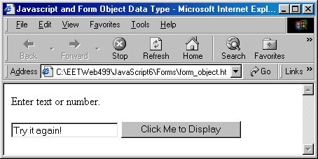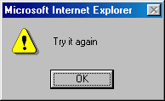

Example 5-5-2: Create a check box with validation.

<HEAD>
<!-- checkbox.htm -->
<TITLE>Checkbox and Validation</TITLE>
<SCRIPT LANGUAGE="JavaScript">
function checkThisBox(form) {
if (form.checkbox1.checked) {
alert("This box is checked.")
} else {
alert("The box is not checked.")
}
}
</SCRIPT>
</HEAD>
<BODY>
<FORM>
<INPUT TYPE="checkbox" NAME="checkbox1">Check here<P>
<INPUT TYPE="button" NAME="button1" VALUE="Click to validate"
onClick="checkThisBox(this.form)">
</FORM>
</BODY>
</HTML>

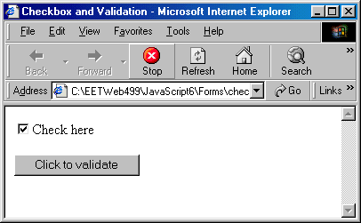

Example 5-5-3: Upload a file to server.

<HTML>
<!-- fileupload.html -->
<HEAD>
<TITLE>Form for Upload File</TITLE>
<SCRIPT LANGUAGE="JavaScript">

function closeWindow()
{
window.close()
}

</SCRIPT>
</HEAD>
<BODY>
<FONT FACE="Arial" SIZE="-1"><H2>Upload A File</H2></FONT>
<FORM METHOD="POST" ACTION="/cgi-bin/thisUPLOAD.CGI" ENCTYPE="multipart/form-data">
<TABLE>
<TR>
<TD>File to upload</TD>
<TD><INPUT TYPE="file" SIZE="20" NAME="upfile"></TD>
</TR>
<TR>
<TD COLSPAN="2" ALIGN="CENTER"><INPUT TYPE="submit" VALUE="Upload Now"></TD>
</TR>
</TABLE>
</FORM>
<FORM><INPUT TYPE="button" VALUE = "Close Window" onClick = "closeWindow()"></FORM>
</BODY>
</HTML>

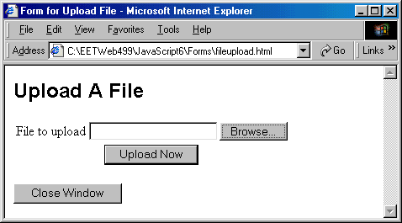

Example 5-5-4: Use option control and function.

<HEAD>
<!-- option.htm -->
<TITLE>Select A Option and Go</TITLE>
<SCRIPT LANGUAGE=JAVASCRIPT TYPE="TEXT/JAVASCRIPT">
function goPage(newLoc)
{
newPage = newLoc.options[newLoc.selectedIndex].value
if (newPage != "")
{
window.location.href = newPage
}
}
</SCRIPT>
</HEAD>
<BODY BGCOLOR=WHITE>
<DIV ALIGN=CENTER>
<!--
<FORM ACTION="goLocation.cgi" METHOD=GET>
-->
<FORM>
<SELECT NAME="newLocation" onChange="goPage(this.form.newLocation)">
<OPTION VALUE="" SELECTED>Select a topic
<OPTION VALUE="checkbox.htm">Check Box example
</SELECT>
<NOSCRIPT>
<INPUT TYPE=SUBMIT VALUE="Go There!">
</NOSCRIPT>
</FORM>
</DIV>
</BODY>
</HTML>

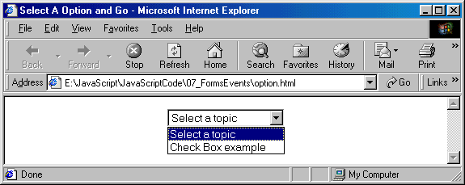

Example 5-5-5: An example shows how to tie together the button and events: onload, onclick, and onmouseover.

<HTML>
<!-- button_mouse.htm -->
<HEAD>
<TITLE>Button and Mouse Event</TITLE>
</HEAD>
<BODY onload="alert('PAGE loaded!')">
<FORM>
<INPUT TYPE="button"
VALUE="Click Here"
onclick="alert('You clicked the button.')"
onmouseover="alert('Your mouse is over the button.')">
</FORM>
</BODY>
</HTML>

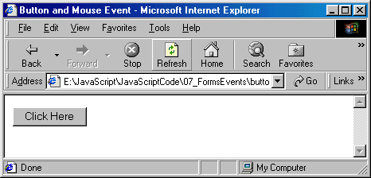

Example 5-5-6: An example shows how to call functions through the button controls and events.

<HTML>
<!-- butmsgs.htm -->
<HEAD>
<TITLE>Buttons, Event, and Messages</TITLE>
<SCRIPT LANGUAGE="JavaScript">
function changeDsp(newTarget,Text){
newTarget.value=Text
alert(Text)
}
</SCRIPT>
</HEAD>
<BODY>
<FORM>
<INPUT TYPE="button" VALUE="Button1" onclick="changeDsp(this,'ONE')"><BR>
<INPUT TYPE="button" VALUE="Button2" onclick="changeDsp(this,'TWO')"><BR>
</FORM>
</BODY>
</HTML>

Before Click on Button1 and Button2:
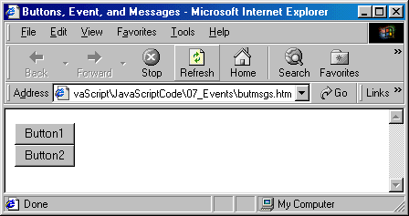

After Click on Button1 and Button2:

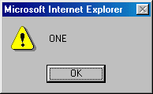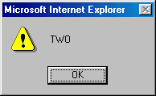

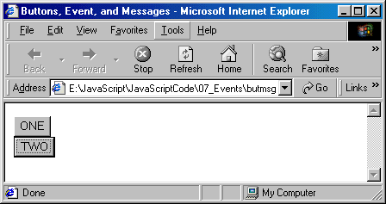

Example 5-5-7: An example that uses input button, text filed of a form, window functions prompt(), and confirm().

<HTML>
<!-- button_alert.htm -->
<HEAD>
<TITLE>Buttons and Alert Dialog Box</TITLE>
</HEAD>
<BODY>
<FORM NAME="new_form">
<INPUT TYPE="button"
VALUE="Academic Dept."
onclick="alert('Electrical and Computer Engineering Technology Department')">
<P>
<INPUT TYPE="button"
VALUE="Your Name?"
onclick="document.new_form.new_text.value=prompt('Type your name','Here')">
<INPUT TYPE="Text"
NAME="new_text"
SIZE="50"
VALUE="Try each button, starting with Academic Dept.">
<P>
<INPUT TYPE="button"
VALUE="Confirm"
onclick="if(confirm('Click OK')){alert('Thank you.')}
else{alert('CLICK OK!!!')}">
</FORM>
</BODY>
</HTML>

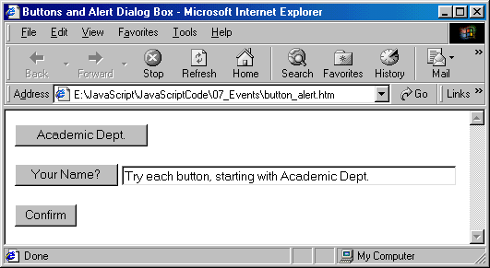

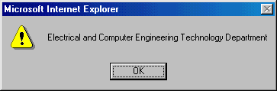

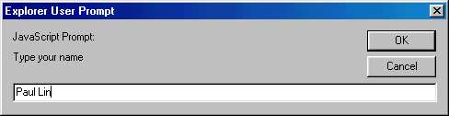

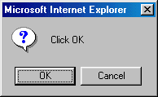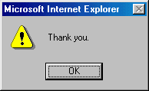

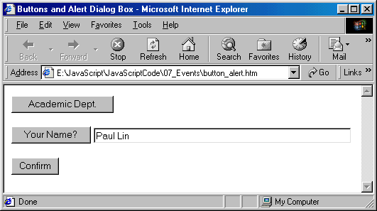

Example 5-5-8: An example that uses buttons to activate events for reading messages.

<!-- ButClick.html-->
<HTML>
<HEAD>
<TITLE>Function passing</TITLE>
<SCRIPT LANGUAGE=JAVASCRIPT TYPE="TEXT/JAVASCRIPT">
<!-- Hide script from older browsers

function docDisplay(message) {
alert(message)
}

// End hiding script from older browsers -->
</SCRIPT>
</HEAD>
<BODY BGCOLOR=GREEN>
<H2>Click Buttom to Activate Event</H2>
<HR>
<FORM>
<INPUT TYPE=BUTTON VALUE="ReadMsg1" onClick="docDisplay('Thank You')">
<INPUT TYPE=BUTTON VALUE="ReadMSg2" onClick="docDisplay('Too Bad')">
<INPUT TYPE=BUTTON VALUE="ReadMsg3" onClick="docDisplay('Are you OK?')">

</FORM>
</BODY>
</HTML>
