6.3 Dynamic Pages with Date and Time

Activities of A dynamic page
- Display current date on a Web page
- Validate the system day is correct
- Customizing the message to reflect the time of day: Good morning, Good afternoon, Good evening
- Time conversion
- Tell how much time left before a special event

Create a new Date object:
Syntax:
dateObj = new Date(arguments); or
dateObj = new Date(yr, mth, dy, hrs: mins;secs); or
dateObj= new Date("mth, dy, yr, hrs: mins;secs)
Examples:
dateObj = new Date("October 8, 2000, 10:00:00")
Today = new Date(2000, 10, 8, 10:00:00")
now = new Date(2000, 10, 8, 10:00:00")

Methods
dateObj.getYear() // return year minus 1900
dateObj.getMonth() // return month from 0-11
dateObj.getDay() // return day of week from Sunday (0)- Saturday(6)
dateObj.getDate() // return date in month from 1-31
dateObj.getTime() // return milliseconds since Jan. 1, 1970 00:00:00
dateObj.getHours() // return hour of day in military time from 0 to 23
dateObj.getMinutes()// return minutes of hour from 0-59
dateObj.getSeconds()// return seconds of minute from 0-59
dateObj.setYear() // set year minus 1900
dateObj.setMonth() // set month from 0-11
dateObj.setDay() // set day of week from Sunday (0)- Saturday(6)
dateObj.setDate() // set date in month from 1-31
dateObj.setTime() // set milliseconds since Jan. 1, 1970 00:00:00
dateObj.setHours() // set hour of day in military time from 0 to 23
dateObj.setMinutes()// set minutes of hour from 0-59
dateObj.setSeconds()// set seconds of minute from 0-59

Day and Month Arrays

dayOfWeeks = new Array("Sunday", "Monday", "Tuesday", "Wednesday", "Thursday", "Friday", "Saturday")

monthOfYear = new Array("January", "February", "March", "April", "May", "June", "July", "August", "September", "October", "November", "December")

Check if the day is valid:

If (now.getDay() > 0 && now.getDay() < 6)
{
// it is a valid day
}

Customizing the message to reflect the time of day: Good morning, Good afternoon, Good evening!

If (now.getHour() < 5)
{
// this is before 5 AM, Early birds?
}

If (now.getHour() > 23 )
{
// this is after 11 PM, Burning mid-night oil?
}

Example 6-9: This JavaScript check to see if it is week day or weekend day.

<HTML>
<!-- checkweekend.html -->
<HEAD>
<TITLE>Check and Display Weekend or Week Day</TITLE>
</HEAD>
<BODY>
<H1>
<SCRIPT LANGUAGE=JAVASCRIPT>
thisDate = new Date

if (thisDate.getDay() > 0 && thisDay.getDay() < 6) {
document.write("Too Bad, Week Day :-(")
}
else {
document.write("Excellent, Weekend Day :-)")
}

// End hiding script from old browsers -->
</SCRIPT>
</H1>
</BODY>
</HTML>

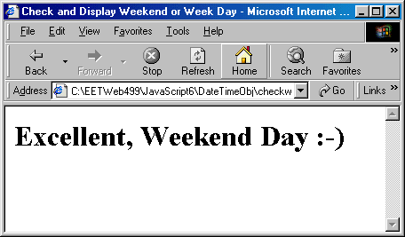
Example 6-10: A JavaScript program that display date and year in a friendly format.

<HTML>
<!-- friendlydate.html -->
<HEAD>
<TITLE>Date Display</TITLE>
<SCRIPT LANGUAGE=JAVASCRIPT>
dayNameArray = new Array ("Sunday","Monday","Tuesday",
"Wednesday","Thursday","Friday","Saturday")
monNameArray = new Array ("January", "February", "March",
"April", "May", "June", "July", "August",
"September", "October", "November", "December")
thisDate = new Date;

</SCRIPT>
</HEAD>
<BODY>
<SCRIPT LANGUAGE=JAVASCRIPT>
var thisYear = thisDate.getYear();
if (thisYear < 100) thisYear += 1900;

document.write("<H1>Today is " +
dayNameArray[thisDate.getDay()] +
", " + monNameArray[thisDate.getMonth()] +
" " + thisDate.getDate() + ", " + thisYear + ".<\/H1>")

</SCRIPT>
</BODY>
</HTML>

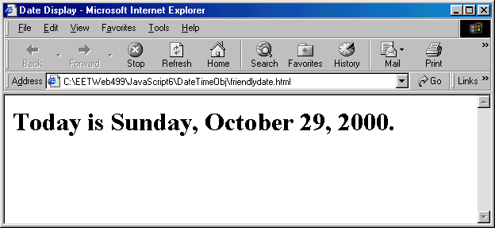

Example 6-11: This JavaScript program displays clock, system time and date, and universal time and date.

<HTML>
<!-- clock.html -->
<HEAD>
<TITLE>JavaScript Clock Example</TITLE>
<SCRIPT LANGUAGE=JAVASCRIPT>

var sysTimeFormat;

function showClock()
{
var ampmStr, clockDspStr, secStr;
var minStr, hourStr;
var second, minutes, hours;
clkTime = new Date;

hours = clkTime.getHours();
minutes = clkTime.getMinutes();
seconds = clkTime.getSeconds();

if (document.clockForm.hours24[0].checked)
{
ampmStr = "";
hourStr = hours;
}
else
{
if(hours == 0) hourStr = 12;

if(hours > 0 && hours < 13)
hourStr = hours;
else
hourStr = hours - 12;

if (hours < 12) ampmStr =" AM";
if (hours > 12) ampmStr =" PM";
}

if (minutes > 9)
minStr = ":" + minutes;
else minStr = ":0"+ minutes;

if (seconds > 9)
secStr = ":" + seconds;
else secStr = ":0"+ seconds;

document.clockForm.clockDisplay.value =
hourStr + minStr + secStr + ampmStr;

document.clockForm.sysTimeDisplay.value =
clkTime.toLocaleString();

document.clockForm.universalTimeDisplay.value =
clkTime.toGMTString();

setTimeout("showClock()",1000);

}
</SCRIPT>
</HEAD>
<BODY BGCOLOR=WHITE onLoad="showClock()">
<CENTER>

<FORM NAME="clockForm">
MidWest Time Now:<BR>
<INPUT TYPE=TEXT NAME="clockDisplay" SIZE=9><P>
Display 24 Hours Clock Time?
<INPUT TYPE=RADIO NAME="hours24" CHECKED>Yes &nbsp;&nbsp;
<INPUT TYPE=RADIO NAME="hours24">No
<BR><BR><BR>
System Time Now:<BR>
<INPUT TYPE = TEXT NAME="sysTimeDisplay" size=20>
<BR><BR><BR>
Date and Time in Universal Format:<BR>
<INPUT TYPE = TEXT NAME="universalTimeDisplay"
size=30>
</FORM>
</CENTER>
</BODY>
</HTML>

