CPET 565/CPET 499 Mobile Computing Systems
Assignment 6-2
Understanding Android XML Files and Building a Simple UI

Team Formation for Assignment 3:
Team 1: Sayed Hassan, hasssn01@ipfw.edu Heidi Prussing, prussinh@students.ipfw.edu
Team 2: Meng-Wei Li, lim01@ipfw.edu Stephen Obima, obiosc01@students.ipfw.edu
Team 3: Robert Tilbury, tilbra01@ipfw.edu Luis Morales, morald01@students.ipfw.edu
Team 4: Joel Bauer, bauejr01@students.ipfw.edu Muhammad Mansur, mansms01@students.ipfw.edu
Team 5: James Fracica, fracj01@students.ipfw.edu; Christopher Frey, freycr01@students.ipfw.edu
Team 6: Michael McNair, mcnamc01@students.ipfw.edu ; Samson Amede, amedsg01@ipfw.edu
Assigned date: 10/10/2012
Assignment 6-2 Due date: 10/17/2012, before 3:30 PM
PART 1 Question Hand-in Item 1 – due Oct. 17, 2012
Copy all questions and your answers in Hw6-3 report (name it cpet565-499-Hw6-3.docx).

PART 2 Lab Activity: Hand-in Item 2 – due Oct. 17, 2012
Submit a lab report (name it cpet565-499-Lab2.docx) that includes the following section: (see the following guideline for your reference, http://www.etcs.ipfw.edu/~lin/InfoForAllCourses/laboratoryreport.htm)
** Objective
** Computer Equipment and Software Used
** Procedure
** Data (Screen shots, results)
** Conclusion

An introduction to Extensible Markup Language (XML).
XML is a language for describing data. It allows you to define your own language and applications using the established rules about formatting and marking up a document. Study the info found in following Web links. (No-hand is required)
- XML Fundamentals, http://www.etcs.ipfw.edu/~lin/CECourses/XML_EAI/3_XML_Fndamental.html and
- XML Technology, http://www.w3.org/standards/xml/
- XML Essentials, http://www.w3.org/standards/xml/core
- XML Schema, http://www.w3.org/standards/xml/schema
  - W3C XML Schema Definition Language (XSD) 1.1 Part 1: Structure, 2012-05-05, http://www.w3.org/TR/2012/REC-xmlschema11-1-20120405/
  - W3C XML Schema Definition Language (XSD) 1.1 Part 2: Datatypes, 2012-05-05, http://www.w3.org/TR/2012/REC-xmlschema11-2-20120405/

Assignment 6-2 (Individual assignment, but team discussion is welcome if needed)
This assignment 6-2 contains two parts:
Part 1: Understand the Android-defined XML files used in Android application project.
Part 2: Second Android Lab Activity: Building a Simple User Interface (http://developer.android.com/training/basics/firstapp/building-ui.html )

Part 1: Understand the Android-defined XML files used in Android application project.
Follow the instructions as shown in Creating the first App, http://developer.android.com/training/basics/firstapp/index.html
and Running Your App, http://developer.android.com/training/basics/firstapp/running-app.html, Then completed the following steps: 6-2 A 1), 2), 3), 4), 5) and 6) to build the Hello World App one more time as shown in 6-3 A - Build Hello World App, then answer questions Q6-2A and Q6-2B.

6-2 A. Build “Hello World App”
- Start your Eclipse, click New Android App Project in the tool bar
- Fill-in the form with the Application Name as shown below
=> Application Name: HelloWorldApp
=> Project Name: this is the name of your project folder
=>Package Name: this is the unique package namespace for your app
=>Build SDK: use latest version (use SDK Manager for installing the updated version)
=>Minimum Required SDK: this is the lowest version of Android that this app will support
Click Next button
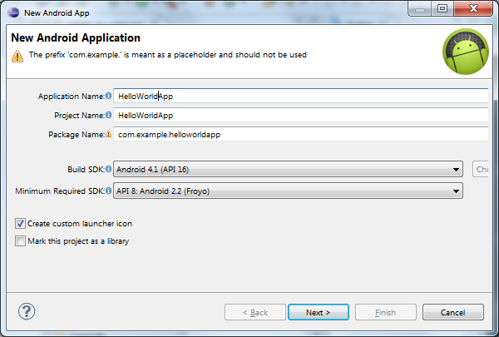
- Create a launcher icon for your app
- Select “BlankActivity”, then click Next
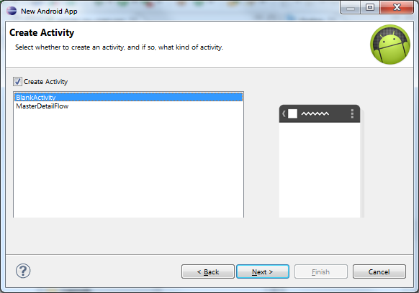
- Leave all the details for this BlankActivity in their default and click Finish
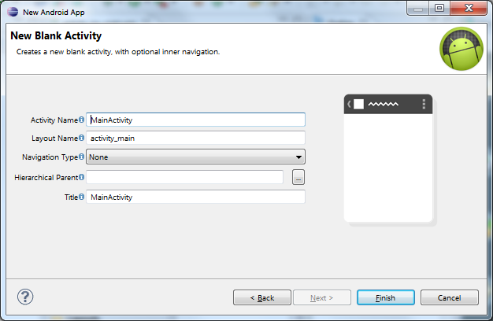

- From the Package Explorer window, you will find the following folders:

HelloWorldApp
- src
- gen [Generated Java Files]
- Android 4.1
- Android Dependencies
- assets
- bin
- libs
- res
  - drawable-hdpi
  - drawable-ldpi
  - drawable-mdpi
  - drawable-xhdpi
  - layout
    - activity_main_xml
  - menu
    - activity_main_xml
  - values
    - strings.xml
    - styles.xml
  - values-v11
  - values-v14
- AndroidManifest.xml
- ic_launcher-web.png
- proguard-proj.txt
- projectproperties

Questions:
Q6-2A. Examine the directories/folders and files in the Hello World App
Study the AndroidManifest.xml File available at http://developer.android.com/guide/topics/manifest/manifest-intro.html, then give a summary of the AndroidManifest.xml.
- Locate AndroidManifest.xml file inside the Package Explorer of the Eclipse IDE, right Click on it, choose Open With Text Editor to display the content of file (similar to the one as shown below), and then copy it onto your answer file (this homework doc file).
- List and explain all the elements and their related attributes that appear in the manifest file of this Hello World App.

<manifest xmlns:android="http://schemas.android.com/apk/res/android"
package="com.example.helloworldapp"
android:versionCode="1"
android:versionName="1.0" >

<uses-sdk
android:minSdkVersion="8"
android:targetSdkVersion="15" />

<application
android:icon="@drawable/ic_launcher"
android:label="@string/app_name"
android:theme="@style/AppTheme" >
<activity
android:name=".MainActivity"
android:label="@string/title_activity_main" >
<intent-filter>
<action android:name="android.intent.action.MAIN" />

<category android:name="android.intent.category.LAUNCHER" />
</intent-filter>
</activity>
</application>
</manifest>

Questions:
Q6-2B. Examine the Android Layout files defined in the Hello World App
Study the Android layout (http://developer.android.com/guide/topics/ui/declaring-layout.html ) which defines the visual structure for a Smartphone’ user interface (UI) for an activity (http://developer.android.com/guide/components/activities.html ) or app widget (http://developer.android.com/guide/topics/appwidgets/index.html ). The activity_main.xml file declares UI elements in XML with Android’s defined XML vocabulary that corresponds to the View classes and subclasses.
- To view the defined layout file and copy this file, you may
- Right click the activity_main.xml file located in the res\layout folder inside the Package Explorer
- Choose => Open With Text Editor to see the activity_main.xml as shown below
- Then copy it onto your answer file (this homework doc file)
- List and explain all the elements and their related attributes that appear in the layout file of this Hello World App.

<RelativeLayout xmlns:android="http://schemas.android.com/apk/res/android"
xmlns:tools="http://schemas.android.com/tools"
android:layout_width="match_parent"
android:layout_height="match_parent" >

<TextView
android:layout_width="wrap_content"
android:layout_height="wrap_content"
android:layout_centerHorizontal="true"
android:layout_centerVertical="true"
android:text="@string/hello_world"
tools:context=".MainActivity" />

</RelativeLayout>

Hand-in Item 1 – due Oct. 17, 2012
Copy all questions and your answers in Hw6-3 report (name it cpet565-499-Hw6-3.docx).

Part 2: Second Android Lab Activity: Building a Simple User Interface with one text input field and a message send button. (http://developer.android.com/training/basics/firstapp/building-ui.html )
This Android programming activity allows you to modify the Hello App created in Part 1 as follows:
- Create a LinearLayout (instead of RelativeLayout)
- Add a user-editable Text Field inside the LinearLayout
- Add string resources in the user interface (UI)
- Add a Button
- Run the program using a simulator and copy the results on to your Lab 2 report.
This lab activity will modify the HelloWorldApp\res\layout\activity_main.xml as follows:
<?xml version="1.0" encoding="utf-8"?>
<LinearLayout xmlns:android="http://schemas.android.com/apk/res/android"
xmlns:tools="http://schemas.android.com/tools"
android:layout_width="match_parent"
android:layout_height="match_parent"
android:orientation="horizontal">

<EditText android:id="@+id/edit_message"
android:layout_weight="1"
android:layout_width="0dp"
android:layout_height="wrap_content"
android:hint="@string/edit_message"/>

<Button
android:layout_width="wrap_content"
android:layout_height="wrap_content"
android:text="@string/button_send" />

</LinearLayout>

And you will also modify the HelloWorldApp\res\values\strings.xml as follows:
<?xml version="1.0" encoding="utf-8"?>
<resources>

<string name="app_name">HelloWorldApp</string>
<string name="edit_message">Enter a message</string>
<string name="button_send"> Send</string>
<string name="menu_settings">Settings</string>
<string name="title_activity_main">MainActivity</string>

</resources>

Hand-in Item 2 – due Oct. 17, 2012
Submit a lab report (name it cpet565-499-Lab2.docx) that includes the following section: (see the following guideline for your reference, http://www.etcs.ipfw.edu/~lin/InfoForAllCourses/laboratoryreport.htm)
** Objective
** Computer Equipment and Software Used
** Procedure
** Data (Screen shots, results)
** Conclusion

