Design and Implementation of an Internet-Based Virtual Lab System for eLearning Support

Paul I-Hai Lin and Melissa Lin*

Purdue University Fort Wayne Campus
*HenEm Inc., Parkville, Missouri
lin@ipfw.edu linm@ipfw.edu

Abstract

Significant advances in Internet and computer technology have made it possible to develop an Internet-based virtual lab system to support distance learning courses that require a laboratory component where Internet-based control laboratory experiments such as measurement, monitoring, and control applications can be accessed remotely. The proposed virtual lab system architecture includes such features as control, measurement, networking, and reporting. This paper addresses issues in the architecture selection, electronics, embedded processors and software, Web and Internet technologies, and laboratory development.

I. Introduction

Many on-line learning support and delivering software systems such as WebCT, Blackboard, etc., are used by distance education instructors to develop and deploy online courses. These software systems normally integrate such desired functions as presentation of the course modules, educational tools to facilitate learning, communication support through email, online chat room, group collaboration through discussion pages and whiteboard, course assessment tools for preparing quiz and self-evaluation, and administrative tools to assist the process of management and continuing improvement of the course. However, technological realities and lab hardware requirements/constraints of these software systems present challenges to educators who want to develop online technical courses in the fields of engineering or engineering technology with physical laboratory activities.
The proposed virtual lab system architecture combines TCP/IP network architecture, Internet-based Web technology, networking, and functions of remote measurement, monitoring, and control. This virtual lab system also includes technologies needed for supporting real-time digital control, data gathering, remote access, views of the history of user access logs, remote laboratory experiment.
This paper recommends related Internet and Web technologies needed for developing a virtual Lab system and summarizes the project experience that supporting e-Learning courses. This paper is organized as follows: section II explores virtual lab system design issues, section III describes implementation and maintenance of the virtual Lab system, and section IV provides some laboratory examples that supported by this virtual lab system.
II. The Virtual Lab System Design Issues
The design of a virtual lab system for real-time Internet-based measurement, monitoring, and control should consider all aspects of the system including communications, sensors, actuators, instrumentation, and controls. The virtual lab system should be designed and integrated to include a simple user interface through Web browser, instrument networking and control interfacing modules, instrument operation monitoring and lab scheduling subsystems.

Figure 1. Virtual Lab System Architecture

The desired virtual lab system is strongly focused on interactions between end-users, the sensors, actuators, control and measurement systems located at the lowest end of the system. Figure 1 shows our virtual lab system architecture including the following features to enable collaboration among various legacy subsystems (both software and hardware):
- Adopting open network communication (Ethernet and TCP/IP)
- Supporting distributed measurement and control application development
- Enabling rapid system development that supports related technologies and legacy components (for example, an RS232 enabled digital multimeter, IEEE 488-bus interface, an Opto22 Web server, analog and digital I/Os, and legacy software)
- Enabling visual feedback through a Web camera
- Supporting a Web browser client, and other Web clients
- Supporting remote procedure (method) calls through Web server (Java Servlet, applets, Java Remote Method Invocation, Visual Basic clients, C clients, Visual C++ clients, C# clients, etc).

Figure 2. Software and Hardware Modules of the V-Lab

Figure 2 shows the desired software and hardware modules of the virtual lab system (V-Lab) which includes sensors, actuators, interface modules, networked I/O, A/D, and D/A. The architecture of the proposed V-Lab system, as shown in Figure 1 and 2, is based on the client/server model and consists of the following major modules: sensors and actuators, data acquisition and signal conditioning, input/output links, networking interface, Common Gateway Interface (CGI)-accessed control programs, a Web server, and a database. Through TCP/IP and Web technologies by which the virtual lab system can be efficiently accessed, controlled and monitored at any time, any place.

Assume that a Web server, HTML documents, control pages for services and operation, and related lab experiment control programs are already developed and installed, the basic operation of this virtual lab system, as shown in Figure 3, is as follows:
- A user logs on to a PC and connects to the Internet, uses a Web browser to logon to the Web server.
- A login page is sent to the user for authenticating the user account and password.
- The user receives a main control Web page that contains forms to show all supported access activities; the user selects needed operations, setup values, and then submits the form back to the Web server.
- The Web server receives the requested information and calls appropriate CGI programs (C/C++, Visual basic, Java, etc) to perform requested tasks.
- Finally, the status of the system operation is reported back to the user.

Figure 3. Operations of an Internet-based V-Lab System

Once the control system has been defined, the selection of the sensors, I/O devices, computer hardware/software, and networking devices and connections can be determined. There are nine basic building blocks that may be applied to the Internet-based measurement, monitoring and controls activities:

- Develop a detailed virtual lab system’s operating specifications
- Determine the real-time needs of the operation in order to meet the requirements of logic, software, networking, and hardware platform
- Select I/O sensors for measurement, monitoring and control interface
- Design local operator interface and control circuits
- Determine the control parameters to aid in the control of the program
- Determine and install Web Servers
- Design Web Pages for measurement, monitoring and control
- CGI Programming for measurement, monitoring and control
- View and test the desired system

III. Implementation and Maintenance of the V-Lab System
Web Server Configuration. The implementation of a web-based virtual Lab system is more than just writing Web pages, and/or side CGI programs, it may consists of a series of tasks starting from building a Web server, specifying, building and testing lab circuits and control software, etc. Notice that configuring a Web server for publishing HTML documents is a major step in implementing a web-based lab.

Multiple Web Servers. To increase the system reliability and be able to support various web-based lab activities, multiple Web servers may be considered. The web server software used in our V-Lab system includes the Apache server (open source), and Microsoft Internet Information server. Some web servers were designed to use CGI programs (Perl, Visual Basic, and C/C++) as external gateway interface programs to interface to databases, digital and analog I/Os. Other legacy web servers with digital and analog I/Os are also connected to the web-based lab system. Apache servers are setup to work with Tomcat Servlet Engine, Java Servlet, and JSP for experimentation with Java technology. A V-Lab user can indirectly access the system through the course Web page or through the network diagram page as shown in Figure 4.

Figure 4. V-Lab System Network Diagram Page

Integrated Software Strategies. To support reuse and rapid software development, we included existing Visual Basic and Visual C++ interfacing programs for interfacing to serial ports, parallel ports, and digital I/Os. Application programs for running RS232-based digital multi-meter and data acquisition cards are modified to allow remote access through web server. These stand-alone programs can be converted to CGI (common gateway interface) programs for remote access with minimum effort. Because of the low-level I/O control requirement, we use CGI instead of Java for measurement control applications. A list of programming languages used to develop applications and labs for our web-based lab is found in [2]-[10]:
- HTML - for web pages
- JavaScript - used in the client-side page for making dynamic pages, and performing some client side computations
- Perl - for writing server-side scripts to access and process login files, data files, and databases
- Visual Basic - for writing thick client applications and server-side CGI applications
- Visual C++ - for writing thick client applications and server-side CGI applications
In addition, other popular server-side programming tools such as ASP, JSP, Java Servlet, and Visual Basic.NET, which can be found in [10]-[12], are also used to support some lab activities.

Electrical/Electronics Hardware for Virtual Lab System. The architecture of the Internet-Based Monitoring and Controls for HVAC Applications [13] was slightly modified and used as a reference for our web-based V-Lab system development. As shown in Figure 5, major hardware/software modules including sensors, I/Os, data acquisition, signal conditioning, modules and software CGI program are pre-configured and can be accessed through prewritten Web pages and CGI programs.
Figure 5. Control Server of the Virtual Lab System

IV. V-Lab System Laboratory Examples

The login page (homepage1.shtml) was designed to authenticate users for using our web-based V-Lab system. Login as Professor is granted to access the system without date and time restriction. Students are asked to reserve their time slots through the schedule link on this page before they can access the V-Lab system.
The main page of the Virtual Lab system including the laboratory assignment page is as shown in Figure 6. This HTML page is design to include the following features:
- Links to all available lab assignment pages
- Links to show graphic diagrams of circuits and equipment that relate to each lab
- Links for users to invoke CGI programs to exercise control and measurement systems.
- Upload links for students to turn in their homework assignments
- File/program download links
- A secured homework, lab, and test grades display page for instructors and students
- Access to the Web-based Lab Web camera and other useful links
- e-Mail links for students to communicate with the instructor

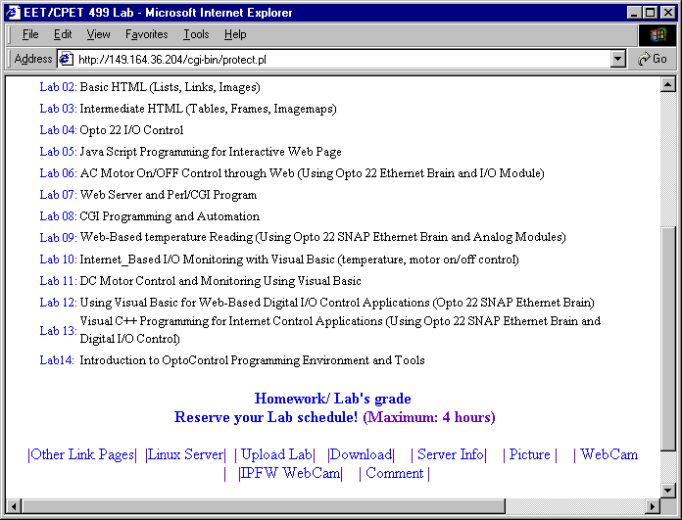
Figure 6. The V-Lab System Login Page

The experimental Internet-based motor monitoring and control system, as shown in Figure 7, consists of the following major components:
- A PC with WindowsXP operating system, a Web server, and a Microsoft Access database; an 8255 digital I/O card (with 24 digital I/Os for On/Off control of lights, and fan motors), and a digital multimeter (for motor current measurement) accessed via a RS232 serial port
- An Ethernet brain controller, Ethernet-base I/O modules including four A/D channels, two D/A channels, and eight digital I/Os from Opto 22
The experiment involves creating a Web control page for the Internet-based climate control system, as shown in Figure 8. Authorized users can request this web page from the web-server; then click on the ON or OFF button to submit the operation request to the web server for dispatch the control requests to appropriate I/O modules in an Opto22 Ethernet brain and I/O controller. The brain then passes the command to digital output module, turns the fan motor on or off.
Figure 7. An Experimental Setup for V-Lab System

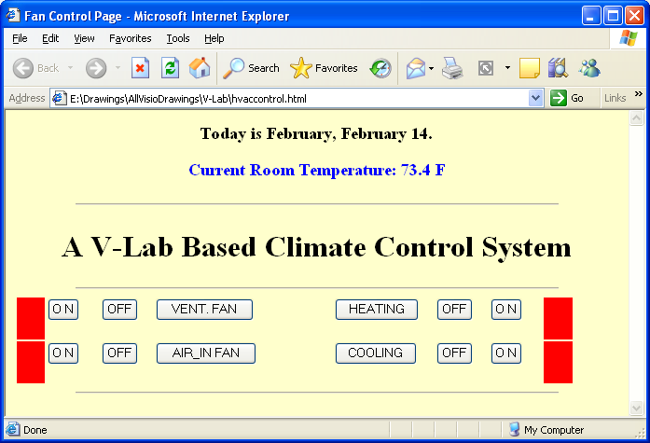
Figure 8. The Web Page for Climate Control System

Conclusion
This paper presented the architecture of a virtual lab system for use in distance laboratory delivery. The virtual lab system design and implementation issues, and lab examples were also described. The preliminary investigation of the proposed virtual lab suggests the following findings:
- The architecture is flexible and scalable.
- It allows easier connection of multi-vendor equipment
- It can be accessed easily with TCP/IP-based office and campus network, and Internets with password authentication. However, an improved application security mechanism to offer protection against the most common break-in scenario in needed.
The author expects to continue the research on issues related to application layer security of the V-Lab system and expanding system integration capabilities to include existing Mitsubishi RV-M1 robots (in Manufacturing Technology department), Electrical Machine lab (through LabView system), and MATLAB data acquisition and control, and other legacy controls.

References

- Paul I-Hai Lin and Hal Broberg, "Web Programming for Industrial Applications: A New Course," Session 1520, Proceedings of the 2001 ASEE Annual Conferences, New Mexico.
- Paul I-Hai Lin, "Distributed Control and Measurement via the Internet," Indiana Electronics Manufacturing Association Annual Technical Conference, Indianapolis, Indiana, Nov. 4, 1999.
- Paul I-Hai Lin, Computer Networking & Data Communications: The Internet and Web Development technology Series, Indiana U-Purdue U Fort Wayne, October 2000.
- Paul I-Hai Lin, Building Web Applications with HTML: The Internet and Web Development technology Series, Indiana U-Purdue U Fort Wayne, October 2000.
- Paul I-Hai Lin, Developing Advanced Web Applications Using JavaScript/Jscript: The Internet and Web Development Technology Series, Indiana U-Purdue U Fort Wayne, October 2000.
- Paul I-Hai Lin, Programming with CGI/Perl: The Internet and Web Development Technology Series Indiana U-Purdue U Fort Wayne, October 2000.
- Paul I-Hai Lin, Tutorial On Java Computing for Distributed Applications Over The Internet, IEEE IAS Annual Conference, Phoenix, Arizona, IEEE Industry Applications Society Publication, October 1999.
- Paul I-Hai Lin, Web Programming for Industrial Applications, www.etcs.ipfw.edu/~lin, Purdue University Fort Wayne Campus, Fall 2000.
- Paul I-Hai Lin, Lecture Notes and Laboratories of C++ Objected-Oriented Programming with Industrial Applications, www.etcs.ipfw.edu/~lin, Indiana University-Purdue University Fort Wayne, Fall 1999.
- Deitel, Deitel & Nieto, Internet & World Wide Web - How to Program, 2nd Edition, Prentice Hall, 2001.
- Deitel, Deitel & Stantry, Advanced Javas Platform - How to Program, Prentice Hall, 2001.
- Deitel, Deitel & Nieto, Visual Basic.NET - How to Program, 2nd Edition, Prentice Hall, 2001.
- Paul I-Hai Lin and Hal Broberg, "Internet-Based Monitoring and Controls for HVAC Applications," IEEE Industry Applications Magazine, January/February 2002, pp. 49-54.
- Chung-Ping Young, Wei-Lun Juang, and Michael J. Devaney, "Real-Time Intranet-Controlled Virtual Instrument Multiple-Circuit Power Monitoring," IEEE Trans. on Instrumentation and Measurement, Vol. 49, No. 2, June 2000, pp. 579-58.
- Luigino Benetazzo, et. al., "A Web-Based Distributed Virtual Educational Laboratory," IEEE Trans. on Instrumentation and Measurement, Vol. 49, No. 2, April 2000, pp. 349-354.
- Jim Conallen, Building Web Applications with UML, 2000, Addison Wesley
- Michael Dunbar, "Plug-and-Play Sensors in Wireless Networks," IEEE Instrumentation & Measurement Magazine, March 2001, pp. 19-23.
- Fernando Zubillaga-Elorza and Charles R. Allen, "Virtual Instrument Toolkit: Rapid Prototyping on the Web," IEEE Internet Computing, Vol. 3, No. 5, September/October 1999, pp. 41-48.
- Nenad Ivezic, Thomas E. Potok, and Line Pouchard, "Multiagent Framework for Lean Manufacturing," IEEE Internet Computing, Vol. 3, No. 5, September/October 1999, pp. 58-59.
- L. Callegaro, G.C. Bosco, P.P. Capra, and D. Serazio, “A Remotely Controlled Coaxial Switch for Impedance Standard Calibration, “ IEEE Trans. on Instrum. Meas., Vol. 51, pp. 628-631, August 2002.
- G. Moczar, T. Csubak, and P. Varady, Distributed Measurement System for Heat Metering and Control, “ IEEE Trans. on Instrum. Meas., Vol. 51, pp. 691-694, August 2002.
- Richard A. Dubdley and Nick M. Ridler, “A Distributed Measurement Architecture for Industrial Applications,” IEEE Trans. on Instrum. Meas., Vol. 52, pp. 165-174, February 2003.
- S. Chen, “Open Design of Networked Power Quality Monitoring Systems, “ IEEE Trans. on Instrum. Meas., Vol. 52, pp. 597-601, April 2004.
- Philip Koopman, “Embedded System Security,” IEEE Cpmuter, pp. 95-97, July 2004.
- L. Cristaldi. et. al, “A Virtual Environment for Remote Testing of Complex System,” IEEE Trans. on Instrum. Meas., Vol. 54, pp. 123-133, February 2005.
- M. de Magistries, “A MATLAB-Based Virtual Laboratory for Teaching Introductory Quasi-Stationary Electromagnetics, “ IEEE Trans. on Educations, Vol. 48, pp. 81-88, February 2005.
- S. Bermejo, “Cooperative Electronic Learning in Virtual Laboratories Through Forums, “ IEEE Trans. on Educations, Vol. 48, pp. 140-149, February 2005.

